O’ZBEKISTON RESPUBLIKASI OLIY VA O’RTA MAXSUS TA’LIM VAZIRLIGI
TOSHKENT VILOYATI CHIRCHIQ DAVLAT PEDAGOGIKA INSTITUTI

TIL ASPEKTLARINI O`RGATISH AMALIYOTI KOMPETENSIYASI
(ingliz)
FANIDAN O’QUV-USLUBIY MAJMUA

Bilim sohasi: 100000-Gumanitar
Ta’lim sohasi: 110000-Pedagogika
Bakalavriat yo’nalishi: 51114000-Xorijiy til va adabiyoti(ingliz tili)


Chirchiq-2019
O’ZBЕKISTON RЕSPUBLIKASI
OLIY VA O’RTA MAXSUS TA’LIM VAZIRLIGI

TOSHKENT VILOYATI CHIRCHIQ DAVLAT PEDAGOGIKA
INSTITUTI

“TASDIQLAYMAN”
O'quv ishlari bo'yicha prorektor
I.Q.Xaydarov “ ” 2019-yil

“Xorijiy tillar” kafеdrasi “Chet tili nazariy aspektlari” fanidan

O’QUV – USLUBIY MAJMUA

Bilim sohasi: 100000 – Gumanitar
Ta’lim sohasi: 110000 – Pedagogika
Ta’lim yo‘nalishi: 5111400 – Xorijiy til va adabiyoti (ingliz tili)

CHIRCHIQ – 2019

Mazkur o'quv-uslubiy majmua O'zbekiston Respublikasi Oliy va o'rta maxsus ta’lim vazirligining 201_-yil dagi -sonli buyrug'i bilan tasdiqlngan “Chet tili nazariy aspektlari” o'quv fan dasturi asosida tayyorlangan.

Tuzuvchilar: M.A.Yusupova- “Xorijiy tillar” kafedrasi mudiri
N.N.Yuldasheva- Toshkent viloyati Chirchiq davlat pedagogika instituti “Xorijiy tillar” kafedrasi o'qituvchisi
Z.A.Umirova - Toshkent viloyati Chirchiq davlat pedagogikinstituti “Xorijiy tillar” kafedrasi o'qituvchisi

Taqrizchilar: J.Sh.Djumabayeva - O'zMU “Ingliz filologiyasi” kafedrasi mudiri, f.f.d., professor.

N.A.Sadullayeva - O'zMU “Qiyosiy tilshunoslik” kafedrasi mudiri, f.f.n., dots.

O'quv-uslubiy majmua “Tarix va tillar” fakultetining “Xorijiy tillar” kafedrasi majlisida (2019-yil 24-avgust 1-son bayonnoma) muhokama etildi va fakultetning o'quv-uslubiy kengashiga tavsiya etildi.

“Xorijiy tillar” kafedrasi mudiri M.A.Yusupova

“Xorijiy tillar” kafedrasi kotibasi F.Djabborova

O'quv-uslubiy majmuasi “Tarix va tillar” fakulteti o'quv-uslubiy kengashida ko'rib chiqildi (2019-yil 26-avgust 1-don bayonnoma) va institutning ilmiy-yslubiy kengashiga tasdiqlashga topshirildi.

Tarix va tillar fakulteti dekani y.f.n.dots. R.A.Ikramov

Tarix va tillar fakulteti o'quv-usulubiy
kengashi kotibasi f.f.n. dots.A.R.Davlatova

O'quv-uslubiy majmuasi Toshkent viloyati Chirchiq davlat pedagogika institutining ilmiy-uslubiy kengashida ko'rib chiqildi va tasdiqlandi. (2019-yil 27-avgust 1-son bayonnoma).

O’QUV-USLUBIY MAJMUASINING TARKIBI
MUNDARIJA
1. O’QUV-METODIK MATERIALLAR
1.1. Amaliy mashg’ulot mavzulari
2. GLOSSARIY
3. ILOVALAR
3.1. Fan dasturi
3.2. Ishchi o’quv dasturi
3.3. Testlar

Lesson 1. Talking about language. Learning vocabulary. M:Brainstorming. ·
Number of students: 25-30 |  | Time: 2 hours
Form of the lesson: |  | Practical training
Plan of the lesson: |  | 1. Introduction  2. How to learn words  3. Learning for vocabulary tests  4. Learning vocabulary by reading  5. More information about learning words  6. Things to know about the words you learn
The aim of the lesson: |  | to enhance sudents’ reading, writing, listening, speaking abilities
Tasks of the teacher: |  | To check student knowledge about:
The results of educational process: |  | The student must answer for all questions and know:
Methods and techniques of teaching |  | brainstorming, working in pairs
Forms of teaching |  | Individual, frontal and collective work, work in pairs
Conditions of teaching |  | Auditorium equipped for working in pairs
Stages,time | Activity
Stages,time | Of the teacher |  | Of students
Stage 1.  Introduction of the lesson(10 min) | 1.1. At the beginning of the lesson distribu

Stage 2.

The main part of the lesson(60 min)
Stage 3.  Conclusive  (10 min) | 3.1. Makes conclusions on the theme in whole, generalize received educational results, encourage active participants. Notes significance of received knowledge for future professional and educational activity.  3.2. Gives tasks for independent work
· Parents · Grammar · Vocabulary | learning English

Introduction Learning vocabulary is a very important part of learning a language. The more words you know, the more you will be able to understand what you hear and read; and the better you will be able to say what you want to when speaking or writing.

Which words to learnEvery day you hear or read many new English words. You also find them in your dictionary when you are translating from your own language. You can’t possibly learn all these new words, so your first problem is to decide which ones to concentrate on. Here are some suggestions:
- learn the words that are important to the subjects you are studying
- learn the words that you read or hear again and again
- learn the words that you know you will often want to use yourself
- do not learn words that are rare or not useful (your teacher can help you with this)

How to learn words
Once you have chosen which words to learn, you next have to decide how you are going to learn them. Here are a few ideas:
- write the words in a notebook (with their translations or definitions)
- write the words and definitions on small cards
(advice on how to do this)
- say the words many times (if you have an electronic dictionary you can hear how the word is pronounced)
- put the words into different groups (you could use a graphic organiser)
- write them in a file for use with a computer program (such as Quizlet or the one on this site)
- make associations (in pictures or with other words)
- ask someone to test you
- use the words in your own speaking or writing
Some students put a tick or cross in their dictionary next to every word they look up. The next time they turn to a page with a marked word, they quickly check to see if they remember the meaning of that word.
In all of the above ways, you are doing something with the words. It’s usually not enough to just read through a list of words with their definitions or translations and try to remember them. Most students find that they memorise words better if they do something with them. Even better is to try and learn the word in a typical combination with other words. Learning that to apologize means to say sorry is a good start, but it's much better to learn a whole expression containing the word, e.g. He apologized for being late. Not only is this often easier to remember, but you are also learning some very important information on how the word is used.

Learning for vocabulary tests
The previous section on this page gives general advice on how to learn the words that you have chosen as important for you. Often, however, you will be given a set of words by your teacher and told to learn them for a vocabulary test. In this case you need to be sure exactly how you will be tested, because this will influence how you learn the words. There are several ways that the teacher might test your vocabulary learning, but the ways are broadly divided into two categories:
- You will be given the word and have to:
  - write a definition
  - use it in an example sentence
  - translate it into your language
- You will be given:
  - a definition
  - a gapped example sentence
  - the translation in your language
and you have to write the English word.
If you do a vocabulary test from the second group above, then in most cases you will need to learn the exact spelling of the word and will lose marks if you misspell it. As with all tests, be sure to ask the teacher exactly how you will be tested and exactly how you will be graded. You will then avoid wasting time studying something that you will be not be tested on.

Learning vocabulary by reading
The way you learned very many of the words in your own language was by meeting them in the books and magazines you read. The context of a new word in a sentence or story was often enough for you to guess the meaning. Meeting the word again and again in your reading helped you learn it for use in your own speaking and writing. Doing lots of extra reading for pleasure - both fiction and non-fiction - is an excellent way to learn new English words, too. But choose books that you find quite easy to read. Difficult stories or texts that you struggle to understand will not help you to develop your vocabulary the natural way. But remember: to learn new words from reading you have to read A LOT!
The vocabulary you know can be divided into two groups - passive vocabulary and active vocabulary. Passive vocabulary contains all the words that you understand when you read or listen, but which you do not use (or cannot remember) in your own writing and speaking. Active vocabulary is all the words you understand, plus all the words that you can use yourself. Your active vocabulary, in English and your own language, is probably much smaller than your passive vocabulary.
The more you work on learning a word, as suggested above, the more likely it is that it will become part of your active vocabulary.

Things to know about the words you learn
Usually the first things you learn about a new English word are what it means and its translation in your own language. But there are other things you need to find out before you can say that you know a word like a native speaker does. For example, you have to learn:
- how it is spelled
- how it is pronounced
- how it is inflected (i.e. how it changes if it is a verb, noun or adjective)
- other grammar information about it
- how it collocates (i.e. what other words are often used with it)
if it has a particular style or register
- the context in which it is most likely to be used. Native speakers learn these things about words by hearing them and reading them again and again. This is the best way for you to learn them, too.

Lesson 2. Prefixes. Suffixes. M: Pair work.
Number of students: 25-30 |  | Time: 2 hours
Form of the lesson: |  | Practical training

Plan of the lesson:
The aim of the lesson: |  | to enhance sudents’ reading, writing, listening, speaking abilities
Tasks of the teacher: |  | To check student knowledge about:
The results of educational process: |  | The student must answer for all questions and know:
Methods and techniques of teaching |  | brainstorming, working in pairs
Forms of teaching |  | Individual, frontal and collective work, work in pairs
Conditions of teaching |  | Auditorium equipped for working in pairs
Stages,time | Activity
Stages,time | Of the teacher |  | Of students
Stage 1.  Introduction of the lesson(10 min) | 1.1. At the beginning of the lesson distribu

Stage 2.

The main part of the lesson(60 min)
Stage 3.  Conclusive  (10 min) | 3.1. Makes conclusions on the theme in whole, generalize received educational results, encourage active participants. Notes significance of received knowledge for future professional and educational activity.  3.2. Gives tasks for independent work

Blog

Prefix definition: an affix attached to the beginning of a word to modify its meaning.
Suffix definition: a particle attached to the end of a word to modify its meaning or change it into a different word class.

What is the Difference Between Prefixes and Suffixes?
In the English language, we often place prefixes and suffixes at the beginning and end, respectively, of a word in order to modify it.The original word does have meaning in itself, but by adding a prefix or suffix to it, we change the word.
What is a prefix? Prefixes are placed at the beginning of a word in order to alter its meaning.
- Janet resubmitted her application after she was initially denied a loan.
Resubmitted includes the prefix re which means again.
What is a suffix? Suffixes are placed at the end of a word in order to alter its meaning or change the classification of the word.
- We work hard in order to ensure our children’s happiness.
Happiness includes the state of being suffix ness. By adding the suffix, we have changed our word from an adjective to a noun in order for it to fit grammatically in our sentence.

What are Prefixes?
What does prefix mean? A prefix can be a letter or group of letters that may be added to the beginning of a word in order to modify its meaning.
Prefix Examples:
- a-, an- = without; amoral, anemic
- ante- = before; antecedent
- co- = with; co-worker
- de- = off, remove; de-ice
- ex =out of, former; ex-boyfriend
- il = not; illegal
- inter = between; intergalactic
- post = after; postpone
- super = above; supersede
- un = not; unnatural
Let’s try using a prefix in a sentence.
- Craig was dissatisfied with the customer service he received at the store.
  - Prefix = dis = negative

When to Hyphenate Prefixes
Do you hyphenate prefixes? At times, you will want to add a hyphen in between your prefix and word.
Proper nouns: when adding a prefix to a proper noun, you must add a hyphen:
- Not liking apple pie may be seen as un-American.
Same vowel: If the last letter of your prefix is the same as the first letter in the word, you need to add a hyphen:
- In order to be allowed re-entry to the amusement park, patrons must obtain a stamped ticket.
Special prefixes: Always use a hyphen when you use ex- and self-.
- Lisa was self-conscious about her body after having a baby.
- The ex-student body president trained the current officer on how to organize prom.
Clarification: Use a hyphen when a word may cause confusion or look odd in the sentence.
- The mother reminder the children to re-cover the sandbox after they were done playing.
We need the hyphen, so that readers don’t confuse re-cover with the word recover, which means to reinstate health or regain a lost possession.

What are Suffixes?
What does suffix mean? Suffixes are used at the end of words in order to change the word to fit grammatically within your sentence.
Suffix Examples:
- –al = having characteristics of; remedial, denial
- –ed = past-tense verbs; traveled, talked
- –en = made of, consisting of; wooden, golden
- –er, -est = comparative; stronger, strongest
- –tion, -ion = state of being, condition; completion, relation
- –ity = quality of; humility, enormity
- –less = without; hopeless, homeless
- –ly = characteristic of; brotherly, lovely
- –s, -es = more than one; apples, trenches
Let’s look at an example of a suffix used in a sentence:
- In government class, students will research the current election.
  - Suffix = ion = act, process

When to Hyphenate Suffixes
Do you hyphenate suffixes? We rarely hyphenate suffixes, but here are some instances in which you may add one.
Cumbersome words: an optional hyphen can be used when a word seems lengthy without one.
- community-wide
Exception words: -like, -type, -elect,
- scholarly-like
When last letter is same as first letter:
- graffiti-ism, past-tense

Summary
Define prefix: the definition of prefix is an element placed at the beginning of a word to alter or qualify its meaning.
Define suffix: the definition of suffix is a particle placed at the end of a word to alter its meaning or adjust its grammatical sense.
In summary,
- Prefixes and suffixes are added to words to change them.
- Prefixes are added to change the meaning of the root word.
- Suffixes are added so that the word will make grammatical sense in a sentence.
Here are a couple of final examples of how we use prefixes and suffixes.
- Many science fiction books include an intergalactic war.
  - Prefix = inter = between
- The employee rushed to his car after work on Friday.
  - Suffix = ed = past-tense verb

Writing Topics
Confusing Words
Starting a Blog
MLA Writing Style
APA Writing Style

Lesson 3.Words you may confuse. M.: Group work.
Number of students: 25-30 |  | Time: 2 hours
Form of the lesson: |  | Practical training

Plan of the lesson:
The aim of the lesson: |  | to enhance sudents’ reading, writing, listening, speaking abilities
Tasks of the teacher: |  | To check student knowledge about:
The results of educational process: |  | The student must answer for all questions and know:
Methods and techniques of teaching |  | brainstorming, working in pairs
Forms of teaching |  | Individual, frontal and collective work, work in pairs
Conditions of teaching |  | Auditorium equipped for working in pairs
Stages,time | Activity
Stages,time | Of the teacher |  | Of students
Stage 1.  Introduction of the lesson(10 min) | 1.1. At the beginning of the lesson distribu

Stage 2.

The main part of the lesson(60 min)
Stage 3.  Conclusive  (10 min) | 3.1. Makes conclusions on the theme in whole, generalize received educational results, encourage active participants. Notes significance of received knowledge for future professional and educational activity.  3.2. Gives tasks for independent work

Everyone knows the problem with spell-check: your word might be spelled right, but it may be the wrong word. English is full of confusing words that sound alike but are spelled differently. It’s also full of words that share similar (but not identical) meanings that are easy to misuse. Below are some of the most commonly confused and misused words in English.
Here’s a tip: Looking for a specific pair of commonly confused words on this page? Use ctrl+F or command+F to search the page quickly.

Advice/Advise Advice is a noun: Chester gave Posey good advice. Advise is a verb: Chester advised Posey to avoid the questionable chicken salad.
Affect/Effect Affect is usually a verb: Chester’s humming affected Posey’s ability to concentrate. Effect is usually a noun: Chester was sorry for the effect his humming had. If you find yourself stumped about which one to use in a sentence, try substituting the word “alter” or “result.” If “alter” fits (Chester’s humming altered Posey’s ability to concentrate), use affect. If “result” fits (Chester was sorry for the result his humming had), use effect.
Among/Amongst Among is the preferred and most common variant of this word in American English. Amongst is more common in British English. Neither version is wrong, but amongst may seem fussy to American readers.
Among/Between Among expresses a collective or loose relationship of several items: Chester found a letter hidden among the papers on the desk. Between expresses the relationship of one thing to another thing or to many other things: Posey spent all day carrying messages between Chester and the other students. The idea that between can be used only when talking about two things is a myth—it’s perfectly correct to use between if you are talking about multiple binary relationships.
Assure/Ensure/Insure Assure means to tell someone that something will definitely happen or is definitely true: Posey assured Chester that no one would cheat at Bingo. Ensure means to guarantee or make sure of something: Posey took steps to ensure that no one cheated at Bingo. Insure means to take out an insurance policy: Posey was glad the Bingo hall was insured against damage caused by rowdy Bingo players.
Breath/Breathe Breath is a noun; it’s the air that goes in and out of your lungs: Chester held his breath while Posey skateboarded down the stairs. Breathe is a verb; it means to exhale or inhale: After Posey’s spectacular landing, Chester had to remind himself to breathe again.
Capital/Capitol Capital has several meanings. It can refer to an uppercase letter, money, or a city where a seat of government is located: Chester visited Brasίlia, the capital of Brazil. Capitol means the building where a legislature meets: Posey visited the cafe in the basement of the capitol after watching a bill become a law.
Complement/Compliment A complement is something that completes something else. It’s often used to describe things that go well together: Chester’s lime green boots were a perfect complement to his jacket. A compliment is a nice thing to say: Posey received many compliments on her purple fedora.
Disinterested/Uninterested Disinterested means impartial: A panel of disinterested judges who had never met the contestants before judged the singing contest. Uninterested means bored or not wanting to be involved with something: Posey was uninterested in attending Chester’s singing class.
Defence/Defense Defense is standard in American English. Defence is found mainly in British English.
Emigrate/Immigrate Emigrate means to move away from a city or country to live somewhere else: Chester’s grandfather emigrated from Canada sixty years ago. Immigrate means to move into a country from somewhere else: Posey’s sister immigrated to Ireland in 2004.
E.g./I.e. These two Latin abbreviations are often mixed up, but e.g. means “for example,” while i.e. means “that is.”
Empathy/Sympathy Empathy is the ability to understand another person’s perspective or feelings. Sympathy is a feeling of sorrow for someone else’s suffering. A sympathizer is someone who agrees with a particular ideal or cause.
Farther/Further Farther refers to physical distance: Posey can run farther than Chester. Further refers to metaphorical distance: Chester is further away from finishing his project than Posey is.
Flaunt/Flout Flaunt means to show off: Chester flaunted his stylish new outfit. Flout means to defy, especially in a way that shows scorn: Posey flouted the business-casual dress code by wearing a tiara and flip-flops.
Gaff/Gaffe A gaff is a type of spear or hook with a long handle: Chester completed his sailor costume with a gaff borrowed from his uncle’s fishing boat. A gaffe is a faux pas or social misstep: Posey made a gaffe when she accidentally called Chester by the wrong name.
Gray/Grey Gray is the standard American English spelling. Grey is the standard British English spelling.
Historic/Historical Historic means famous, important, and influential: Chester visited the beach in Kitty Hawk where the Wright brothers made their historic first airplane flight. Historical means related to history: Posey donned a historical bonnet for the renaissance fair.
Imply/Infer Imply means to hint at something without saying it directly: Chester implied that Posey was in trouble, but he wouldn’t tell her why. Infer means to deduce something that hasn’t been stated directly: Posey inferred that Chester was nervous about something from the way he kept looking over his shoulder.
It’s/Its It’s is a contraction of “it is”: Posey needs to pack for her trip because it’s only two days away. Its is a possessive pronoun that means “belonging to it”: Chester is obsessed with both the book and its author.
Lay/Lie To lay means to put or to place. One way to remember this is that there is an a in both to lay and to place: Posey will lay out her outfit before she goes to bed. To lie means to recline. One way to remember this is that there is an e in both to lie and to recline: Chester will lie down for a nap. Be careful, though. The past tense of to lay is laid: Posey laid out her outfit. The past tense of to lie is lay: Chester lay down for a nap over an hour ago.
Lead/Led Lead, when it rhymes with “bed,” refers to a type of metal: Posey wore a lead apron while the dentist X-rayed her teeth. Led is the past tense of the verb to lead, which means to guide or to be first: Chester led the way.
Learned/Learnt Learned is standard in American English. Learnt is standard in British English.
Loose/Lose Loose is usually an adjective: Posey discovered that the cows were loose. Lose is always a verb. It means to misplace something or to be unvictorious in a game or contest: Chester was careful not to lose his ticket.
Principal/Principle Principal can be a noun or adjective. As a noun, it refers to the person in charge of a school or organization: Posey was called into the principal’s office. As an adjective, it means most important: The principal reason for this meeting is to brainstorm ideas for the theme of Chester’s birthday party. A principle (always a noun) is a firmly held belief or ideal: Posey doesn’t like surprise parties as a matter of principle.
Inquiry/Enquiry Inquiry and enquiry both mean “a request for information.” Inquiry is the standard American English spelling. Enquiry is the British spelling.
Stationary/Stationery Stationary means unmoving: The revolving door remained stationary because Posey was pushing on it the wrong way. Stationery refers to letter writing materials and especially to high quality paper: Chester printed his résumé on his best stationery.
Than/Then Than is used for comparisons: Posey runs faster than Chester. Then is used to indicate time or sequence: Posey took off running, and then Chester came along and finished her breakfast.
Their/There/They’re Their is the possessive form of “they”: Chester and Posey took their time. There indicates a place: It took them an hour to get there. They’re is a contraction of “they are”: Are Chester and Posey coming? They’re almost here.
To/Too To is a preposition that can indicate direction: Posey walked to school. She said hello to Chester when she saw him. To is also used in the infinitive form of verbs: Chester waited until the last minute to do his homework. Too is used as an intensifier, and also means “also”: Posey waited too long to do her homework, too.
Toward/Towards Toward is standard in American English. Towards is standard in British English.
Who’s/Whose Who’s is a contraction of “who is”: Who’s calling Chester at this hour? Whose is a possessive pronoun that means “belonging to [someone]”: Chester, whose phone hadn’t stopped ringing all morning, barely ate anything for breakfast.

Lesson 4. Birth, marriage and death. M. : Collage.
Number of students: 25-30 |  | Time: 2 hours
Form of the lesson: |  | Practical training

Plan of the lesson:
The aim of the lesson: |  | to enhance sudents’ reading, writing, listening, speaking abilities
Tasks of the teacher: |  | To check student knowledge about:
The results of educational process: |  | The student must answer for all questions and know:
Methods and techniques of teaching |  | brainstorming, working in pairs
Forms of teaching |  | Individual, frontal and collective work, work in pairs
Conditions of teaching |  | Auditorium equipped for working in pairs
Stages,time | Activity
Stages,time | Of the teacher |  | Of students
Stage 1.  Introduction of the lesson(10 min) | 1.1. At the beginning of the lesson distribu

Stage 2.

The main part of the lesson(60 min)
Stage 3.  Conclusive  (10 min) | 3.1. Makes conclusions on the theme in whole, generalize received educational results, encourage active participants. Notes significance of received knowledge for future professional and educational activity.  3.2. Gives tasks for independent work

 | Number of students: 25-30 |  |  |  | Time – 2 hours
 |  | Form of the lesson |  | Practical | training
 |  | Plan of the |  | 1. Biography of A.Coppard
 |  |  |  | 2.Analysis of Tribute by A.Coppard
The aim of the lesson: read and forming whole imagination about Tribute by A. Coppard
Tasks of the teacher: |  |  |  | The results of educational process:
To check student knowledge about: |  |  |  | The student must answer for all questions and know:
• | methods and ways of interpretation |  | of the | • | be acquainted with the methods and ways of
 | belles-lettres text; |  |  |  | interpretation.
• | scheme of interpretation |  |  | • Be able to work on the scheme.
 |  |  |  | • | Stylistic analysis of the text
Methods and techniques of teaching |  |  |  | brainstorming, working in pairs
Forms of teaching |  |  |  | Individual, frontal and collective work, work in pairs
Conditions of teaching |  |  |  | Auditorium equipped for working in pairs

Stages, time |  |  | Activity
 |  |  | Of the teacher | Of students
Stage |  | 1. | 1.1. At the beginning of the lesson distributes the text of | The students read the two
Introduction of the |  |  | the practical training and task . | texts and interpret them as
lesson |  |  |  | follows.
(10min.)
Stage 2. |  |  | 2.1. Ask on the first question of the text, pays attention to | to read and analyze the
The | main | part | the students understanding of the text and using their | to read and analyze the
 |  |  |  | texts based on the scheme of
of the | lesson | (60 | knowledge in stylistic through interpretation of the text. | texts based on the scheme of
 |  |  |  | interpretation of literary text;
min.) |  |  |  | interpretation of literary text;
min.) |  |  |  | to interpret the texts
 |  |  |  | critically within
 |  |  |  | philosophically trends;
 |  |  |  | to reveal stylistic devices
 |  |  |  | given in the text;
 |  |  |  | to analyze the richness of
 |  |  |  | the vocabulary of the author
 |  |  |  | discussing using them.
Stage 3. |  |  | 3.1. Makes conclusions on the theme in whole, generalize
Conclusive |  |  | received educational results, encourage active participants.
(10 min.) |  |  | Notes significance of received knowledge for future
 |  |  | professional and educational activity.
 |  |  | 3.2. Gives tasks for independent work

a Blog

Birth
The emergence of a baby or other young from the body of its mother the start of life as a physically separate being. The emergence of a new individual from the body of its parent. The act or process of bringing forth young from the womb. Birth is defined as a baby emerging from a mother's womb or the start of something. In the womb, a fetus has both a presentation and a position. Presentation refers to the baby’s body that leads or is expected to lead, out of the birth canal 9. For example, if a baby’s rear is set to come out of the birth canal first, baby is said to be in “breech presentation”.

Marriage
According to the book
Marriage may be defined as formal and durable sexual union of one or more men which is conducted within a set of designed rights and duties.

According to family code of the Philippines
Marriage is a physical legal and moral union between man and woman in complete community life for the establishment of a family.

Importance of marriage
To have a permanent relationship with the person you love.
To beget children and have happy family
For economic and social upliftment or insurance

Types of marriage
1- monogamy- marriage between one man and one woman.
2 -polygamy or plural marriages refers to the marriage of more than one mate at a given time. It has 3 forms.
1. Polygyny one husband and 2 more wives
2. Polyandry one wife and 2 or more husbands
3. Group marriage of several men to several women

Characteristics of marriage
1. Marriage is a universal social institution. It is found in almost all societies and at all stages of development.
2. Marriage is a permanent bond between husband and wife. It is designed to fulfill the social, psychological, biological and religious aims.
3. Marriage is a specific relationship between two individuals of opposite sex and based on mutual rights and obligations. Relationship is enduring.
4. Marriage requires social approval. The relationship between men and women must have social approval. Without which marriage is not valid.
5. Marriage establishes family. Family helps in providing facilities for the procreation and upbringing of children.
6. Marriage creates mutual obligations between husband and wife. The couple fulfill their mutual obligations on the basis of customs or rules.
7. Marriage has certain symbols like ring, vermillion, special cloths, special sign before the house etc

Death
Death is to stop all biological functions that support the living organism. Generally, phenomena leading to death include: aging, predation ,malnutrition , disease, suicide, murder, hunger, dehydration, and major trauma or accidents. Death – particularly the death of humans – has commonly been considered a sad or unpleasant occasion, due to the affection for the being that has died and the termination of social and familial bonds with the deceased. Many cultures and religions have the idea of an afterlife, and also hold the idea of reward or judgment and punishment for past sin.
150000 people die around the world each day
Death is the permanent separation of our body and mind. Although there is a relationship at present between our body and mind, this will definitely come to an end and our body and mind will separate forever. In reality, the mind separates from the physical body every night when we fall asleep and we experience all the appearances of our dream world. For as long as the connection between our physical body and our mind remains intact, our mind will remain connected to our body, but when we die this relationship is broken. From an ordinary perspective death has little meaning; it simply marks the end of one life and the beginning of the next life. We will lose everything we have gained in this life and all our present relationships will finish; in the end all these things and relationships are deceptive as none of them will help us at the time of death and in our future lives.
Types of death
Clinic systemic somatic death
Biological molecular death
Clinical reversible cessation of vital functions of the brain. Heart and lungs. Life ceases in the body but persists in component parts of the body
Biological this is the death of the tissues and cells individually. It signifies the loss of life in the component parts of the body.

Handout 1.
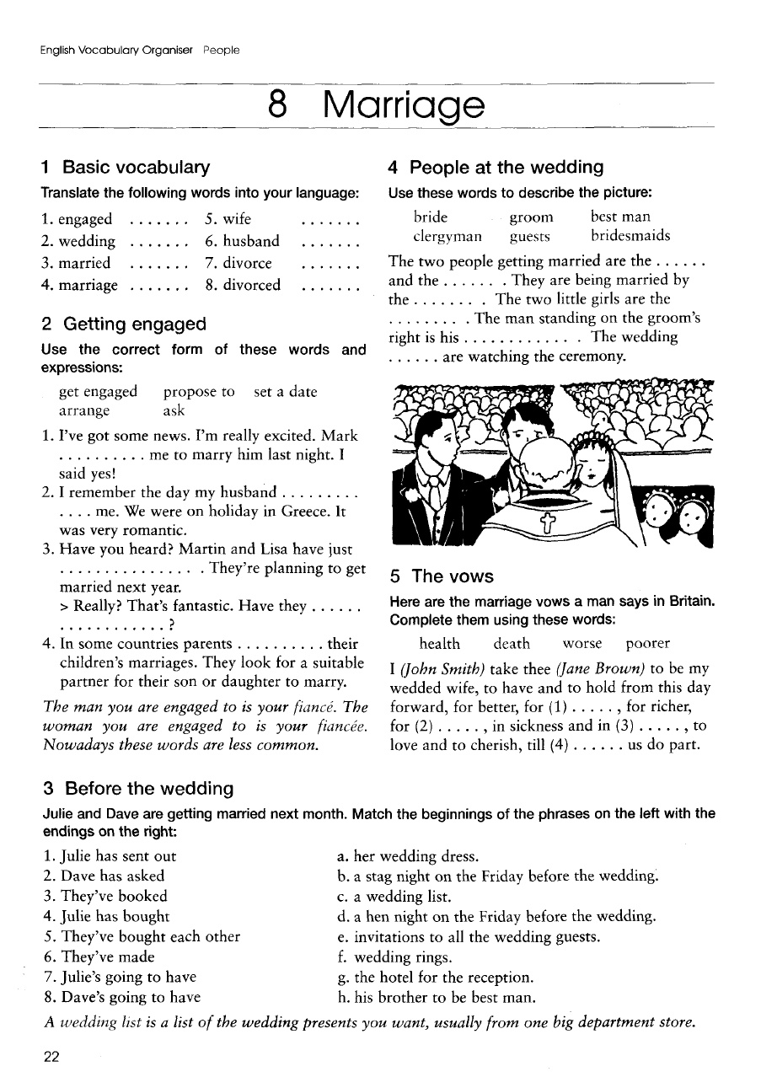

Handout 2.

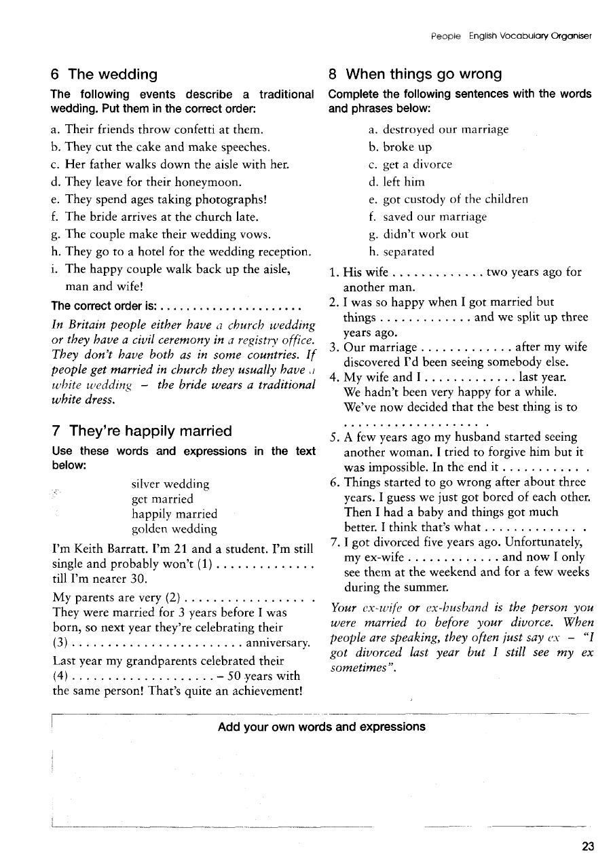

Handout 3.
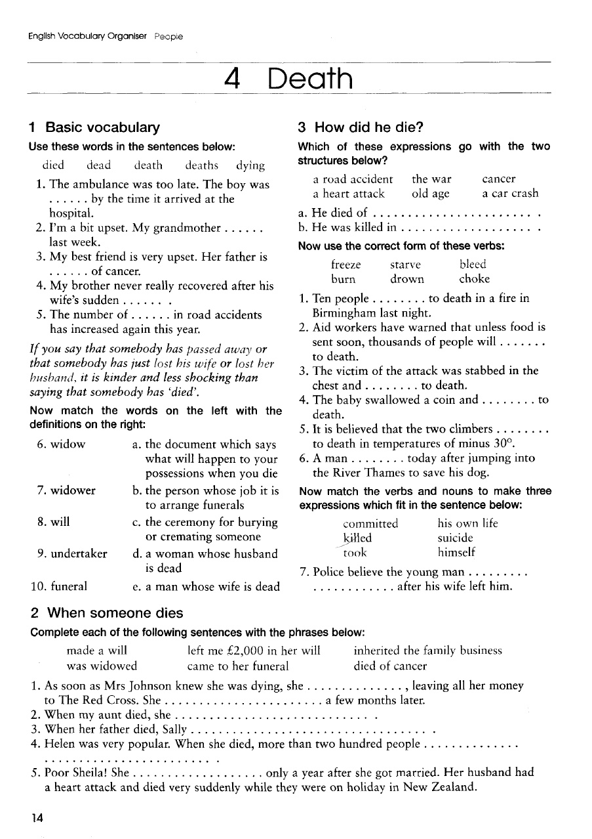

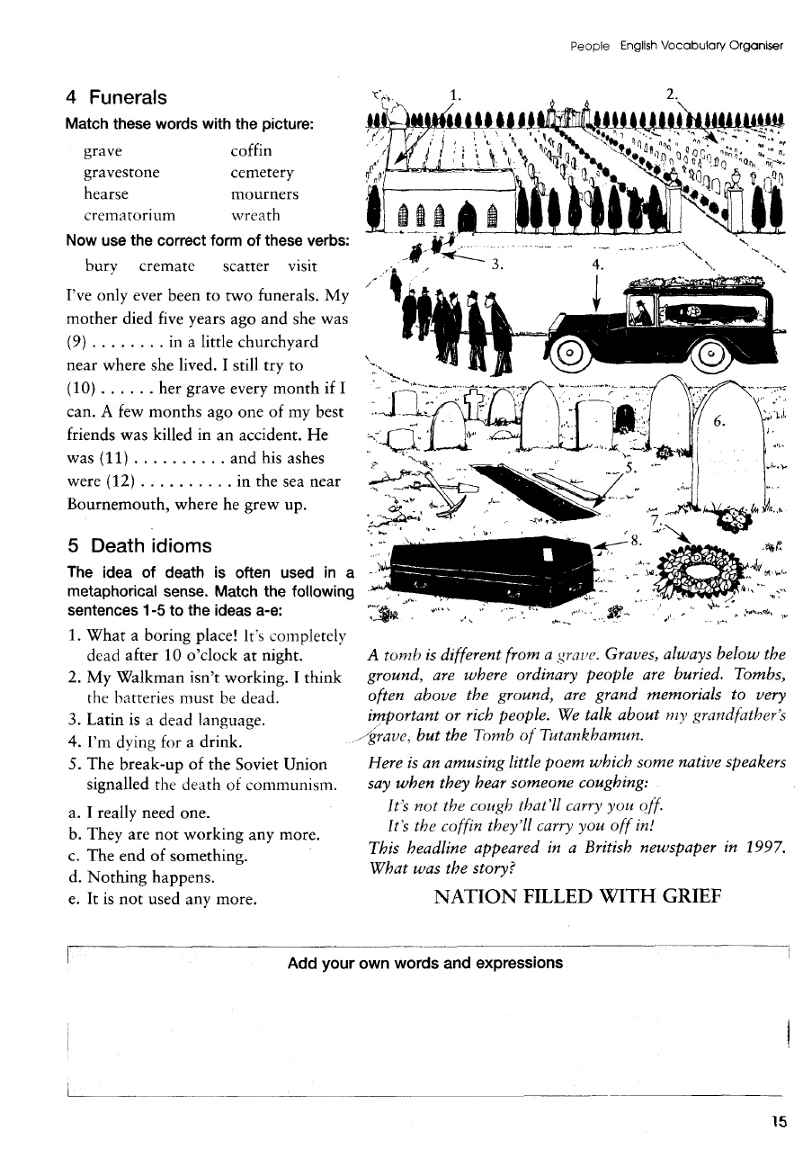

Lesson 5. Family words. M: Pair work.
Number of students: 25-30 |  | Time: 2 hours
Form of the lesson: |  | Practical training

Plan of the lesson:
The aim of the lesson: |  | to enhance sudents’ reading, writing, listening, speaking abilities
Tasks of the teacher: |  | To check student knowledge about:
The results of educational process: |  | The student must answer for all questions and know:
Methods and techniques of teaching |  | brainstorming, working in pairs
Forms of teaching |  | Individual, frontal and collective work, work in pairs
Conditions of teaching |  | Auditorium equipped for working in pairs
Stages,time | Activity
Stages,time | Of the teacher |  | Of students
Stage 1.  Introduction of the lesson(10 min) | 1.1. At the beginning of the lesson distribu

Stage 2.

The main part of the lesson(60 min)
Stage 3.  Conclusive  (10 min) | 3.1. Makes conclusions on the theme in whole, generalize received educational results, encourage active participants. Notes significance of received knowledge for future professional and educational activity.  3.2. Gives tasks for independent work

 | Number of students: 25-30 |  |  |  | Time – 2 hours
 |  | Form of the lesson |  | Practical | training
 |  | Plan of the |  | 1. Biography of A.Coppard
 |  |  |  | 2.Analysis of Tribute by A.Coppard
The aim of the lesson: read and forming whole imagination about Tribute by A. Coppard
Tasks of the teacher: |  |  |  | The results of educational process:
To check student knowledge about: |  |  |  | The student must answer for all questions and know:
• | methods and ways of interpretation |  | of the | • | be acquainted with the methods and ways of
 | belles-lettres text; |  |  |  | interpretation.
• | scheme of interpretation |  |  | • Be able to work on the scheme.
 |  |  |  | • | Stylistic analysis of the text
Methods and techniques of teaching |  |  |  | brainstorming, working in pairs
Forms of teaching |  |  |  | Individual, frontal and collective work, work in pairs
Conditions of teaching |  |  |  | Auditorium equipped for working in pairs

Stages, time |  |  | Activity
 |  |  | Of the teacher | Of students
Stage |  | 1. | 1.1. At the beginning of the lesson distributes the text of | The students read the two
Introduction of the |  |  | the practical training and task . | texts and interpret them as
lesson |  |  |  | follows.
(10min.)
Stage 2. |  |  | 2.1. Ask on the first question of the text, pays attention to | to read and analyze the
The | main | part | the students understanding of the text and using their | to read and analyze the
 |  |  |  | texts based on the scheme of
of the | lesson | (60 | knowledge in stylistic through interpretation of the text. | texts based on the scheme of
 |  |  |  | interpretation of literary text;
min.) |  |  |  | interpretation of literary text;
min.) |  |  |  | to interpret the texts
 |  |  |  | critically within
 |  |  |  | philosophically trends;
 |  |  |  | to reveal stylistic devices
 |  |  |  | given in the text;
 |  |  |  | to analyze the richness of
 |  |  |  | the vocabulary of the author
 |  |  |  | discussing using them.
Stage 3. |  |  | 3.1. Makes conclusions on the theme in whole, generalize
Conclusive |  |  | received educational results, encourage active participants.
(10 min.) |  |  | Notes significance of received knowledge for future
 |  |  | professional and educational activity.
 |  |  | 3.2. Gives tasks for independent work

a Blog

Vocabulary
deceive | to make someone believe something
dreadful | that is not true
dreadful | something that is very bad
endure | to suffer in a difficult situation for a long
engaged | time
engaged | to have a agreement to marry someone
fall in love | to grow in a strong romantic feeling for
gloomy | someone
gloomy | sad
inevitable | something that is certain to happen
intense | something that has a strong effect, or
torment | is felt strongly
torment | to make someone suffer much mental
tragic | or physical pain
tragic | something that is very sad, often
 | involving death

Pre-Text Discussion

Have you ever fallen in love? What does it feel like? Do you see stars or fireworks? Does you heart pound wildly? Or do you simply feel warm and peaceful inside? Read the story excerpt and see how Edna felt when she fell in love.
Falling In Love

It seemed impossible that anyone should be unhappy on such a beautiful morning. Nobody was, decided Edna, except herself. The windows were flung wide in the houses. From within there came the sound of pianos, little hands chased each other and ran away from each other, practicing scales. The trees fluttered in the sunny gardens, all bright with spring flowers. Street boys whistled, a little dog barked; people passed by, walking so lightly, so swiftly, they looked as though they wanted to break into a run. Now she actually saw in the distance a parasol, peach-colored, the first parasol of the year.Perhaps even Edna did not look quite as unhappy as she felt. It is not easy to look tragic at eighteen, when you are extremely pretty, with the cheeks and lips and shining eyes of perfect health. Above all, when you are wearing a French blue frock and your new spring hat trimmed with cornflowers. True, she carried under her arm a book bound in horrid black leather. Perhaps the book provided a gloomy note, but only by accident; it was the ordinary library binding. For Edna had made going to the library an excuse for getting out of the house to think, to realize what had happened, to decide somehow what was to be done now.An awful thing had happened. Quite suddenly, at the theater last night, when she and Jimmy were seated side by side, without a moment’s warning, in fact she had just finished a chocolate almond and passed the box to him again, she fell in love with an actor.The feeling was unlike anything she had ever imagined before. It wasn’t in the least bit pleasant. It was hardly thrilling, unless you can call the most dreadful sensation of hopeless misery, despair, agony and wretchedness, thrilling. Combined with the certainty that if that actor met her on the pavement afterwards, while Jimmy was fetching their cab, she would follow him to the ends of the earth, at a nod, without giving another thought to Jimmy or her father and mother and countless friends again. The play had begun fairly cheerfully. That was at the chocolate almond stage. Then the hero had gone blind. Terrible moment! Edna had cried so much she had to borrow Jimmy’s handkerchief as well. Not that crying mattered. Whole rows were in tears. Even the men blew their noses with a loud trumpeting noise and tried to peer at the program instead of looking at the stage. Jimmy, most mercifully remaining dry eyed squeezed her free hand, and whispered, “Cheer up, darling girl,” and it was then she had taken a last chocolate almond to please him. Then there had been that ghastly scene with the hero alone on the stage in a deserted room at twilight, with a band playing outside and the sound of cheering coming from the street. He had tried – Ah, how painfully, how pitifully to grope his way to the window. He had succeeded at last. There he stood holding the curtain while one beam of light, just one beam, shone full on his raised face, and the band faded away into the distance. It was simply more emotion than Edna could stand. From that moment she knew that life could never be the same. She drew her hand away from Jimmy’s, leaned back, and shut the chocolate box forever. This at last was love. Edna and Jimmy were engaged. They had announced it a year ago, but they had known they were going to marry each other ever since they sat on the grass in the Botanical Gardens together and shared biscuits and tea. It was so much an accepted thing that Edna had worn a wonderfully good imitation of an engagement ring all the time she was at school. Up until now they had been devoted to each other. But now it was over. It was so completely over that Edna found it difficult to believe that Jimmy did not realize it too. She smiled wisely, sadly, as she turned into the gardens of the Convent of the Sacred Heart and mounted the path that led through them to Hill Street. How much better to know it now than to wait until after they were married! Now it was possible that Jimmy would get over it. No, it was no use deceiving herself. His life would be simply ruined, that was inevitable. But he was young. Time, people always said, might make a little difference. In forty years when he was an old man, he might be able to think of her calmly, perhaps, but what about her? What did the future hold for her? If she did not marry Jimmy, of course she would marry nobody. The man she was in love with was a famous actor. Edna had far too much common sense not to realize that it would never be. It was very odd. She didn’t even want to be in love with him, but her love was too intense for that. It had to be endured, silently; it had to torment her. It was, she supposed, simply that kind of love.
Questions for Discussion:
1.How did Edna feel when she experienced true love?
2.What made her feelings change so quickly?
3.Do you think that Edna should break her engagement with Jimmy?
Grammar Notes
Phrasal Verbs with “to get”
to get ahead of somebody | to exceed someone else’s
 | position or progress…The
 | students of group 4 have
 | gotten ahead of all
 | other groups in winter
to get along with | term.
to get along with | to agree, to have a good
 | relationship…Ann and
 | her boss get along well.
to get away with something | escape punishment… His
 | math teacher was sick
 | today, so Jake got away
 | with not doing his
to get around | homework.
to get around | to persuade somebody, to
 | evade the law…My
 | friend knows how to get
to get around to | around her parents.
to get around to | To find time to do
 | something, to do at a later
 | time... I’ll get around to
Grammar Practice

Exercise: Replace the words in italics with the most suitable phrasal verb with “to get.”

1.It took me over two hours to succeed in reaching them by telephone.
2.You’ll have a good relationship with him all right; he is a fine old man.
3.In some months she will have forgotten her ex-boyfriend.

4.This incessant rain and fog is making me feel sad.

5.His offence is serious this time and he won’t escape punishment.
6.Mr. Davis had a difficult time explaining his ideas in Spanish without a translator.
7.The girl has persuaded everybody beginning with the director himself.
8.How are you advancing in your English?

9.You should be very careful with her. She’s just recovering from a bad heart attack.
10. Jason exceeded the other salesmen by selling twelve pairs of shoes yesterday.
Vocabulary Practice

In English there are many terms to describe different degrees of feelings toward someone else. Here are some of those terms: to like – to think that someone or something is nice or pleasant

to fancy – a feeling that you like something or someone to be fond of – to like someone or something very much to have affection for – a feeling of gentle love and caring to be attracted to – to like someone and want to have a romantic relationship with him/her

to love – a strong romantic feeling for someone

to be infatuated with – to have a foolish love or affection for someone

Exercise: Choose one of the terms and put it in its correct form to complete each sentence: to fancy, to love, to be fond of, to like, to have affection. Some sentences may have more than one possible correct answer.

1.A woman is meant to be _______________ not to be understood.
2.I turned round and saw my old professor. I was delighted to come across him again, because I had _______________him immensely.

3.Growing up with Feruza in my school, I always felt a strong____________ for her.

4.My wife has always _______________ coming to the mountains in order to sit in the fresh air and read books.
5.I am ____________ swimming in winter.

6.The young man __________ the woman herself though the mystery of her past troubled him.
7.John was strongly ________________ the beautiful woman he saw across the room.
8.Meg was ___________________ her teacher, even though he was twenty-five years older than she was.

Lesson 6. Parts of the body. Clothes. M. Group work.
Number of students: 25-30 |  | Time: 2 hours
Form of the lesson: |  | Practical training

Plan of the lesson:
The aim of the lesson: |  | to enhance sudents’ reading, writing, listening, speaking abilities
Tasks of the teacher: |  | To check student knowledge about:
The results of educational process: |  | The student must answer for all questions and know:
Methods and techniques of teaching |  | brainstorming, working in pairs
Forms of teaching |  | Individual, frontal and collective work, work in pairs
Conditions of teaching |  | Auditorium equipped for working in pairs
Stages,time | Activity
Stages,time | Of the teacher |  | Of students
Stage 1.  Introduction of the lesson(10 min) | 1.1. At the beginning of the lesson distribu

Stage 2.

The main part of the lesson(60 min)
Stage 3.  Conclusive  (10 min) | 3.1. Makes conclusions on the theme in whole, generalize received educational results, encourage active participants. Notes significance of received knowledge for future professional and educational activity.  3.2. Gives tasks for independent work

a
idiom | meaning | example sentence
all ears | fully listening | Give me a minute to finish my work and then I'll be all ears to hear about your project.
break a leg | good-luck | Today's the big game, eh? Break a leg!
cold feet | nervous just before a big event | My sister didn't get cold feet until she put her wedding gown on.
cost an arm and a leg | be very expensive | These cakes are delicious, but they cost an arm and a leg.
cry your heart out | cry very hard | I cried my heart out when my best friend moved away.
face the music | meet, stand up to unpleasant conseqences, for example criticism or punishment | I stayed out all night. When I eventually got home I had to face the music from my wife.
(my) flesh and blood | relative | I have to hire Mia. She's my own flesh and blood.
get something off one's chest | tell someone your problems | Thanks for listening to me complain about my boss. I just needed to get this off my chest.
give a hand, lend a hand | help (someone) do something | I can give you a hand when you move if you like.
have one's head in the clouds | be unaware or unrealistic about something | Amy has her head in the clouds if she thinks she's going to pass her exams without studying.
head over heels | deeply in love | My brother is head over heels for his new girlfriend.
head start | an earlier start | The kids gave Anthony a head start in the bicycle race because he was the youngest.
in over one's head | taking on a task that you can't handle | I was in over my head when I agreed to babysit the triplets and the dogs.
keep an eye on | take care of, watch in order to protect | I'll keep an eye on the dinner while you're on the phone.
keep one's chin up | try to be cheerful | Keep your chin up. I'm sure you'll make some friends soon.
learn by heart, know by heart | memorize | I learned my multiplication tables by heart in the fourth grade.
let one's hair down | relax, have fun | Go to the cottage and let your hair down this weekend.
(my) lips are sealed | promise to keep a secret | Don't worry, I won't tell your mother how much you spent. My lips are sealed.
makes my blood boil | makes me very angry | It makes my blood boil when people don't tie up their dogs.
neck of the woods | nearby location or region | I heard that they might be opening a post office in our neck of the woods soon.
(an) old hand | an experienced person | My uncle's an old hand at car repair. He'll know what the problem is.
over my dead body | not unless I'm dead and can't stop you | My daughter wants a tatoo. I told her she'd get one over my dead body.
pat on the back | recognition or a thank-you | The party organizers deserve a pat on the back for a job well done.
play something by ear | do something without a plan | We don't know if the weather will be good enough for camping. We'll have to play it by ear.
pull one's leg | joke or tease someone | I was just pulling your leg. I'm not really a police officer.
rule of thumb | basic rule (not always followed) | The rule of thumb is that the students wear black pants and white shirts.
see eye to eye | agree | The couple don't see eye to eye on how to train their pets.
(by the) skin of one's teeth | just barely | I passed my exam by the skin of my teeth.
stick your neck out | help someone a lot, with possible bad consequences for oneself | I stuck my neck out for Bessie when she was thrown out of her house.
sweet tooth | a love of sugar or sweet things | I need three spoonfuls of sugar in my tea. I have a sweet tooth.
thick in the head | not very intelligent | I'm a bit thick in the head when it comes to reading a map.
wash one's hands of something | stop dealing with an issue or problem | I'm washing my hands of Mary's addiction. She is going to have to get some professional help.

Lesson 7. Describing people. Health and illness. M. : Collage.
Stage
lesson
(10min.)
Stage 2.
The | main
of the | lesson
min.)
 |  |  |  | discussing using them.
Stage 3. |  |  | 3.1. Makes conclusions on the theme in whole, generalize
Conclusive |  |  | received educational results, encourage active participants.
(10 min.) |  |  | Notes significance of received knowledge for future
 |  |  | professional and educational activity.
 |  |  | 3.2. Gives tasks for independent work

a Blog

 | In the Hospital
Vocabulary
bred | (past tense of breed) to produce, to be the
bruise | source of
bruise | an injury to the body without breaking the skin
clogging | but causing discoloration
clogging | blocking the flow of liquids
daze | very tired; no clear vision
discharge | to release from the hospital; give permission
intravenous | to leave
intravenous | directly into a vein
lenient | soft, mild, not strong in discipline
pan out | have good or expected results
persist | to refuse to give up; continue without stopping
queerly | strangely; oddly
sedation | calming with medicine
soothing | making calm and peaceful; soft
taciturn | almost always silent; not liking to talk
transfusion | transfer blood from one vein to another

Pre-Text Discussion

1.How often do you go to see a doctor?
2.Do you always follow your doctor’s instructions? If not, why?
3.Àre you quite satisfied with the way your doctor treats you?
4.What do you do to keep yourself in good health?
5.What do you do if the medicine your doctor prescribed, doesn’t help you?

6.Does your health depend on your way of life? How?
Text
An extract from “Evening in Byzantium” by Irwin Shaw
Irwin Shaw (1913-1984) American novelist, short story writer and dramatist was born in New York. He first gained recognition with his antiwar play “Bury the Dead” (1936). His first novel “The Young Lions” (1948) is recognized as his best novel. His novel “Evening in Byzantium” was published in 1973.

He was still alive after three days. He was in a bright room in a good hospital and Bruce Thomas had found him a soft voiced old doctor who was soothing and taciturn. The chief surgeon of the hospital, a cheerful round man, kept dropping in as though he just wanted to chat with Craig about the movies and the theater, but Craig knew that he was watching him closely, looking for symptoms that would mean that an emergency operation might be necessary at any moment. When Craig asked him what the chances were after an operation like that, the surgeon said flatly, without hesitation, ‘Fifty-fifty’. If Craig had had any relatives the doctor could talk to, the doctor would probably have told them instead of the patient, but the only people who had come to his room so far were Thomas and Belinda. He was under light sedation and suffering from no real pain, except for the bruised places on his arms where the needles had been placed for five transfusions and for the varying intravenous feedings of glucose and salt. For some reason, the tubes kept clogging and the needles falling out. The veins in his arms had become increasingly difficult to find and finally the hospital expert, a lovely Scandinavian girl, had been called to see what she could do. She cleared the room, even shutting the door on his private day nurse, a tough old ex-captain in the nursing corps, a veteran of Korea. ‘I can’t stand an audience,’ the expert had said. Talent, in a hospital, as elsewhere, Craig saw, had its imperious prerogatives. The Scandinavian girl had pushed and prodded, shaking her neat blonde head, and then with one deft stroke, had
inserted the needle painlessly into a vein on the back of his right hand and adjusted the flow of solution to it. He never saw her again. He was sorry about that. She reminded him of the young Danish mother by the side of the pool in Antibes. Fifty-fifty, he marveled, and that’s what a man thinks of. The worst thing was the headaches that came after the transfusions. That was normal, he was told. Naturally, in a hospital, pain must seem normal to the people who work there. He could sit up in bed and even eat a little, but the fever persisted. In the morning it was around a hundred and one, in the evening it went up to one hundred and three and a half. The plastic bag hung on a stand above his head, dripping antibiotics into his veins day and night. Either the fever or the antibiotics, or both, kept him in a heavy-lidded daze and he began to lose track of time and not remember how long he had been there. Nobody mentioned it, not he nor any of the doctors, but he knew that they were afraid that he had picked up one of those new hospital-bred wild strains of bacteria for which no treatment had yet been found.

Dr Gibson had forbidden any visitors and he was grateful for that. Dr Gibson had told him that when he had been free of fever for three whole days, he would be discharged. In the meanwhile, he sleepily watched the television set that had been wheeled into his room and placed at the foot of his bed. Mostly, he just watched the baseball games. It gave him pleasure to watch young men running swiftly across green grass in the sunshine, clearly winning and distinctly losing. He remembered having read about the condemned murderer in Massachusetts who also had watched the baseball games on television in his cell and whose only regret was that he would never know whether or not the Dodgers had won the pennant. He wondered if he would know who won the pennant this year.

Finally, Murphy convinced Dr Gibson that he had to see Craig. Craig had had two good days. The fever had gone down to ninety-nine in the morning and one hundred and two at night. Miss Balissano still refused to tell him what his temperature was, but Dr Gibson was more lenient. Murphy’s face when he saw Craig told him as accurately as any mirror how bad it was. He hadn’t looked in a mirror since the operation. ‘I had to see you, Jess,’ Murphy said. ‘I have to leave for the Coast tomorrow. Things’re piling up and I just have to be there.’ ‘Sure, Murph,’ Craig said. His voice sounded thin and old in his ears. ‘Three weeks in New York is all I can manage,’ Murphy said. ‘Is that how long I’ve been here?’ Craig asked. Murphy looked at him queerly.’ ‘Yes,’ he said. ‘ A long time,’ Craig said. ‘Yes. And the doctors won’t give me an estimate about when you’ll get out.’ ‘They don’t know.’ ‘Gibson tells me you won’t be able to work – at anything – for at least six months, even if you get out tomorrow.’ ‘I know,’ Craig said. ‘He told me.’ ‘Thomas can’t wait,’ Murphy said. ‘He’s got to start shooting in a month if he wants to do it this year. For the weather.’‘For the weather,’ Craig nodded.‘He and Wadleigh have been working eighteen hours a day. Thomas says Wadleigh is really panning out. He says you’ll be crazy about the final script.’‘I’m sure.’‘Do you want me to tell you about who they’ve got to play it?’ ‘Not really, Murph.’Again, Murphy looked at him queerly. ‘Don’t worry about the money,’ he said. ‘You’ve got a big chunk up front and five percent of the profits.’‘Tell me some other time,’ Craig said.‘Thomas has been a real gent about everything.’‘I’m sure.’ Craig closed his eyes. Murphy seemed to be far away, at the other end of a long hall and it disturbed him.‘You’re tired,’ Murphy said, ‘I won’t bother you any more. Just call me if you need anything.’‘I’ll do just that.’ Craig didn’t open his eyes. ‘Sonia sends her love.’
‘Thanks Murph.’ ‘Take it easy, kid.’ Murphy went softly out of the room, as Miss Ballissano came in. ‘Turn on the television, please,’ Craig said.

Cultural Notes

1.The temperature was hundred and one - the Fahrenheit thermometer is used both in the U.S. and Great Britain. The normal temperature of a human body is 98.60.

2.the Coast – Hollywood

Check Comprehension

1.What kind of a doctor did Thomas find for Craig?

2.Why did the hospital chief surgeon keep dropping into Craig’s hospital room?
3.What were Craig’s chances to stay alive?

4.What difficulties did the nurse have while giving him injections?
5.Who was invited to give Craig intravenous feedings?

6.What was Craig’s temperature?

7.What did Murphy have to say to Craig?

8.Why was Murphy in a hurry to leave for the Coast?

Grammar Notes
1.The Past Perfect Tense is used for earlier past action. ·He was in a bright room in a good hospital and Bruce Thomas had found him a soft voiced old doctor.

The only people who had come to his room so far were Thomas and Belinda.

Dr. Gibson had forbidden any visitors and he was grateful for that.

2.When the first verb in a cluster is in the past tense, the other verbs following it will also be in the past tense.
Dr. Gibson had told him that when he had been free of fever for three whole days, he would be discharged. In the meanwhile, he sleepily watched the television set that had been wheeled into his room and placed at the foot of his bed.

Grammar Practice

Exercise 1. Replace the infinitives in brackets by the appropriate form of the verb.

1.Dr. Gibson ________(not, to warn) Craig that his wife was coming to see him. He probably thought it ________(to be) a salutary surprise.

2.Gail’s father seemed to be delighted to tell Craig that Gail ________(to leave) the day before for London.

3. When they let him out of the hospital, his temperature________(to be) normal for three days in a row.

4.He was in front of a saloon he ________(to frequent) once.

5.He looked down at the typed list of questions Gail________(to give) him.

6.By now he was sorry he ________(to be) in the office when Alice ________(to call).

Exercise 2. Render the dialogues in indirect speech. Observe the rules of sequence of tenses.

1.Doctor: “Well, did you take my advice and sleep with all windows open?”
Patient: “Yes, doctor”

Doctor: “Good! And you’ve lost that cold you had?”

Patient: “No, doctor. Only my best suit and my watch and chain”.
2.“Are you feeling very ill?” asked the physician.

“Let me see your tongue, please”.

“It’s no use, Doctor,” said the patient. “No tongue can tell you how ill I feel”.
Exercise 3. Complete the sentences, using the correct past tense of the verb in brackets.
1.Susan no longer owned a bike. She ________(sell) it.

2.Mary looked very pale when she arrived for the exam. She________(study) too hard.

3.The boy’s knee was bleeding when he arrived home. He________(fall down).

4.I invited Silvia to the party but she couldn’t come. She________(arrange) to go somewhere else.

5.By the time the firemen ________(arrive), the fire________(go out).

6.The guide offered us tickets for a musical, but Helen ________(already see) it.
Vocabulary Practice

Exercise 1. Choose the right word: pain or ache

1.Ann had not had a wink of sleep for two days as she had a terrible ear ______.
2.Salvatore, who suffered from rheumatism, felt an ______in his bones, especially in bad weather.

3.Bob felt a sharp ______ in his shoulder and fell. He was wounded.
4.My child cried the whole night because of an ear ______. It must be unbearable.
5.At night Mary felt sharp ______ in her left side and in her leg.

6.When my son’s temperature rose and his head ______grew worse I sent for a doctor.

7.People who don’t get enough sleep often have head ______.
Exercise 2. Choose the right word: to recover - to cure - to treat

1.Penicillin has helped to ________ patients from pneumonia.

2.He was ________ for chickenpox but it turned out to be scarlet fever.
3.Try, as the doctors may, no effective ________ for cancer has as yet been developed.
4.Bob was seriously ill and he kept to bed for a month. He followed all the doctor’s instructions and began ________ slowly from his illness.

Exercise 3. Match the first column with the second to complete the sentences.

1. He works out in the gym because

2. Not all cancers are
3. She is not at work because she’s come down

4. She went on a diet and

5. If you’ve got a bad headache
6. After aerobics last week
7. He sprained his ankle and he
8. You have a heart problem and
9.She went out in the pouring rain and caught
10. He had spots all over his face because he

a. with the flu

b. lost weight

c. a cold

d. incurable

e. was in

great pain for

days

f. need an

operation

g. had

measles

h. he wants to

feel fit

i. take an

aspirin

j. my legs felt

really sore

Speaking Practice

Comment on what the narrator or characters say or mean:

1.He was under light sedation and suffering from no real pain.

2.Talent, in a hospital, as elsewhere, had imperious prerogatives.

3.... he sleepily watched the television set that had been wheeled into his room.

‘Don’t worry about the money,’ he said. ‘You’ve got a big chunk up front and five percent of the profits.’

Lesson 8. Feelings. Greeting and other useful phrases. M: Brainstorming.
 | Number of students: 25-30 |  |  |  | Time – 2 hours
 |  | Form of the lesson |  | Practical | training
 |  | Plan of the |  | 1. Biography of A.Coppard
 |  |  |  | 2.Analysis of Tribute by A.Coppard
The aim of the lesson: read and forming whole imagination about Tribute by A. Coppard
Tasks of the teacher: |  |  |  | The results of educational process:
To check student knowledge about: |  |  |  | The student must answer for all questions and know:
• | methods and ways of interpretation |  | of the | • | be acquainted with the methods and ways of
 | belles-lettres text; |  |  |  | interpretation.
• | scheme of interpretation |  |  | • Be able to work on the scheme.
 |  |  |  | • | Stylistic analysis of the text
Methods and techniques of teaching |  |  |  | brainstorming, working in pairs
Forms of teaching |  |  |  | Individual, frontal and collective work, work in pairs
Conditions of teaching |  |  |  | Auditorium equipped for working in pairs

Stages, time |  |  | Activity
 |  |  | Of the teacher | Of students
Stage |  | 1. | 1.1. At the beginning of the lesson distributes the text of | The students read the two
Introduction of the |  |  | the practical training and task . | texts and interpret them as
lesson |  |  |  | follows.
(10min.)
Stage 2. |  |  | 2.1. Ask on the first question of the text, pays attention to | to read and analyze the
The | main | part | the students understanding of the text and using their | to read and analyze the
 |  |  |  | texts based on the scheme of
of the | lesson | (60 | knowledge in stylistic through interpretation of the text. | texts based on the scheme of
 |  |  |  | interpretation of literary text;
min.) |  |  |  | interpretation of literary text;
min.) |  |  |  | to interpret the texts
 |  |  |  | critically within
 |  |  |  | philosophically trends;
 |  |  |  | to reveal stylistic devices
 |  |  |  | given in the text;
 |  |  |  | to analyze the richness of
 |  |  |  | the vocabulary of the author
 |  |  |  | discussing using them.
Stage 3. |  |  | 3.1. Makes conclusions on the theme in whole, generalize
Conclusive |  |  | received educational results, encourage active participants.
(10 min.) |  |  | Notes significance of received knowledge for future
 |  |  | professional and educational activity.
 |  |  | 3.2. Gives tasks for independent work

a Blog

There are many situations in which we may need more formal or business professional language in English. Some common examples include:
- Business meetings & negotiations
- At a job interview
- Communicating with high-level management
- Saying hello to the company president or CEO
- Showing respect to elderly individuals or people we do not know well
- Meeting new business colleagues
- Communicating with new clients, high-level clients, angry clients
In these situations we use more formal or professional language to show respect, to show the importance of a situation or the person or to keep a professional tone. Use the example words and expressions below to appropriate greet individuals or groups and start conversations.
Good morning / Good afternoon / Good Evening
This is the most common form of greeting in a formal situation and is appropriate to use anytime – with colleagues, business clients, formal relationships, new neighbors, etc.
To be particularly respectful, you can also include the person’s last name, for example: “Good morning, Ms Jones.” If you know someone well, you can also use the first name.
When you are greeting a group of people – for example at a meeting – you can also say something such as:
- Good morning, everyone. I hope you are doing well this morning.
Hello. How do you do?
This is used when meeting someone for the first time and is very formal. It may be used in a formal business situation or a formal dinner party event.
Be careful. This is not really a “How are you?” question. It is really a simple greeting and has a similar meaning to “Nice to meet you.
Nice to meet you. / Pleased to meet you.
You are probably already familiar with these expressions from your English studies as they are common in many English books.
These expressions are best used in formal or business situations when you meet someone for the first time, for example, A: “Good morning. How do you do? I’m Josef Rammas with X Company.” B: “Pleased to meet you Mr. Rammas.”
How have you been doing? / How have you been?
This is a very simple, polite and appropriate question to use to start a conversation in a business or formal situation. It is a respectful way to ask “How are you?” with someone you have not seen in a long time or someone you do not see every day.

English Greetings for Informal Situations
With colleagues you know well, clients you have developed a relationship with or people who are acquaintances of yours (not close friends or family, but people you are friendly with), it is appropriate to be a little more relaxed with the language.
Example situations include:
- In the office with your team and colleagues
- Meeting or a lunch with a regular client
- Networking events
- Trade show or job fair
- Conferences
- Greeting neighbors
- Seeing an acquaintance unexpectedly (for example, seeing someone you know at the grocery store or in a restaurant)
It is often also very common to shake hands with someone when you greet them. This is common for business contacts and acquaintances.
Hello / Hi / Hey
Hello and hi are very common and appropriate to use in more informal situations. Most of the time, people include the person’s first name (English speakers tend to be more informal generally speaking).
- Hello, Susan.
- Hi, Lara.
Hey should be reserved for people you know well. This is the most informal of these 3 greetings but it is definitely appropriate for people in your office you see every day and your close work colleagues.
How are you? / How are you doing? / How is it going?
Most of the time we follow “hello” or “hi” with one of these questions.
Careful! These questions should have very simple answers and should be focused on the positive or neutral. You should not answer with a list of everything you did during the day nor should you provide a negative answer.
Example answers include:
- Fine, thanks. And you?
- Great! You?
- Hi, Susan – good thanks. How about you?
- Doing well. And how have you been?
- Not bad. And you? How are you?
- Hello, Lara. How are you?*
  - *Yes, sometimes the answer is with the same question (remember – we have this same situation in Business Professional greetings with How do you do?). This is often confusing the first time you hear it or experience it. Remember – these questions can also be a greeting, not a real question. This is commonly used when passing or walking by someone you know but you have no time to talk.
Good to see you. / It’s great to see you. / Nice to see you.
You can use these expressions when you have not seen someone in a long time or when you see someone unexpectedly.
For example, meeting a client for a lunch, seeing a business contact at a meeting or seeing an acquaintance at the grocery store.
These expressions can be used:
- Immediately after saying hello or hi in the greeting. For example, Hello, Susan. It’s good to see you!
- As part of your closing, after you finish a short conversation. For example, Well, it was great to see you. I have to get going. Have a good day. Goodbye.
Long-time, no see. / It’s been awhile. / When was the last time we saw each other?
These expressions are used when you have not seen someone for a long time. These are also great expressions to use to start a little small talk. The question “When was the last time we saw each other?” is an easy way to start a conversation about what has happened since you last saw each other.
How have you been? / How have things been going (since I last saw you)? / What have you been up to?
These questions are often used after an expression such as, “Long-time, no see” or “It’s been awhile.”
These are similar to asking “How are you?” and are great ways to start some small talk. The questions invite the person to say how they are doing or to share any new, interesting information they are comfortable sharing. For example:
- Great thanks. Did you hear we are moving to California next month?
- Doing well. We’ve just returned from our summer vacation. And how about you?
- Nothing to complain about! The family is good and work is fine. Just the same old, same old. What about you?

English Greetings and Slang for Casual Situations
These greetings are very informal and should be used with people you know very well such as close friends, family, long-time work colleagues or friends you have known for a very long time.
While you may use some of these greetings with English-speaking work colleagues you know well in an everyday situation, these greetings would not be appropriate for a work meeting or to use in any official work events.
Good example situations include:
- Colleagues you see every day and know well
- Friends and family
- At a bar or party
- Seeing an old friend
*It is very important to remember that slang is regional.
Slang greetings can change from country to country, region to region and even city to city. It is important to learn which slang may be appropriate or understood in the region you are in or the people you are communicating with.
For example, using: G’day is generally understood as an Australian greeting. It would sound strange to an American if you used this greeting.
The examples provided here are focused on American English. These are common to what you may hear in American TV shows and movies or with your American colleagues and friends.
If you would like to have some examples of several British casual or slang greetings, here is an article from BBC America called 5 Slang Ways to Say Hello.
And finally, if using these greetings in America, don’t be surprised if someone tries to hug you. While in formal and informal business situations it is common to shake hands, in very casual and familial situations people often hug each other.
Hi / Hey / Hey there / Hey man
These are all common ways of saying “hello” with friends and family.
“Hi” can be used to casually greet people you know well or if you are meeting someone for the first time at a party, for example. However, “hey” is used with people you already know. “Hey” and “Hey there” are most often used among younger people or with peers. While someone may use these greetings with their mother or father, it is not common to use these with one’s grandparents for example.
“Hey man” is used among males and “hey dude” is a similar example. There is not an equivalent causal greeting used only among women. Examples:
- Hi!
- Hey man
- Hey Steve
- Hey mom
- Hey there everyone
Yo
“Yo” is a very informal greeting and should only be used among friends. It is generally not a greeting to be used with parents, teachers or your boss, even if you know them very well.
Howdy
“Howdy” is a regional greeting, which means it is only used in some areas of the United States, for example in the southern region, some midwestern regions and more rural regions. If you use this to greet a friend in New York City, for example, it may sound very strange. A person may think you are speaking like a cowboy or a farmer and, because it is not often used in cities, they may laugh a bit.
“Howdy” is believed to be a shortened form of “How do you do.”
How’s it going? / What’s going on? / How’s everything?
These can all be simple greetings or questions similar to “How are you?” Careful! Similar to the informal situations above, the answer to these questions should usually be a simple answer. Example answers include:
- Good, you?
- Fine, you?
- Not bad
- Hey! How’s it going?*
  - *Yes, again it is important to remember this can be a greeting, not a question. This is particularly true when you are just passing by someone with no time to stop and talk. Here is a possible sample dialogue:
    - A: Hey Dawn, good to see you! How’s it going?
    - B: Hey there! How’s it going?
What’s up? / What’s new?
This is a common, informal way of say “hi” and “how are you.” For “what’s up?” – in pronunciation and informal spelling (for example in texting or an informal email between friends, you might hear/see: Sup / Whassup / Whazzup Common answers include:
- Not much.
- Nothing.
- Hey, what’s up.
Here is an example dialogue:
A: Hey Mina, what’s up?
B: Oh, hey. Not much. How’s it going?

Long-time, no see. / It’s been ages! (since I’ve seen you.) / Where have you been hiding?
Similar to the informal situations above, you may use one of these expressions when you have not seen a friend or family member for a very long time.
These expressions can be used as part of your greeting when you see someone unexpectedly, at a party, a family gathering, etc. The question “where have you been hiding” invites conversation. It is a way of saying, “How have you been?” Here is an example dialogue:
A: Hey! It’s good to see you! It’s been ages! Where have you been hiding?
B: Hi Sue, what’s up? I’ve just been busy, working a lot of long hours. What about you? How have you been?
A: Ah fine. Nothing new really.
I’d love to hear from you! What is your favorite greeting in English?
In your English life, do you use informal or professional greetings more often? What lessons have you learned about greetings in English from your own experiences?
Please be sure to share your experiences or ask questions in the comments section below.
~Annemarie

Get the Confidence to Say What You Want in English
Download my free training on how to build the courage and confidence you need to say what you want in English.

Lesson 9. Travelling. Notices. M: Collage.
Vocabulary
abroad | a foreign country
boarded | to get on a ship, airplane, or train
bucked | move suddenly with strength; with a
definitive | kicking motion
definitive | final, clear, decided
departure | leaving; time of leaving
flight attendants | waiters/waitresses on an airplane
little else | almost nothing
naughty | disobedient; badly behaved
passengers | travelers who have paid for a seat on
pitch | any form of transportation
pitch | sound, tone
portholes | small windows on a ship or an airplane
shuddered | shake in quick, small movements
steadied | to hold on level, smooth path
stewardess | [see “flight attendant”]
whispered | to move almost silently

Pre-Text Discussion

Travel is meant to be pleasant and fun. Can you think of any reasons it would not be so? What are the pros and cons (positive and negative) of travel by airplane? Describe your ideal holiday travel – where, with whom, when, how, how long, etc.
Texts

Family Travel

We were all so excited about going on holiday that we had talked about little else for weeks. However, it had been so long since we had been abroad that I forgot all about the problems of traveling. Finally our day of departure arrived. It was such a long journey that we all had to get up at 2 o’clock in the morning. When we arrived at the airport, our youngest son was being so naughty that I had to spank him. He screamed so loudly that lots of people came running to see what the matter was. Fortunately he had quieted down by the time we boarded the plane. My husband ate so much food that he gave himself a terrible stomachache. The flight attendants thought he was having a heart attack and rushed to help him with oxygen. At that point he became so upset that he knocked his meal all over my new dress. By this point, I was in such bad mood that I burst into tears. Once my husband had recovered, he apologized so sincerely to everyone that we all forgave him.
Check Comprehension

What way of traveling is described in this text?

What is airsickness?

What was spilt on her new dress?
What condition was her husband in by the end of the flight?
Was the family traveling with only one child or more?
From “Evening in Byzantium” by Irwin Shaw

Irwin Shaw (1913-1984) - original name Irwin Gilbert Shamforoff, a prolific American playwright, screenwriter, and author of international bestsellers. At the age of 21 Shaw started his career as a writer by producing scripts for radio shows. In 1951 Shaw left the United States, living 25 years in Europe in such locations as Paris, the Riviera, and Swiss resorts. In Europe Shaw continued to write several bestsellers, including TWO WEEKS IN ANOTHER TOWN (1960), and EVENING IN BYZANTIUM (1973).
The plane bucked as it climbed through black pillars of cloud. To the west, there were streaks of lightning. The seat belt sign, in English and French, remained lit.

The stewardesses served no drinks. The pitch of the engines changed. The passengers did not speak. The tall man, cramped in next to the window, opened a magazine, closed it. Drops of rain made pale, transparent traces, like ghostly fingers, along the Plexiglas portholes. There was a muffled explosion, a ripping noise. A ball of lightning rolled down the aisle, incredibly slow, then flashed out over the wing. The plane shuddered. The pitch of the engines changed again. How comfortable it would be, the man thought, if we crashed, how definitive. But the plane steadied, broke out of the clouds into sunlight. The lady across the aisle said, “That’s the second time that’s happened. I’m beginning to feel that I’m being followed.” The seat light signs went off. The stewardesses started to push the drink cart down the aisle. The man asked for a Scotch and Perrier. He drank appreciatively as the plane whispered south, high across the clouded heart of France.
Check Comprehension

Why do you think the pitch of the plane’s engine changed?

What made the plane shudder?

What did the man say about the plane possibly crashing?
Did the plane crash?

What did the lady mean by what she said?
Vocabulary Practice
Exercise: Use the vocabulary from the texts to complete the following story.
For three years international travel had been only a dream. But now Rebecca had finished packing her suitcases, purchased her tickets, and had all of her documents in order. The day of her 1__________ had finally arrived and she was traveling
2_________ for the first time. For the last week she had thought of 3__________ other than the excitement of her travels. But as she said good-bye to her family and 4________ the plane, she
began to fear traveling alone. Her parents had tried to discourage her from this decision. This was a 5__________ step in her life as an independent adult. As the plane climbed high into the sky after takeoff, she listened to the rising 6__________ of the engines, felt the 7__________ of the plane as it moved with full power up to cruising altitude, and began to relax and enjoy her dream come true.
Grammar Practice

Exercise: Complete the sentences with the verbs in brackets using Past Perfect / Past Perfect Continuous. I’m sorry I left without you last night, but I told you to meet me early because the show started at 8:00. I (try) 1_________ to get tickets for that play for months, and I didn’t want to miss it. By the time I finally left the coffee shop where we were supposed to meet, I (have) 2_________ five cups of coffee and I (wait) 3________ over an hour. I had to leave because I (arrange) 4__________ to meet Kathy in front of the theater.
When I arrived at the theater, Kathy (pick, already) 5__________ up the tickets and she was waiting for us near the entrance. She was really angry because she (wait) 6________ for more than half an hour. She said she (give, almost) 7________ up and (go) 8________ into the theater without us.
Kathy told me you (be) 9________ late several times in the past and that she would not make plans with you again in the future. She mentioned that she (miss) 10________ several movies because of your late arrivals. I think you owe her an apology. And in the future, I suggest you be on time!
Speaking Practice

Task 1: Reread the story in the grammar exercise above. You are the person who was late. Respond with either an apology or an excuse/argument.
Task 2: Reread the story in the vocabulary exercise above. Prepare and present a dialogue between 1) Rebecca and her mother, 2) Rebecca and the stewardess on the flight.

Lesson 10. In the kitchen. In the bathroom and bedroom. In the living room.
Here is some useful vocabulary to talk about rooms in your house, and the furniture in those rooms.Most people in the UK live in a house or a flat.Houses can be detached (= separate from other houses); semi-detached (= connected to one house on one side) or terraced (= connected to two other houses, one on each side.)Flats are usually in a block (a block of flats is a building with four or more floors / storeys) or they are converted from old houses. For example, you can find a flat above a shop.Some people also live in a bungalow: a one-storey house.A house is often on two or more floors. On the ground floor (or downstairs) there’s usually a hall (where you go in) and then other rooms, such as kitchen and living room. On the first floor (or upstairs) there are usually bedrooms and a bathroom.In some houses there is also an attic or loft – a room under the roof. Some houses have a garage attached (for the car), and often there is a garden: a front garden (in front of the house) and a back garden (behind the house).Other rooms are a dining room (either part of the kitchen or a separate room) for eating meals, a utility room (where you can find the washing machine, etc), a study (where there is a desk and computer). In bigger houses there is more than one bathroom. Some bedrooms can have “ensuite” bathrooms, and there is often an extra toilet (or “loo”) downstairs.
Furniture in the kitchen
Many kitchens in the UK are “fitted kitchens” – a kitchen where all the furniture and appliances come together in a package, rather than separate.Here are some of the things you can find in a kitchen:a kitchen table and chairskitchen cupboards (for storage) at eye level fixed to the wall, or at floor levela fridge and perhaps a freezer; or a fridge-freezer (a large fridge with a small freezer built in – often there are three freezer “drawers” for example)a cooker which consists of an oven (for cooking roast meat, or baking cakes, etc) and a hob (four or five rings for cooking pasta etc)a sink (for washing plates, washing vegetables etc)work surfaces (for preparing food)a dishwasher (machine to wash plates etc)a washing machine and clothes dryer (for washing and drying clothes)For more vocabulary on appliances and utensils.

Furniture in the bedroom
In the bedroom you can find one or more beds. Small beds (for one person) are single beds, while larger beds (for two people) are double beds. If children share a room, they often sleep in bunk beds – one bed above the other, which a child can reach with a ladder.On each bed you can find sheets and pillows (for your head) and then either blankets or a duvet to keep you warm.Other furniture in a bedroom is a wardrobe (where you hang clothes such as coats, trousers, skirts and dresses) and a chest of drawers, where you put smaller items like underwear, T-shirts, jumpers, etc.Curtains (or blinds) block out the light from the window. To make the room comfortable you can also find a rug (small carpet) on the floor; a lamp (light next to the bed) and a bedside table (small table next to the bed).
In the bathroom
Most of the time, the toilet (or “loo“) is in the same room as other furniture, but sometimes, the toilet is in a separate, small room.Most English bathrooms also have a shower and a bath. Sometimes the shower is in the bath, and sometimes it’s separate, in a shower cubicle. You can also find a sink (to wash your face, or clean your teeth) and a bathroom mirror above the sink. Normally there are bathroom cabinets (= cupboards for medicine or make-up, etc) and a towel rail (to hang your towels so they dry more quickly). In English bathrooms there’s usually a radiator (for heat and to reduce condensation), and a bath mat to reduce water on the floor.

Furniture in the living room
There are different words for this room. It’s also called a sitting room or a lounge.This is the room where families spend most of their time, or entertain guests, so it’s usually a comfortable room, with a sofa and some armchairs to sit on, with cushions to support your back.Often there’s a carpet on the floor (to cover the floor from wall to wall) or there are rugs on a wooden floor. In most living rooms you can find different types of entertainment system: a TV and DVD player, or a music centre, for example. You can also find tables, such as a coffee table (small table next to the sofa or armchair to put drinks, or magazines).Against the wall there is often a bookcase (a piece of furniture especially for books) or shelves on the wall for books, etc. Some people have “display cabinets” – a piece of furniture with glass doors to show / display their important ornaments. In old houses you can also find a fireplace, but people normally have central heating in the house, and the old fireplace contains a modern gas or electric heater.

Lesson 11. Jobs. At school and university. M: Group work.

Management
president; vice-president; director; manager;
executive officer; CEO (chief executive officer; company executive officer);
deputy director; managing director; financial director; marketing director;
general manager; assistant manager; manager; production manager;
personnel manager; marketing manager; sales manager; project manager;
supervisor; inspector; controller;

Office workers
office worker; office employee; office clerk;
filing clerk; receptionist; secretary; assistant;
typist; stenographer;

Banking and financial activities
banker; bank officer; economist; auditor;
accountant; bookkeeper; teller; cashier; bank clerk;
financier; treasurer; investor; sponsor;
stockbroker; pawnbroker; tax collector;

Sales and stores
sales representative; sales manager;
salesperson; salesman; saleswoman; salesgirl; salesclerk; cashier;
seller; buyer; wholesale buyer; wholesaler; retailer;
merchant; distributor; dealer; trader; advertising agent;
grocer; greengrocer; baker; butcher; florist;

Medicine
doctor; physician; family doctor; general practitioner;
eye specialist; ear specialist; throat specialist; heart specialist;
cardiologist; surgeon; pediatrician; psychiatrist; psychoanalyst;
dentist; dietitian; pharmacist; veterinarian;
nurse; paramedic; nurse's aide;

School and college
principal; dean; professor; teacher; instructor;
schoolteacher; college teacher; university teacher;
head teacher; senior teacher; tutor; mentor; counselor (BrE: counsellor);
teacher of mathematics; mathematics teacher; math teacher (BrE: maths teacher);
English teacher; teacher of English; history teacher; music teacher;
student; pupil; learner;

Science
scientist; scholar; researcher; explorer; inventor;
mathematician; physicist; chemist; biologist; botanist; zoologist;
historian; archaeologist; geologist; psychologist; sociologist;
economist; linguist; astronomer; philosopher; geographer;

IT specialists
computer specialist; computer programmer; computer operator;
software specialist; systems analyst; systems administrator;
web developer; web programmer; webmaster; web designer;

Art and creative work
artist; painter; sculptor; architect; composer; conductor;
musician; pianist; violinist; guitarist; drummer; player;
singer; dancer; opera singer; ballet dancer; performer;
film director; producer; art director; cameraman; actor; actress; player;
writer; poet; author; playwright; dramatist; scenarist; publisher;
journalist; reporter; correspondent; photographer;
designer; fashion designer; dress designer;
interior designer; furniture designer; graphic designer;

Construction, repair, maintenance
builder; construction worker; developer; contractor;
engineer; technician; mechanic; electrical engineer; electrician;
welder; bricklayer; mason; carpenter; plumber; painter; decorator;
repairer; repairman; maintenance man; handyman; caretaker;
housekeeper; cleaning lady; cleaning woman; janitor;

Pilots, drivers, crew members
pilot; flight engineer; flight navigator; flight attendant; stewardess;
dispatcher; mechanic; car mechanic; railroad worker; railway worker;
driver; chauffeur; taxi driver, cabdriver; bus driver; truck driver;
captain; skipper; navigator; sailor;

Law and order
judge; lawyer; attorney; legal adviser; barrister; solicitor;
police officer; policeman; traffic officer; detective;
guard; bodyguard; lifeguard; warden; prison guard;

Restaurants
chef; head cook; cook;
maitre d'hotel (maitre d'); headwaiter; waiter; waitress;
bartender; barman; barmaid;
dishwasher; busboy;

Other
firefighter, fireman; tailor; seamstress; postman, mailman;
travel agent; travel guide; model; politician; porter;
editor; proofreader; printer; translator; interpreter; librarian;
jeweler (BrE: jeweller); telephone operator; coal miner;
farmer; farm worker; fisherman; hunter; forester; gardener;
hairdresser; hair stylist; barber; beautician; cosmetologist;
specialist; expert; consultant; adviser; priest; clergyman;

Places of work
office; agency; company; firm; corporation; business firm; enterprise;
plant; factory; restaurant; department store; bank; hospital; hotel;
school; university; library; theater; museum; art gallery;
transportation company; shipping company; construction company;
publishing company; film company; insurance company;
advertising agency; travel agency; rental agency;

Related terms
to look for a job; to find a job; to apply for a job; to get a job;
to offer a job; to hire; to be hired; to fire; to be fired; to be laid off;
to lose one's job; to quit; to quit one's job; to leave; to resign; to retire;
employment; unemployment; unemployed; jobless; job seeker;
letter of application for a job; resume; CV; job interview;
work agreement; contract; employer; employee; co-worker; promotion;

Describing a job
a job in electronics; a teaching job; a position as secretary;
an interesting job; a boring job; a good job; a difficult job; a challenging job;
a well-paid job; a highly paid job; a low-paid job; a badly paid job;
a full-time job; a part-time job; a permanent job; a stable job; a temporary job;
to work full-time; to work part-time; to have a part-time job;
to be on the staff; a staff of ten workers; a staff member; a member of staff;
to work overtime; to work on weekdays; to work on Saturdays; a day off;

Describing workers
worker, employee, workman, laborer (BrE: labourer);
skilled workers; unskilled workers; qualified workers; experienced workers;
a full-time worker; a part-time worker; a temporary worker; a freelance worker;
seasonal workers; manual workers; blue-collar workers; white-collar workers;

Pay, taxes, benefits
pay; wages; salary; earnings; fee; bonus; tips; income; payday; payment;
to be paid by the hour; to be paid by the month; to earn (to get, to make) money;
monthly pay; weekly pay; hourly pay; yearly pay; annual pay;
monthly salary; yearly salary; annual salary; salaried workers;
weekly wages; hourly wage; minimum wages; low wages; high wages;
gross pay; net pay; take-home pay; overtime pay; severance pay;
gross earnings; net earnings; average earnings; annual earnings;
taxes; expenses; deductions; dues; fine; penalty; compensation;
fringe benefits; sick leave; maternity leave; holiday; vacation; pension plan;
medical insurance; health insurance; accident insurance; life insurance;

Pay: Examples in sentences
She gets ten dollars an hour. She is paid ten dollars an hour. Her hourly pay is ten dollars.
He gets two thousand dollars a month. His monthly pay is two thousand dollars. His monthly salary is two thousand dollars.
They get twenty-three thousand dollars a year. Their annual pay is $23,000.
His salary is thirty-four thousand dollars a year. His salary is $34,000 a year.
He earns thirty thousand dollars a year. He earned twenty thousand dollars last year by writing short stories. She earns two thousand a month.
How much do you earn? How much did you get last year? How much does he make?

Related phrases
What do you do? What business are you in?
I am a teacher. I am a car dealer. I am a freelance writer.
I am a sales representative. I sell computers.
I work as a psychologist. I work as a stockbroker.
I work at a bank. I work at a small travel agency.
I work at a hotel. I work at a transportation company.
I work for a newspaper. I work for a film company.
I am in real estate. I am in advertising.
I have a small business of my own.
I am a homemaker. I work at home.
I am unemployed at the moment. I am looking for a job right now.
I am looking for a job in marketing. I am looking for a job as a driver.
I am seeking a position as librarian. I am seeking a position as office clerk.
He is looking for a place as a housekeeper. She is looking for a place as a cook.
I'd like to apply for a job. I'd like to apply for the position of shop assistant.
He was offered the position of salesclerk. She has a position as cashier.

Note: work, labor, job, position, profession, occupation

12 Doing exercises. M: Group work.

Read the following examples (1 – 12) and write in the most suitable verb from above. You
may have to change the form of the verb.
1 – “Stop worrying so much,” he _______________ her. “Everything will be ok.”
2 – A: Why are you home so late?
B: My boss _______________ that I stay until I’d finished the report she needs
for tomorrow.
A: Well, you can’t _______________. You knew that you would have to work
hard if you took this job.
3 – The American and British governments _________________ a lot of people that
Iraq was developing weapons of mass destruction (nuclear bombs) so they
invaded the country. They were wrong.
4 – The student ________________ her teacher that she would be late the next day.
5 – He called his wife to tell her that he had been involved in a car accident,
__________ her that he wasn’t badly hurt.
6 – She _________________ her students to stop messing around and wasting time as
they only had a few more months to improve their English (!)
7 – A: Where are you off to?
B: I’m going round to Bill’s place.
A: I thought you were going to stay home tonight?
B: Well, I was but he _________________me to go and see him.
8 – He _________________ that he hadn’t been telling the truth.
9 – A: Who are you talking to?
B: I’m on the phone. I’m _________________ our reservation for tonight.
10 – A: Did she tell you that she’s getting divorced?
B: She _________________ it when we were talking about Ann’s wedding. I
was so surprised.
11 – During the convention he _______________ that he was retiring next year, after
25 years service. He _______________ that he would be very sad to leave the
company and _______________ that he had been having health problems
recently.
12 – He __________________ that it was an accident and he never meant to break it
but I’m not so sure.
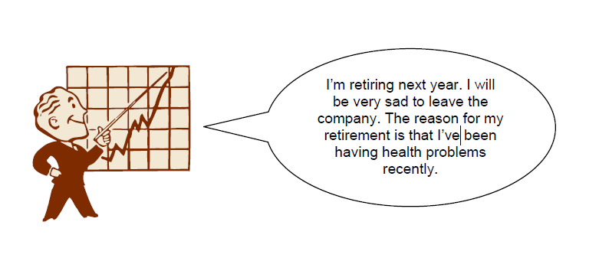.
Reporting Verbs (Worksheet 2)
Divide the verbs on the previous page into the two following categories:
‘tell verbs’ ‘say verbs’
(the hearer is usually the direct object. (the hearer is not usually the direct
Example – “I told him to hurry up.”) object. Example – “I said that
yesterday.”)
reassure mention
Choose 3 verbs from the ‘tell’ category, 3 verbs from the ‘say’ category and write
examples using them below.
Example – “The teacher reassured her students that if they continued to study hard
they would do well in their test.”
“I mentioned it at the meeting last week.”
1 –
2 –
3 –
4 –
5 –
6 –
Reporting Verbs (Worksheet 3)
1 | Please, please, please can I go on  holiday with my friends? Please. | A | She claimed that she’s going on  holiday with her friends.
2 | If you let me go on holiday with my  friends I promise I’ll study really  hard in school next term and will  clean my bedroom every day. | B | She repeated that she’d like to go on  holiday with her friends.
3 | As I told you before, I’d like to go  on holiday with my friends. | C | She assured her parents she’d behave  on holiday.
4 | Excuse me, I have something to tell  you. I’m going on holiday with my  friends this summer. | D | She mentioned that she was going on  holiday with her friends.
5 | This summer I’ll take some French  classes, learn how to drive and go  on holiday with … some friends. | E | She insisted that she was going on  holiday with her friends.
6 | Me? What am I doing this summer?  Er … I’m, uh, going on holiday  with some friends. | F | She begged her parents to let her go  on holiday with her friends.
7 | I promise my friends and I will  behave ourselves on holiday. | G | She stated that she was going on  holiday with her friends.
8 | Don’t worry. Nothing bad will  happen to me on holiday. I’ll be  perfectly safe. | H | She announced that she was going  on holiday with her friends.
9 | I’m going on holiday with my  friends this summer and I’ll like to  make sure that our travel  arrangements are still ok. | I | She admitted that she’d already  arranged a holiday with her friends.
10 | I’m going on holiday this summer  with my friends. | J | She confirmed her holiday plans.
11 | I don’t care what you say. I am  going on holiday with my friends  this summer. | K | She tried to persuade her parents to  let her go on holiday with her friends.
12 | Ok, ok it’s true. I have booked a  holiday with my friends this  summer. Do you forgive me? | L | She reassured her parents about her  holiday.

Look at the remarks above and match them to the best description.
1 ______ 2_______ 3_______ 4_______
5_______ 6_______ 7_______ 8 _______
9_______ 10_______ 11_______ 12_______
Reporting Verbs (Worksheet 4)
Read out the sentence below. Think about stress and intonation. The other students have to
guess the reporting verb that describes your situation. Don’t tell the others what the
reporting verb is, they should guess.
“I made a reservation two days ago for a table for two at 7 o’clock this evening. I’d just like
to check that the reservation is still ok. My name’s Smith.”
(You confirmed your reservation)

Read out the sentence below. Think about stress and intonation. The other students have to
guess the reporting verb that describes your situation. Don’t tell the others what the
reporting verb is, they should guess.
“Come on, let’s go to the pub. You’re tired? Well, then a couple of drinks will help you to
sleep well tonight. We can just go for an hour and so and then leave. What do you think?
Come on, you look like you need a drink. You’ll come? Great!”
(You persuaded your friend to go to the pub)

Read out the sentence below. Think about stress and intonation. The other students have to
guess the reporting verb that describes your situation. Don’t tell the others what the
reporting verb is, they should guess.
“Ladies and gentlemen. Can I have everyone’s attention for a couple of minutes? Thank
you. First of all I’d like to welcome you all to our annual conference. Before we get started
today I’d like to let everyone know that this year was our company’s most successful year.”
(You announced that this year has been a very successful year.)

Read out the sentence below. Think about stress and intonation. The other students have to
guess the reporting verb that describes your situation. Don’t tell the others what the reporting
verb is, they should guess.
(On the phone) “Hi mum, it’s me. How are you? Me? I’m fine. No, really I am fine. Yes mum,
I am sleeping enough and eating well. No, I haven’t been going out too much. Yes, I am
working hard. No, not too hard. Mum will you please stop worrying so much. I’m taking care
of myself and am feeling great, I promise.”
(You reassured your mother that you were fine.)

Lesson 13. Communications. Typical telephone conversation. M: Individual work.
Telephoning in English includes learning a number of special phrases, as well as focusing on listening skills. Some of the most important phrases include how to answer the phone, how to ask for others, how to connect, and how to take messages.

Introducing Yourself
Here are a few ways to informally introduce yourself on the telephone:
- This is Ken.
- Hello, Ken speaking
If you'd like to reply more formally, use your full name.
- This is Jennifer Smith speaking.
- Hello, Jennifer Smith speaking.
If you are answering for a business, just state the business name. In this case, it's common to ask how you can help:
- Good morning, Thomson Company. How may I help you?
- Plumbers Insurance. How can I be of service today?

British / American Difference
- Hello, this is Ken
- Brighton 0987654
The first example response is in American English and the second is in British English. As you can see there are differences in both forms. The telephone articles include both British and American English, as well as phrases that are common to both forms.
In American English, we answer the phone stating "This is ..." In British English, it's common to answer the phone by stating the telephone number. The phrase "This is ..." is used only on the telephone to substitute the phrase "My name is ..." which is not used to answer the telephone.

Asking Who Is on the Telephone
Sometimes, you'll need to find out who is calling. Ask them politely for this information:
- Excuse me, who is this?
- May (Can) I ask who is calling, please?

Asking for Someone
At other times, you'll need to speak to someone else. This is especially true when you telephone a business. Here are some examples:
- Can I have extension 321? (extensions are internal numbers at a company)
- Could I speak to...? (Can I - more informal / May I - more formal)
- Is Jack in? (informal idiom meaning: Is Jack in the office?

Connecting Someone
If you answer the phone, you might need to connect the caller to someone at your business. Here are some useful phrases:
- I'll put you through (put through - phrasal verb meaning 'connect')
- Can you hold the line? Can you hold on a moment?

When Someone Is Not Available
These phrases can be used to express that someone is not available to speak on the telephone.
- I'm afraid ... is not available at the moment
- The line is busy... (when the extension requested is being used)
- Mr. Jackson isn't in... Mr. Jackson is out at the moment...

Taking a Message
If someone isn't available, you might want to take a message to help the caller.
- Could (Can, May) I take a message?
- Could (Can, May) I tell him who is calling?
- Would you like to leave a message?
Continue practicing your skills by using the practical exercises below which include information on leaving messages on the telephone, how to ask native speakers to slow down, role plays on the telephone and more.

Practice With a Role Play
Begin by learning important telephone English with the dialogue below. Here is a short telephone conversation with some of the key phrases:
Operator: Hello, Frank and Brothers, How can I help you?
Peter: This is Peter Jackson. Can I have extension 3421?
Operator: Certainly, hold on a minute, I'll put you through...
Frank: Bob Peterson's office, Frank speaking.
Peter: This is Peter Jackson calling, is Bob in?
Frank: I'm afraid he's out at the moment. Can I take a message?
Peter: Yes, Could you ask him to call me at ... I need to talk to him about the Nuovo line, it's urgent.
Frank: Could you repeat the number please?
Peter: Yes, that's ..., and this is Peter Jackson.
Frank: Thank you Mr. Jackson, I'll make sure Bob gets this asap.
Peter: Thanks, bye.
Frank: Bye.
As you can see, the language is rather informal and there are some important differences from face-to-face conversational English.

14 Holidays. Shops and shopping. M.: Pair work.
Vocabulary
anchor | to lower an anchor on a ship to keep it from
brave | moving
brave | a young fighting man from a Native American
encourage | tribe
encourage | to help someone become confident or brave
harvest | enough to do something
harvest | the time when crops are gathered from the
passenger | fields
passenger | someone who is traveling by car, boat, etc.
pilgrim | but who is not driving it
pilgrim | someone who travels a long way to another
spoil | place for a religious reason
spoil | to ruin something by making it less attractive,
threat | enjoyable or useful
threat | a statement or warning of trouble, pain or
tribe | sadness
tribe | a group of people from the same race, culture;
voyage | ruled by a chief
voyage | a long trip, especially on a ship or a space
 | vehicle

Pre-Text Discussion
What does it mean to be “thankful?” Often we are most thankful for those things that we have worked hard to achieve. What are you especially thankful for in your life? Read this article about one small group of people who struggled and worked very hard to make a new home for themselves. They had much to be thankful for.

Text

THANKSGIVING IN THE UNITED STATES

THE PILGRIMS SET SAIL FOR AMERICA
In 1608, a group of people later known as the “Pilgrims” left England to seek religious freedom in Holland. After some years, their children began to learn the Dutch life style and language. The Pilgrims became concerned with this because they considered the Dutch ideas a threat to their children’s education. On September 16, 1620, after many years of planning and preparation, the Pilgrims set sail for America, the “New World”, where they could live their lives in freedom. They sailed from Plymouth, England on a ship called the “Mayflower”. The 44 Pilgrims were joined by 58 other passengers and sailors. The trip to the New World was long, cold and damp. It took over two months. The Pilgrims were overcrowded, their food was spoiling, and their water was running out. By the time land was sighted on November 19th, many passengers had become sick and one had died. After the long, hard journey, the Pilgrims sighted Cape Cod on November 19. They anchored on November 21 at the site of Provincetown, Massachusetts. The settlers soon discovered Plymouth Harbor, on the western side of Cape Cod Bay and made their historic landing on December 21, 1620. The first winter was very cold. Most of the days it snowed, which made it hard to construct their homes, so most of them lived on the ship. In March, the weather began to turn warmer and the health of the Pilgrims improved. Of the 102 original passengers, less than 50 had survived the first winter.

THE FIRST THANKSGIVING

On March 16, 1621, something very important happened. An Indian brave walked into the Pilgrim’s settlement and greeted them in English. This Indian’s name was Samoset and he was a member of the Pemaquid tribe. Captains from fishing boats that sailed off the coast, had taught him to speak English. He spent the night and left the next day only to return with another Indian named Squanto. Squanto spoke better English than Samoset. Squanto told the Pilgrims of his voyages across the ocean to Spain and England, where he had learned to speak English. Squanto went on to live with the Pilgrims and teach them how to survive in this new land. After a busy summer of planting and hunting the Pilgrims were ready to face the next winter. The October harvest was very successful. The Pilgrims had enough food to make it through the coming cold months. There was corn, fruits and vegetables; fish packed in salt and meat to be smoked. They had much to celebrate and be thankful for. They were at peace with their Indian neighbors, had houses and food. In November, Governor William Bradford declared a day of «thanksgiving» and a great feast was held in honor of the occasion. Squanto and Samoset and also Massasiot, chief of the Wampanoag tribe and ninety other Indians came to celebrate with the Pilgrims for three days. Together they shared their food, competed in various games, and most of all, gave thanks that they had survived the first year in their new home.

OFFICIAL THANKSGIVING HOLIDAY
The Pilgrims continued to observe this day of Thanksgiving each year and throughout America’s early history, special days of thanks were declared. In 1863, during the American Civil War (1861-1865), President Abraham Lincoln proclaimed the last Thursday in November Thanksgiving Day in order to encourage the Union soldier’s morale. After the war, Congress established Thanksgiving as a national holiday, to be celebrated every year.

Check Comprehension

Write short answers to the following questions

1.Based on the definition of the word pilgrim, why do you think the “Pilgrims” were called by this name?
2.Why did they feel the need to travel to America?

3.What event helped the Pilgrims the most in learning to live in their new home?
4.What did they have to be thankful for?

TIMELINE:

Make a timeline of the events that happened in the history of the Pilgrims. Record the dates and what happened on those dates. Also record the important events that do not have dates.
Grammar Practice

Exercise: Adjective or Adverb. Choose the correct item from the choices in the parentheses:

1.He (correct, correctly) defined the terms. The answer sounded (correctly, correct).
2.She (quickly, quick) adjusted the menu. She adapted (quick, quickly) to any situation.
3.He measured the floor (exact, exactly). They proved to be (perfectly, perfect) (exact, exactly) measurements.
4.The stillness of the tomb was (awfully, awful). The tomb was (awfully, awful) still.
5.It was a (dangerously, dangerous) lake to swim in. The man was (dangerous, dangerously) drunk. The gas smelled (dangerously,dangerous).

6.She performed (magnificent, magnificently). It was a (magnificent, magnificently) beautiful performance.
7.Her voice sounds (beautifully, beautiful). She sang the song (exact, exactly) as it was written. We heard it (perfectly, perfect).
8.He was a very (sensibly, sensible) person. He acted very (sensible, sensibly).

9.Mike wrote too (slow, slowly) on the exam. He always writes (slow, slowly).
10.Talk (softly, soft) or don’t talk at all. The music played (softly, soft).
11Andrea knows the material very (good, well). She always treats us (good, well).
12.You must send payments (regular, regularly). We deal on a (strictly, strict) cash basis.
13.The mechanic’s tools were (well, good). The foreman said that his work was (good, well) done.
14.She worked (careful, carefully) with the sick child. She was a very (careful, carefully) worker.
15.He did not pass the course as (easy, easily) as he thought he would.
16.I find this novel very (interesting, interestingly). It was (interesting, interestingly) written.

Vocabulary Practice

Exercise: Read each of the following sentences. Determine whether the vocabulary word in italics is used correctly or incorrectly. If incorrect, rewrite the sentence using the word correctly.

1.The ship’s captain ordered the sailors to lower the anchor immediately. He wanted to anchor the ship far enough from shore to protect it from beating against the rocks.

2.A young Dutch boy wanted to passenger on the Mayflower with the Pilgrims, but his parents didn’t allow him to go.

3.With the help of their new American Indian friends, the pilgrims had an encourage harvest in October 1621.
4.Most of the pilgrims’ food spoiled on the ship while crossing the ocean.
5.The English speaking Indian named Samoset tribed with the Pemaquids.
6.Though the voyage was difficult, the Pilgrims did not regret going to America.

Speaking Practice

Task 1: You have been invited to make a proposal before the parliament. You want to propose a new national holiday on which to give thanks. Which day would you choose and why? What would you name the holiday? Are there any historical or recent events that support a new holiday? Prepare and present your proposal for the parliament (your class).
Task 2: In small groups, defend or refute the following statements.

1.Every nation has a special day of thanksgiving even though they use different names for this holiday and celebrate in different ways..

2.A holiday for giving thanks is a waste of time that would be better spent working to increase the products for which thanks is being given.

Lesson 15. In a hotel. Eating out. M: Brainstorming.
The words below are some of the most important used to talk about how food tastes, the condition it is in, and how we cook. Practice the sentences and learn how to talk about your food.

Food Condition
- fresh - Sushi always requires fresh fish.
- off - I'm afraid this cheese tastes off.
- raw - Sushi is made from raw fish as well as vegetables, seaweed, and rice.
- ripe - Make sure the bananas are ripe so I can use them in the cake.
- rotten - This meat smells rotten. I think we should throw it away.
- tough - The steak was very tough. I could hardly chew it!
- tender - The lamb was so tender that it seemed to melt in my mouth.
- undercooked - The undercooked salmon was very poor.
- unripe - Many types of fruit are picked unripe and become ripe as they are shipped.
- overcooked - The broccoli was overcooked. It should have been crisper.

Food Verbs
- bake - I'll bake a cake for her birthday party.
- boil - You should boil these potatoes for forty-five minutes.
- cook - What would you like me to cook for dinner?
- fry - I usually fry some eggs and bacon on Saturday mornings.
- grill - During the summer I like to grill meat outside.
- heat - Heat up the soup and make some sandwiches.
- microwave - Microwave the macaroni for three minutes and eat.
- poach - Jennifer prefers to poach her eggs.
- roast - Let's put this in the oven and roast for two hours.
- steam - The best way to cook many vegetables is to steam them for a few minutes.

Food Quantities
- bar - Melt one bar of butter for the sauce.
- liter - I'll put a liter of water on to boil for the pasta.
- loaf - I bought three loaves of bread at the supermarket.
- lump - Put of a lump of butter on top of the casserole to make it tasty.
- piece - Would you like a piece of chicken?
- pint - I drank a pint of ale at the pub.
- portion - Have you eaten your portion of vegetables today?
- slice - Please put three slices of cheese on my sandwich.
- spoonful - Add two spoonfuls of sugar to sweeten.

Food Taste
- bitter - The almonds were very bitter. I could hardly eat the cookies.
- bland - This sauce is very bland. It doesn't taste like anything.
- creamy - I enjoy eating creamy tomato soup on cold winter days.
- crisp - The apple was crisp and delicious.
- crunchy - Granola is a very crunch type of breakfast cereal.
- hot - The soup is hot. Let it cool down.
- mild - The spices are very mild.
- salty - The sauce was much too salty. I think you should add some water and boil it down.
- savory - Savory crackers with cheese make a great snack.
- sour - Lemons are very sour!
- spicy - Greg enjoys eating spicy Mexican food.
- sweet - The cherry pie wasn't too sweet. It was just right.
- tasteless - The vegetables have been cooked for too long. They're tasteless.

Food Types
- barbecue - Do you enjoy barbecue during the summer?
- buffet - We went to an Indian buffet and had all we could eat.
- four-course meal - My wife and I enjoy making four-course meals on special occasions.
- picnic - Let's take a picnic to the park and enjoy the good weather.
- snack - You should eat a snack at four, but don't eat too much.
- TV dinner - TV dinners are disgusting but fast.

Eating and Drinking
- bite - Don't bite off more meat than you can comfortably chew.
- chew - You should chew each bite well before you swallow.
- swallow - If you swallow too much you might choke on your food.
- sip - It's best to slowly sip a cocktail rather than gulp it down.
- guzzle - He guzzled a glass of water after he finished the job.
- gulp down - He hungrily gulped down the meal as he was very hungry.

Preparing Drinks
- add - Add two shots of whiskey and some rum.
- fill - Fill the glass with ice.
- mix - Mix in a teaspoon of sugar.
- pour - Pour your drink over ice cubes.
- shake - Shake the drink well and pour into a glass.
- stir - Stir the ingredients well and enjoy with your favorite seafood.
If you know all of these words, try the advanced level food vocabulary page to really expand your vocabulary. Teachers can use this lesson about food to help students plan a meal of their own.

16 Crime. M: Group work.
In English, there are a lot of specific words for different types of crimes and the criminals who commit them. Unfortunately, the list of crimes and criminals is long! Because the words have specific legal meanings, only a short, basic definition is given below. You may wish to download and print out the list, and write the correct translation of the words in your own language. This would give you the exact meaning.
CRIME | DEFINITION | CRIMINAL
abduction | taking someone away by force, demanding money for their safe return
arson | setting fire to a building, cars or property on purpose | arsonist
assassination | killing a famous person or public figure | assassin
assault | attacking someone physically | assailant
bigamy | marrying someone when you are already married to another person | bigamist
blackmail | threatening to reveal someone’s secrets if a lot of money is not paid | blackmailer*
bombing | detonating an explosive device with the plan of harming people or property | bomber
bribery | giving money or granting favors to influence another person’s decisions or behavior | briber*
burglary | breaking into a house in order to steal something | burglar
child abuse | treating a child badly in a physical, emotional, or sexual way | child abuser
corruption | behaving illegally and dishonestly; especially those in power
crime | doing something illegal that can be punished by law | criminal
cybercrime | doing something illegal over the Internet or a computer system | cyber criminal  hacker**
domestic violence | behaving violently inside the home
drunk driving | driving with too much alcohol in your blood | drunk driver
embezzlement | stealing large amounts of money that you are responsible for, often over a period of time | embezzler
espionage | spying, to obtain political or military information | spy
forgery | illegally copying documents, money, etc. to cheat people | forger
fraud | getting money from people by cheating them | con artist  fraud
genocide | killing on purpose a large number of people, especially from a particular group or area
hijacking | taking control of a plane, train etc by force, often to meet political demands | hijacker
hit and run | not stopping to help a person hurt in an accident caused by you
homicide | killing another person on purpose
hooliganism | being violent or aggressive on purpose; often used to describe youth | hooligan
identity theft | using someone else’s personal information for one’s own gain
kidnapping | taking someone away by force, often demanding money for their safe return | kidnapper
libel | damaging someone’s reputation by writing lies about them
looting | taking things illegally and by force, during a riot, war, etc. | looter
lynching | killing someone without legal process, often by hanging, often by an angry mob
manslaughter | killing someone by accident
mugging | attacking someone with a plan to rob them | mugger
murder | killing someone on purpose | murderer
perjury | lying in court, while under oath
pickpocketing | stealing wallets, money, etc. from people’s pockets in crowded places | pickpocketer
pilfering | stealing small quantities of goods over time
poaching | hunting illegally | poacher
rape | forcing someone to have sex | rapist
riot | causing a noisy, violent public disturbance | rioter
robbery | stealing large amounts of money with force or violence from a bank, store, etc. | robber
shoplifting | stealing something from a store | shoplifter
slander | damaging someone’s reputation by speaking lies about them
smuggling | taking things secretly in or out of a place, country, jail, etc. | smuggler
speeding | driving above the speed limit
terrorism | using violence, threats, or fear, usually for political purposes | terrorist
theft | stealing, in general | thief
trafficking | trading something illegal like drugs, people, etc.
treason | betraying one’s country by helping its enemies | traitor
trespassing | entering another person’s area; hurting people/damaging property through force | trespasser
vandalism | destroying private or public property purposely | vandal
voyeurism | secretly watching naked people or sexual acts & getting sexually excited | voyeur
* uncommon
** hacker does not technically mean a cyber criminal, but the word is often used to describe those who commit computer crimes.

17 Doing exercises. M: Group work.

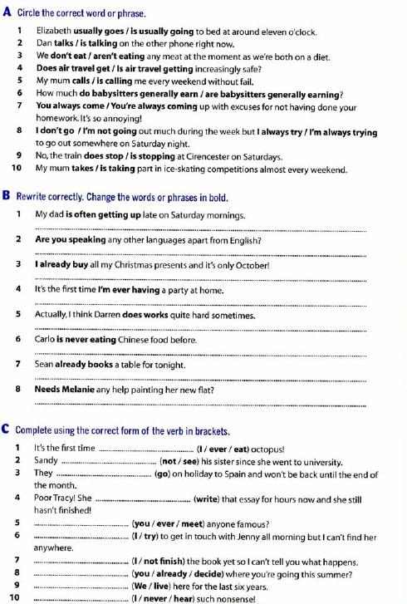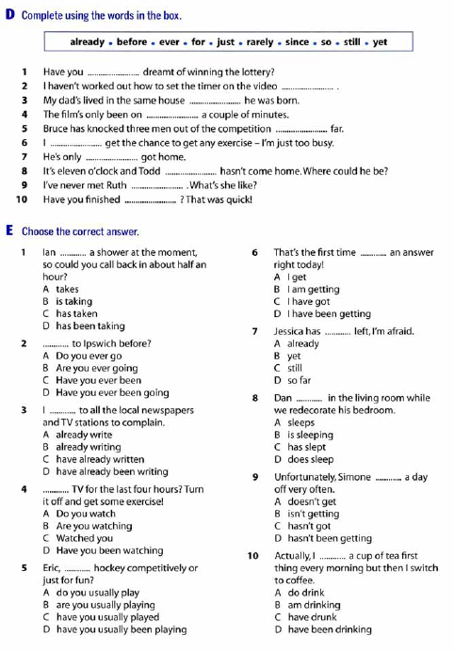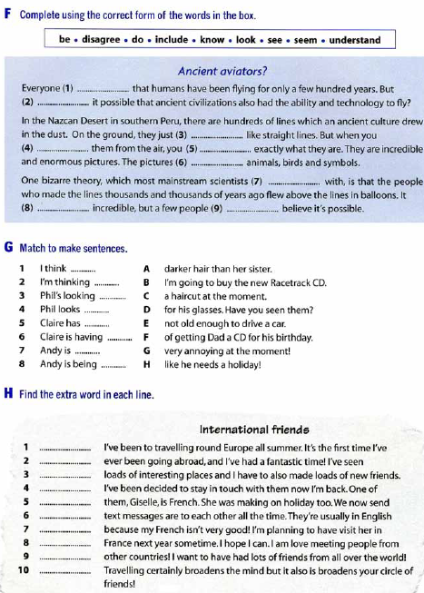

18 Everyday problems. M: Individual work.
Vocabulary:
to oversleep -sleep longer than you planned to in the morning
miss a train - arrive too late to do something
slip on the sidewalk - slide unintentionally for a short distance, typically losing one's balance or footing

sprain an ankle - to injure a joint such as your wrist/ ancle by suddenly stretching or turning it too much
skin knees
brake glasses,
lose keys -become unable to find (something or someone).
get stuck - not be able to move
stub a toe - accidentally strike (one's toe) against something.
have a fight
crawle into bed - move forward on the hands and knees or by dragging the body close to the ground.
couldn't take any more.

A Bad Day
I overslept and missed my train,
slipped on the sidewalk in the pouring rain,
sprained my ankle, skinned my knees,
broke my glasses, lost my keys,
got stuck in the elevator,
it wouldn't go,
kicked it twice and stubbed my toe,
bought a pen | that didn't write,
took it back and had a fight,
went home angrily,
locked the door,
crawled into bed,
couldn't take any more.

And some more "problem" words are here:

run out of - use all of something so there is nomore left
get lost - you don't know where you are or where to go
an accident - something bad that happens and often hurts people

19 Global problems. M: Brainstorming.
Global Issues Vocabulary

- environmental: relating to the natural world, especially to its conservation
- pollution: harm done to the environment through chemicals or waste products that affects the air, soil, or water of the earth.
- political turmoil: a state of confusion or problems in the government of a country or region
- poverty: the state of not having enough money to take care of basic needs such as food, clothing, and housing
- hunger: a shortage of food affecting a few individuals or small area
- famine: a severe shortage of food resulting in widespread hunger
- child labor: the full-time employment of children, especially of those who are legally too young to work
- genocide: the systematic killing of all the people from a national, ethnic, or religious group, or an attempt to do this
- natural disasters: an event such as an earthquake caused by natural forces rather than by human action

A text
One critical issue is preserving and protecting the environment. The burning of fossil fuels (oil, coal, and natural gas) produces greenhouse gases (gases that heat up the atmosphere) that deplete the ozone layer and result in global warming and climate change (changes in the earth’s temperature and weather patterns).
Some scientists believe that we have already done irreparable damage to the planet, and now we are suffering the consequences of rising sea levels and increasingly frequent natural disasters such as earthquakes, hurricanes, and tornados. A number of animal species have gone extinct, and many more are endangered.
To reverse this trend, we must invest in clean energy (energy sources that do not pollute the environment) with renewable resources (elements like water and air, which can be re-used) and utilize manufacturing methods that are not harmful to the environment.
There are still many regions of the world where children die of hunger/starvation (die from not having enough food). Unfortunately, extreme poverty is common in the rural areas of developing countries, where the population often suffers from food shortages (not enough food) and lack of access to clean water.
In the cities, homeless people sleep on the streets if there is not enough room in local homeless shelters. There are also many families on the margins of society (outside the dominant society and culture) who are living below the poverty line and struggle to make ends meet every month.
Although many governments create welfare programs (programs that give money to poor people) to alleviate poverty, the widening gap between rich and poor suggests that poverty may never be completely eradicated.
Poverty and underdevelopment contribute to a host of additional problems as well. For example, many people die of preventable diseases because they have no access the safe and effective vaccines that exist. A number of large corporations use child labor in the manufacturing of their products, as poor families may feel they have no other option for survival.
In addition, young women from disadvantaged backgrounds (poor families and situations) are prime targets for human trafficking and sexual exploitation.

20 Zero affixation. M: Group work.
Zero affixation is a word with no change in form, in addition the meaning isn’t always the same. These are the examples of zero affixation when many words in English can function as a noun and verb, or noun and adjective, or verb and adjective.
What’s the answer? (noun)
Answer the questions. (verb)
- I must clean my room. (verb)
- It’s a clean room. (adjective)
- I don’t like the cold (noun)
- I don’t like cold weather. (adjective)
- I didn’t reply to the letter. (verb)
- I wrote a reply to the letter. (verb)
- We stayed in Paris for a short time. (verb)
- We have a short stay in Paris. (noun)
Up to now, we have studied word formation processes that employ affixes attached to roots (or other complex bases), or roots attached to other roots (to form compounds). But there are also words that relate to each other without the intervention of an affix, whether in derivation or inflection. These are some of the processes that we are going to review in this section:
- reduplication
- apophony
- conversion and syncretism
- “zero” affixation
A reduplicated word is, as its mane suggests, a word that is related to a base by copying onto the base (on part or as a whole) and attaching the copy to the base itself. Reduplication cannot be observed in English, so we need to turn to other languages. Like Klamath, where reduplication is very productive in may forms. Consider the following forms:
SIMPLE |  | DISTRIBUTIVE
honkanga | ‘fly aroun’ | ho-hankanga | ‘fly around here and there’
gama | ‘grind’ | ga-gama | ‘grind repeatedly’
hislan | ‘he shot himself’ | hi-haslan | ‘they shot themselves’
si?apQa | ‘they wipe their own faces’ | si-s?apQa | ‘they wipe their own faces repeatedly’
The distributive forms of these verbs do not have a prefix in their structure: notice that they are all different in their phonology. Rather, what is going on here is that the first consonant-vowel (CV) sequence of the stem is copied at the beginning of the stem. There are further changes that affect the first vowel of the stem, which either changes to a or is deleted. These changes are not necessarily a feature of reduplication across langauges, the fact that really matters here is the copying of a part of the stem onto itself (i.e. the first CV sequence in this case). Reduplication, as a formal process that builds up word structure, can be used in inflection or in derivation.
Apophony is the general name given to a morphological process in which a new word is created not by affixation to a root, but by changing some of the sounds in that word. Some verb-noun pairs are so related:
verb | noun | sound change
pretend | pretense | [d]/[s]
prove | proof | [v]/[f]
sing | song | [ɪ]/[ɑ]
bathe | bath | [eð]/[æθ]
clothe | cloth | [oð]/[ɔθ]
Notice that when the change affects the consonants, the change affects primarily the voicing of the consonant (voiced in the verb, voiceless in the noun) without affecting point of articulation. In the case of sing/song, there is a change in the vowel. In the case of bathe/bath and clothe/cloth, finally, there is vowel change and voicing alternation on the final consonant, together. Compare these cases to memory/memorize or write/writer, where the verb/noun derivation is effected by suffixation.
The word pairs in the previous table are different lexemes. A typical case in which apophony results in different grammatical words is the formation of irregular plurals in English. For example:
singular | plural
mouse | mice
louse | lice
goose | geese
foot | feet
tooth | teeth
man | men
The conjugation of some English irregular verbs also uses apophony to distinguish among grammatical words. Here are some typical verbs, belonging to four different inflectional classes (cf. Bloch 1947)
Class | Pres. | Pret. | Part.
D2 | come | came | come
F2 | crow | crew ¹ | crowed
D3 | win | won | won
D5 | begin | began | begun
All of these forms have a past tense (also called a preterite) which differs from the present in a vocalic change, without a past tense suffix. When we consider the perfect participle, however, four different patterns emerge. As an exercise, consider the verbs listed below. Can you assign each to one of the four classes in our table? Can you begin to discern the regularities (or sub-regularities, rather, since these are all “irregular” verbs) in the different classes?
bid² | dig | lead | shrink
bind | dive | read | sing
bleed | drink | ring | sink
cling | feed | run | swim
Class D2 has an alternative root in the preterite, and forms the perfect participle just like the present (bid and run belong in this class); class F2 has an alternative root in the preterite, and forms the perfect participle by adding -(e)d (dive is the only other verb in this class); class D5 has two alternative roots, one in the preterite, one in the perfect participle (drink, ring, shrink, sing, sink, and swim go there); and finally all other verbs in the table go into class D3, in which an alternative root is used for both the preterite and the perfect participle.
Conversion is a process by which the same word form belongs to two different parts of speech, and hence two different lexemes. Thus, a verb like bottle can be derived from a noun like bottle without any affixation (as we did with -ize before, for instance). Here are some additional examples.
bend (V/N) | dry (Adj/V) | profit (N/V)
cold (Adj/N) | fight (V/N) | spy (V/N)
clean (Adj/V) | map (N/V) | scalp (N/V)
two grammatical words can also differ without afixation or apophony (relative to each other), therefore resulting in the same word form. Think of the example of D2 and D3 verbs above. In D2 verbs, the present and the participle are identical (come vs. preterite came), in D3 verbs the preterite and the participle are identical (won vs. present win). We have already introduced the term syncretism to describe this fact, but with reference to words that are inflected by means of affixes, as in the past tense of “weak” (i.e. regular) verbs like live or pass (Bloch’s classes A1 and B1, respectively).
Zero affixation is not easy to demonstrate in English, given the realive poverty of the inflectional system. But we have already seen an instance of it in Turkish, where the 3rd person singular form of verbs is distinguished from the rest by having no affix at all. Spanish number/gender systems provide another example. Thi first table below shows cases where a stem has a “thematic” vowel followed by the number suffix in the plural. So we could consider that there is a zero affix for the singular. A more dramatic picture emerges with some nouns ending in consonant, in the masculine. Here the opposition in the singular calls for a zero suffix for masculine gender (notice, too, that this zero suffix is in contrast with the overt thematic vowel from the first group). But if there is also a zero suffix for singular number, does this mean that a word like pintor has two zero suffixes, one after the other?
Gloss | ‘grandparent’ | ‘neighbor’ | ‘singer’ | ‘dentist’
M.Sg | abuelo | vecino | cantante | dentista
F.Sg | abuela | vecina | cantante | dentista
M.Pl | abuelos | vecinos | cantantes | dentistas
F.Pl | abuelas | vecinas | cantantes | dentistas

Gloss | ‘paintor’ | ‘judge’ | ‘marquis’ | ‘champion’
M.Sg | pintor | juez | marqués | campeón
F.Sg | pintora | jueza | marquesa | campeona
M.PL | pintores | jueces | marqueses | campeones
F.PL | pintoras | juezas | marquesas | campeonas
Something is amiss here. In a later sub-section we will develop a framework that avoids zero suffixes and, in so doing, opens up a new way to treat other problematic cases in morphological analysis. But first we should look at other form-content mismatch
- Also forms the regular past tense crowed
- There are two different verbs with the form bid. Bid₁ means ‘to offer money for an auctioned item’, bid₂ means ‘greet or say goodbye to someone’. Both verbs form their perfect participle with -n (bidden), with an alternative form bid, but the preterite of bid₂ is formed by apophony, as bade. The preterite of bid₁ is also bid, an instance of syncretism. Bid₁ takes on prefixes like over- and out-, while bid₂ combines with the prefix for- to form forbid (conjugated like bid₂ in the preterite as forbade). Interestingly, Bloch (1947) transcribes bade as /bæ:d/, not /be:d/, the latter being a very recent innovation!

Lesson 21 Compound nouns and adjectives. M: Individual work.

What is a Compound Noun
Compound nouns are words for people, animals, places, things, or ideas, made up of two or more words. Most compound nouns are made with nouns that have been modified by adjectives or other nouns.
In many compound nouns, the first word describes or modifies the second word, giving us insight into what kind of thing an item is, or providing us with clues about the item’s purpose. The second word usually identifies the item.
Compound nouns are sometimes one word, like toothpaste, haircut, or bedroom. These are often referred to as closed or solid compound nouns.
Sometimes compound nouns are connected with a hyphen: dry-cleaning, daughter-in-law, and well-being are some examples of hyphenated compound nouns.
Sometimes compound nouns appear as two separate words: full moon, Christmas tree, and swimming pool are some examples of compound nouns that are formed with two separate words. These are often referred to as open or spaced compound nouns.

Compound Noun Examples
The more you read and write, the more compound noun examples you’ll encounter. The following sentences are just a few examples of compound nouns. Compound noun examples have been italicized for easy identification.
Compound nouns can be made with two nouns:
Let’s just wait at this bus stop.
I love watching fireflies on warm summer nights.
While you’re at the store, please pick up some toothpaste, a six-pack of ginger ale, and some egg rolls.
Compound nouns can be made with an adjective and a noun:
Let’s watch the full moon come up over the mountain.
Please erase the blackboard for me.
Compound nouns can be made with a verb and a noun:
Be sure to add bleach to the washing machine.
Let’s be sure to stay somewhere with a swimming pool.
Compound nouns can be made with a noun and a verb:
He always gets up before sunrise.
I really could use an updated hairstyle.

Compound adjectives – Exceptions
Note that combining an adverb and an adjective does not create a compound adjective. No hyphen is required because it is already clear that the adverb modifies the adjective rather than the subsequent noun. For example:
- It was a terribly hot day.
- It is an amazingly good idea.
In addition, you should not place a hyphen in a compound adjective if the adjectives are capitalized, such as when they are part of a title.

Examples of compound adjectives
- This is a four-foot table.
- Daniella is a part-time worker.
- This is an all-too-common error.
- Beware of the green-eyed monster.
- He is a cold-blooded man.
- I love this brightly-lit room!
- Danny’s dog is well-behaved.
- You have to be open-minded about things.

Compound adjective exercises
1. From each group, choose the sentence that contains a compound adjective:
- Sheila was horribly moody.
- We’d like you to be part of the decision-making process.
- The company showed steady improvement in their stock trades.
- This is a widely used procedure for finishing wood floors.
- Moths ate his woolen socks.
- That was really generous of you.
- Sharon’s adopted son is five years old today.
- My new car has leather upholstery.
- She was a well-known actress by the time she reached age five.
Answers:B, A, C
2. Using hyphens in compound adjectives: Which sentences are correct?
- The group was full of rowdy 10 year old schoolboys.
- The group was full of rowdy 10-year-old schoolboys.
- The actress is well known.
- The actress is well-known.
- They enjoyed a three-year profit streak.
- They enjoyed a three-year-profit streak.
Answers:B, A, A
3. Using –ly adverbs in compound adjectives: Which sentences are correct?
- Along the river, rapidly increasing floodwaters caused evacuations.
- Along the river, rapidly-increasing floodwaters caused evacuations.
- My neighbor Jim is an internationally recognized author.
- My neighbor Jim is an internationally-recognized author.
- The bank robbers tried to hatch their ill conceived plan and failed.
- The bank robbers tried to hatch their ill-conceived plan and failed.
Answers:A, A, B
4. Choose the correct compound adjective for each sentence.
- He is fond of ______________________ Scotch.
  - good
  - 12-year-old
  - 10 year old
- The weather has been ___________________ lately.
  - terribly-cold
  - terribly cold
  - too cold
- Babysitting these kids is like trying to manage a _____________________.
  - three ring circus
  - three-ring-circus
  - three-ring circus
Answers: A – 12-year-old B – terribly cold C – three-ring circus
5. Fill in the blanks with the best compound adjective for the situation:
- Melanie has everything she needs. She is _____________________.
  - two-faced
  - very badly behaved
  - well-cared for
- Louis overcomes difficulties easily. He is _______________________.
  - short-tempered
  - level-headed
  - internationally renowned
- Mr. Chan likes to hear about new ideas. He is ______________________.
  - strong-minded
  - two faced
  - open-minded
Answers: A – well-cared for B – level-headed C – open-minded
6. Fill in the blanks with the best phrase for the situation:
- Jesse was promoted, so he bought ________________________________.
  - himself-a brand new car
  - himself a brand-new-car
  - himself a brand-new car
- The _______________________ has been going on for decades.
  - gun control debate
  - gun-control debate
  - gun-control-debate
- The sound of ___________________________ always soothes my mind.
  - gently-flowing water
  - gently flowing water
  - gently-flowing-water
Answers: A – himself a brand-new car B – gun-control debate C – gently flowing water
7. Creating compound adjectives: From each group, choose the sentence pair that makes the most sense.
- I don’t like glue that dries slowly. = This is a quick-drying glue.
- Did you know that some plants eat meat? = Did you know that there are meat-eating plants?
- Professor Brown has a very narrow mind. = Professor Brown’s mind is very narrow.
- The price of the car was high. = It was a high-priced car.
- The meal tasted good. = This was a tasteful-meal.
- He likes to weigh in on political issues. = He is loud-mouthed and boring.
- The tapeworm measured 35 inches. = The tape-worm measured 35-inches.
- The duck has flat feet. = That’s a flat-footed duck.
- Why not try some carrot juice? = Have some carrot-juice.
Answers:B – meat-eating plants A – high-priced car B – flat-footed duck
8. Compound adjectives containing numbers: From each group, choose the sentence containing the correct compound adjective.
- The earthworms were at least three inches long.
- He ate a 12-inch sandwich for lunch.
- The sumo champion weighed 210-kilograms.
- He drives a one-ton truck.
- Our house has three-bedrooms and two-bathrooms.
- There are nine-carrots in each bottle of juice.
- My new chainsaw cost three-hundred dollars.
- I got a 300-dollar chainsaw for two hundred dollars.
- The best chainsaws cost more than three-hundred-dollars.
Answers:B – 12-inch sandwich A – one-ton truck B – 300-dollar chainsaw
9. Use the underlined phrase to make a compound adjective.
- He suggested an innovative plan to save money.
- Her brother had a sharp mind.
- My cat died suddenly when it was ten years old.
Answers:
- He suggested an innovative money-saving plan.
- Her brother was sharp-minded.
- My ten-year-old cat died suddenly.

Lesson 22 Collocation. Verb or adjective plus preposition. M: Collage.
Prepositions cause a great deal of confusion. Most ESL students find it difficult to use them correctly.
One way of learning the correct use of prepositions is to look at several examples illustrating usage. In English, there are a large number of collocations. These are words which are often used together with other words.
Examples of collocation are given below.

Comment
The word comment takes the preposition ‘on’.
He commented on her lovely hair. (NOT He commented about her lovely hair.)

Reason
What is the reason for her unhappiness? (NOT What is the reason of her unhappiness?)
The word reason collocates with the preposition for.

Discuss
The verb discuss does not take a preposition.
Let us discuss your problem. (NOT Let us discuss about your problem.)

Consider
The verb consider does not take any preposition.
You should consider every aspect of the situation. (NOT You should consider about every aspect of the situation.)

Participate
Incorrect: They were asked to participate the group discussion.
Correct: They were asked to participate in the group discussion.
The word participate collocates with the preposition ‘in’.
Adapt
Incorrect: One must be able to adapt changing circumstances.
Correct: One must be able to adapt to changing circumstances.
The verb adapt takes the preposition ‘to’.
Dissatisfaction
Incorrect: These protests show their dissatisfaction of the new rules.
Correct: These protests show their dissatisfaction with the new rules.
Dissatisfaction takes the preposition ‘over’.

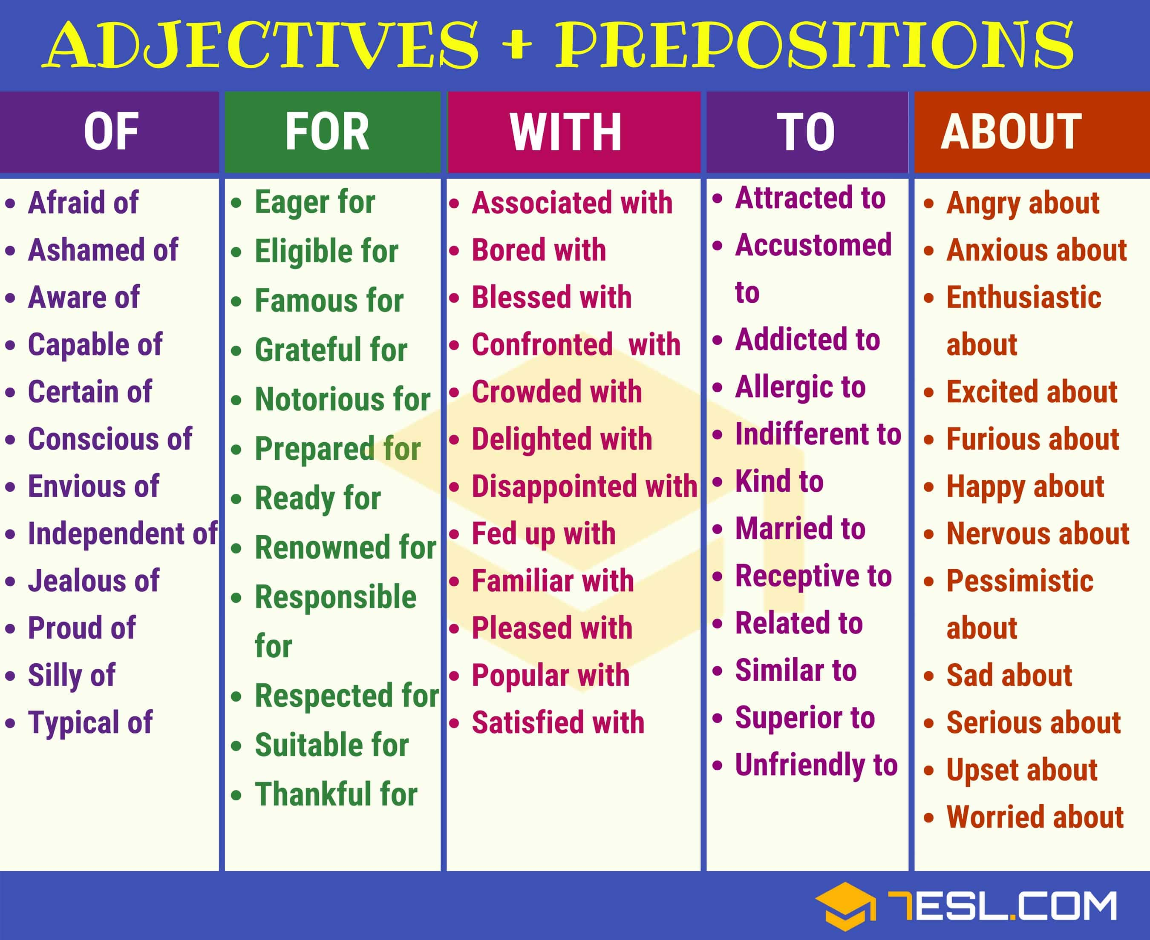

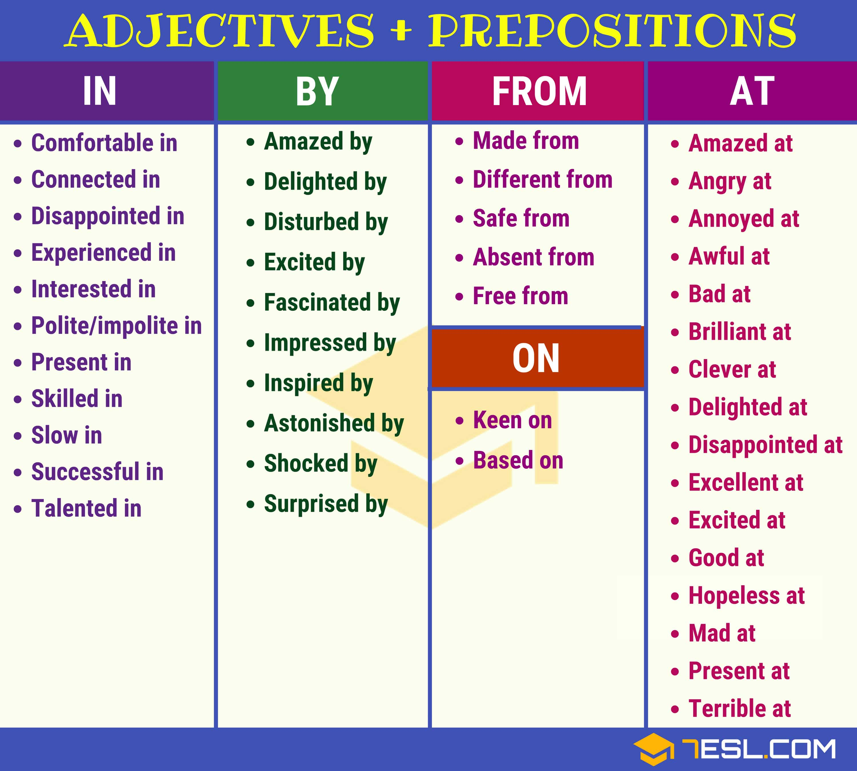

Lesson 23 Doing exercises. M: Group work.
- Class and homework tasks:
- Tasks focussing on active use of vocabulary should be on the use of vocabulary for communication (e.g. text/table completion, labelling, interview, etc.)
- Tasks focussing on passive recognition of meaning should be on inferring meaning of vocabulary from context (e.g. matching, word-formation, etc.)

Assessment criteria
- Appropriate use of vocabulary in context
- Range of vocabulary (see Indicative content in Vocabulary Course Description)
- Taskfulfilment
- Fluency
- Recognition of meanings of words in context
- Use of appropriate vocabulary building strategies

- Tests
Progress and Final Tests should be based both on knowledge of vocabulary covered during the semester as well as on strategies developed.
  - Knowledge based tasks: these should focus on students’ ability to use the vocabulary covered during the semester in communication
  - Strategy based tasks: these should focus on the strategies students use for dealing with vocabulary, e.g. strategies for guessing meaning of the word from context/based on its grammatical form, use of parallel expressions (synonyms, antonyms, etc) for avoiding repetition, associating words, etc.
- Tests have several text-based tasks using different test methods (multiple choice, open/banked gap filling, matching, error identification/correction etc.)
- Each task should be based on a separate text and have several questions/items (see sample tasks below).
- Texts for text-based tasks should be on the topics covered during the semester. These should be the new texts that students haven’t worked with before.
- Difficulty level of the texts should be similar to the ones which students have worked with so far
- Length of the texts: 100-250 words each.
- Instructions to tasks should be clear.
- There should be an example at the beginning of each task to help students how to complete the task.
- Focus of questions/items in tasks should be on the elements of Indicative Content covered so far (see Vocabulary Course Description)
- Correct answer for a question/item is assigned with 1 point, wrong answer is assigned with 0 point.
- Keys for open gap filling, word formation and error identification tasks may have more than one correct answer for each question/item.

Sample Progress and Final Test Tasks:

- BANKED GAP FILLING

Task 1
Read the text below and fill in the gaps 1-5 using the words in the box. There are more words than you need. There is an example (0) at the beginning of the text.

a) another | b) at | c) extra | d) though
e) to | f) too | g) wonderful | h) wondering

DearHarry,

Since I won’t be able to send you (0) ___a___ letter soon, happy birthday. I am having a great time here with Viktor (1) ______ his house, I hope you are doing well with your aunt and uncle. Even (2) ______ I’ve been with Viktor, I have been doing a lot of thinking, especially about what Dumbledore said last year. Since You-Know-Who (most wizards were (3) ______ afraid to use Voldemort’s real name, so they said ‘You-Know-Who’ instead) is back, you’ll have to be (4) ______ careful since you do seem to run into him often. I’ve also been (5) ______ about what the jobs are that Dumbledore sent everyone to do. I guess we’ll find out this September.

Sincerely,
Hermione
Key: 1b, 2d, 3f, 4c, 5h
Focus: this type of task focuses on student’s knowledge of vocabulary items from the vocabulary list. The strategy that students apply in this task is recognition of the word which should be used in the given context: deciding whether the word suits the gap semantically (meaning) and grammatically (form).

- MULTIPLE CHOICE

Task 1
Read the text below. Then circle the appropriate letter (a, b, c or d) for each gap in the text. There is an example at the beginning (0).

Dear Harry,
Since I won’t be able to send you (0) ___c___ letter soon, happy birthday. I am having a great time here with Viktor (1) ______ his house, I hope you are doing well with your aunt and uncle. Even (2) ______ I’ve been with Viktor, I have been doing a lot of thinking, especially about what Dumbledore said last year. Since You-Know-Who (most wizards were (3) ______ afraid to use Voldemort’s real name, so they said ‘You-Know-Who’ instead) is back, you’ll have to be (4) ______ careful since you do seem to run into him often. I’ve also been (5) ______ about what the jobs are that Dumbledore sent everyone to do. I guess we’ll find out this September.

Sincerely,
Hermione

0 a) other b) none c) another d) neither
1 a) at b) in c) on d) to
2 a) since b) though c) for d) as
3 a) moreover b) besides c) else d) too
4 a) extra b) added c) spare d) farther
5 a) wondered b) wonderful c) wondering d) wonder

Key: 1a, 2b, 3d, 4a, 5c
Focus: this type of task focuses on student’s knowledge of vocabulary items from the options. The strategy that students apply in this task is recognition of the word which should be used in the given context: deciding whether the word suits the gap semantically (meaning) and grammatically (form).

- OPEN GAP FILLING

Read the text below. Some words are missing from the text. Use only one word to complete each gap. There is an example at the beginning (0).
Dear Harry,
Since I won’t be able to send you (0) _another_ letter soon, happy birthday. I am having a great time here with Viktor (1) ______ his house, I hope you are doing well with your aunt and uncle. Even (2) ______ I’ve been with Viktor, I have been doing a lot of thinking, especially about what Dumbledore said last year. Since You-Know-Who (most wizards were (3) ______ afraid to use Voldemort’s real name, so they said ‘You-Know-Who’ instead) is back, you’ll have to be (4) ______ careful since you do seem to run into him often. I’ve also been (5) ______ about what the jobs are that Dumbledore sent everyone to do. I guess we’ll find out this September.

Sincerely,
Hermione
Key: 1 at, 2 though, 3 too, 4 extra/more/super, 5 wondering/thinking

Focus: this type of task focuses on student’s ability to recall the words. The strategy that students apply in this task is recalling the word which should be used in the given context from their memory and deciding whether the word suits the gap semantically (meaning) and grammatically (form).

- WORD FORMATION

Read the text below. Some words are missing from the text. Change the words in the brackets to complete each gap. Write only one word on each line. Spelling is important in this task; the answer must contain no spelling errors to be accepted as correct.There is an example at the beginning (0).
Dear Harry,
Since I won’t be able to send you another letter soon, happy birthday. I am (0) __having_ (have) a great time here with Viktor at his house, I hope you are doing well with your aunt and uncle. Even though I’ve been with Viktor, I have been doing a lot of (1) ______ (think), especially about what Dumbledore said last year. Since You-Know-Who (most wizards were too afraid to use Voldemort’s real name, so they said ‘You-Know-Who’ instead) is back, you’ll have to be extra (2) ______ (care) since you do seem to run into him often. I’ve also been wondering about what the jobs are that Dumbledore sent everyone to do. I guess we’ll find out this September.

Sincerely,
Hermione
Key: 1 thinking, 2 careful

Focus: this type of task focuses on student’s knowledge of form and use of vocabulary items. The strategy that students apply in this task is deciding which from of the word suits the gap semantically (meaning) and grammatically (form).

- MATCHING
(synonyms/antonyms, words/set phrases/idioms/phrasal verbs with their definitions, varieties, abbreviations, level of formality, text analysis)

Read the text and find the words/phrases which mean:
- returned __________
- meetunexpectedly __________
- learnsomethingnew __________

Dear Harry,

Since I won’t be able to send you another letter soon, happy birthday. I am having a great time here with Viktor at his house, I hope you are doing well with your aunt and uncle. Even though I’ve been with Viktor, I have been doing a lot of thinking, especially about what Dumbledore said last year. Since You-Know-Who (most wizards were too afraid to use Voldemort’s real name, so they said ‘You-Know-Who’ instead) is back, you’ll have to be extra careful since you do seem to run into him often. I’ve also been wondering about what the jobs are that Dumbledore sent everyone to do. I guess we’ll find out this September.

Sincerely,

CASE STUDY 1
Task 4 Write the verb in brackets in the correct form, present simple or present continuous, in each gap.
- My brother (do) a degree at university so I (see) him very often, unfortunately.
- Darren usually (get) home until about eight o'clock.
- I'm sorry to hear that your parents (get) divorced.
- You (go) to the end of the street and (turn) right.
- Why ice (float)?
- It's lovely now the evenings (get) longer, isn't it?
- My dad (eat) meat at all - he's a vegetarian.
- Actually, we (listen) to The Libertines at all - this is Pete Docherty's second band,Babyshambles.
- A man (walk) into a bar. Ouch! Not a good idea to walk into an iron bar!
- …………..you (phone) me from your mobile? The line's not very good.
- ……….. you often (order) things online?
- There's an Englishman, an Irishman and a Scotsman. They (walk) across the desert when
one of them (spot) a camel in the distance ...
- Beckham (have) control of the ball ... It's Beckham ... And he (score)!
- WOMAN (give) €500 MILLION LOTTERY WIN TO CHARITY
- My dad……. (always / tell) jokes! They'reusuallyrubbish, though.
- 'Phil……. (wear) ties, does he?'
'Actually, he………………. (wear) a tie to work most days
CASE STUDY 2
Write a verb from the box in the correct form, present simple or present continuous, in each gap. Use the words in brackets with the verb. Use contractions where possible. You can use the verbs more than once.
contact • do • drive • focus • go • happen • have • like • look • need • say
sound take • think • try • work

Sandy: Hey, George! How's things? What (1) (you) ?
George: Hi, Sandy! Fine! (2) (I / just) some research for that history project.
Sandy: (3) (how / it) ?
George: Yeah, (4) (it / well) , thanks. The website (5) (I) at now is
very good. It's got loads of useful information.
Sandy: Great! Listen, the reason (6) (I) you is that my (7) (mum)
past the library every morning on the way to work, and (8) (she) she can give
you a lift tomorrow morning, if you like.
George: Wow, that's really kind of her, but actually (9) (it) long to walk there from here,
so (10) (she) to worry. Can you thank her for me, though?
Sandy: Sure!
George: (11) (what) with your project? (12) (you) a title yet?
Sandy: No! (13) (I / even) a topic yet! (14) (I / really) on it at
the moment, though. (15) (I) to finish my physics project first.
George: Why (16) (you) something on the Second World War? That's interesting.
Sandy: No, (17) (I) wars! I'd rather do something (18) (that)
more on social history.
George: Like what?
Sandy: Like the role of women in the Industrial Revolution.
George: (19) (that) good.
Sandy: (20) (you) so? Okay. Maybe I'll do that, then.
CASE STUDY 3
Circle the correct word or phrase.

- Could you explain what 'antidisestablishmentarianism' means / is meaning, please?
- Each song only costs / is only costing 50 cents at the moment because they're on special offer.
- Itdoesn't matter / isn't mattering which of the books we've studied this term you do your essay on.
- It's only a quick call as I ring / I'm ringing from my mobile.
- I think I recognise / I'm recognising that woman over there. Wasn't she on that quiz show last night?
- Excuse me, does the nut cake contain / is the nut cake containing walnuts? I'mallergictothem.
- I really don't agree / I'm really not agreeing that capital punishment deters people from committing murder.
- Whydon't you play / aren't you playing football, Mark? I thought you had a match this afternoon.
- Stay out of this, Simon, itdoesn't concern / isn't concerning you at all.
You really resemble / are resembling your father when you frown like that
11 Ifyou're not watching / you don't watch TV, turn it off!
- The number you have dialled does not exist / is not existing.Pleasetryagain.
- I want everyone to do exercise H, and that includes / is including you too, Anne!
- We're having / We have the living room repainted so it's probably best if we go into the kitchen.
15 Right now, my job involves / is involving a huge amount of foreign travel
CASE STUDY 4
Write a verb from the box in the correct form, present simple or present continuous, in each gap.

appeal • be • consider • depend • feel • have • look • see • smell • think

- A I………………………….. for a book on fly fishing. Do you have any in stock?
В Stan like he's in a bad mood this morning.
- A How you about inviting Jackie to come with us on Saturday?
В Britney very well, so I've told her she can go home.
- A Jan and I buying a new flat.
В Why you Ray Davis to be a better songwriter than Paul McCartney?
- A We a barbecue right now, so can I call you back this evening?
В the Deacons a swimming pool?
- A The idea of going to a Greek island really to me.
В Police for witnesses to the attack.
- A This chicken very fresh. I think I'll throw it away just to be on the safe side.
В Why you that chicken, Mum?
- A I on you, James. Don't let me down!
В Whether we get there by six on the traffic.
- A Julian a bit busy at the moment, actually.
В Guys, you too noisy! Can't you keep it down, please?
- A you Bob would like a CD for his birthday?
В Oliver said he about moving out of the city.
- A I hear that Doug quite a lot of Katy these days. Is that true?
В I Manchester United lost again.

Lesson 24 Phrasal verbs: form and meaning/grammar and style. M: Individual work.

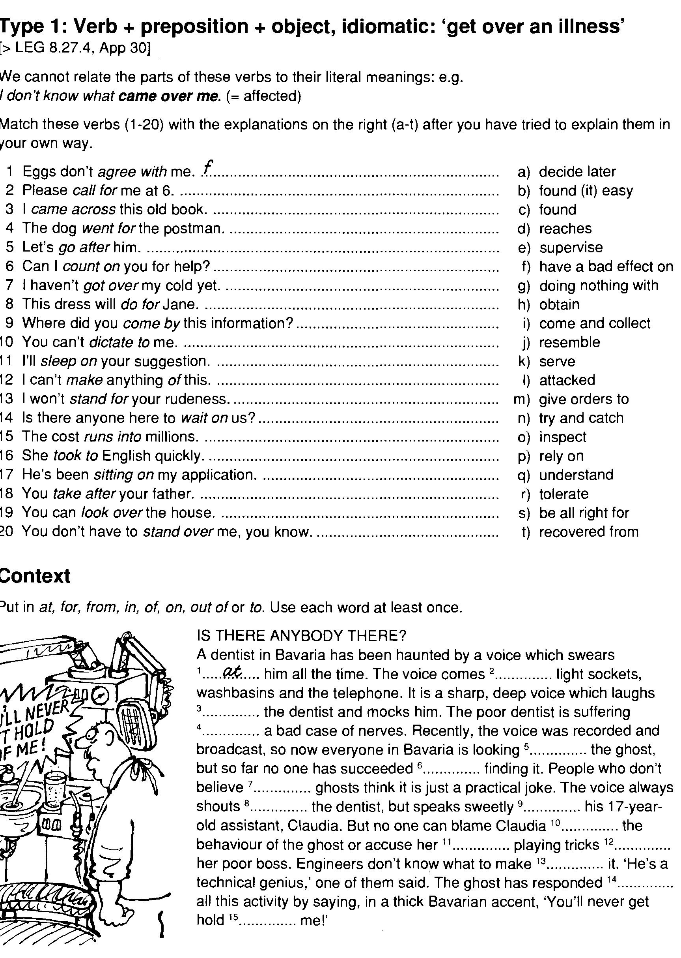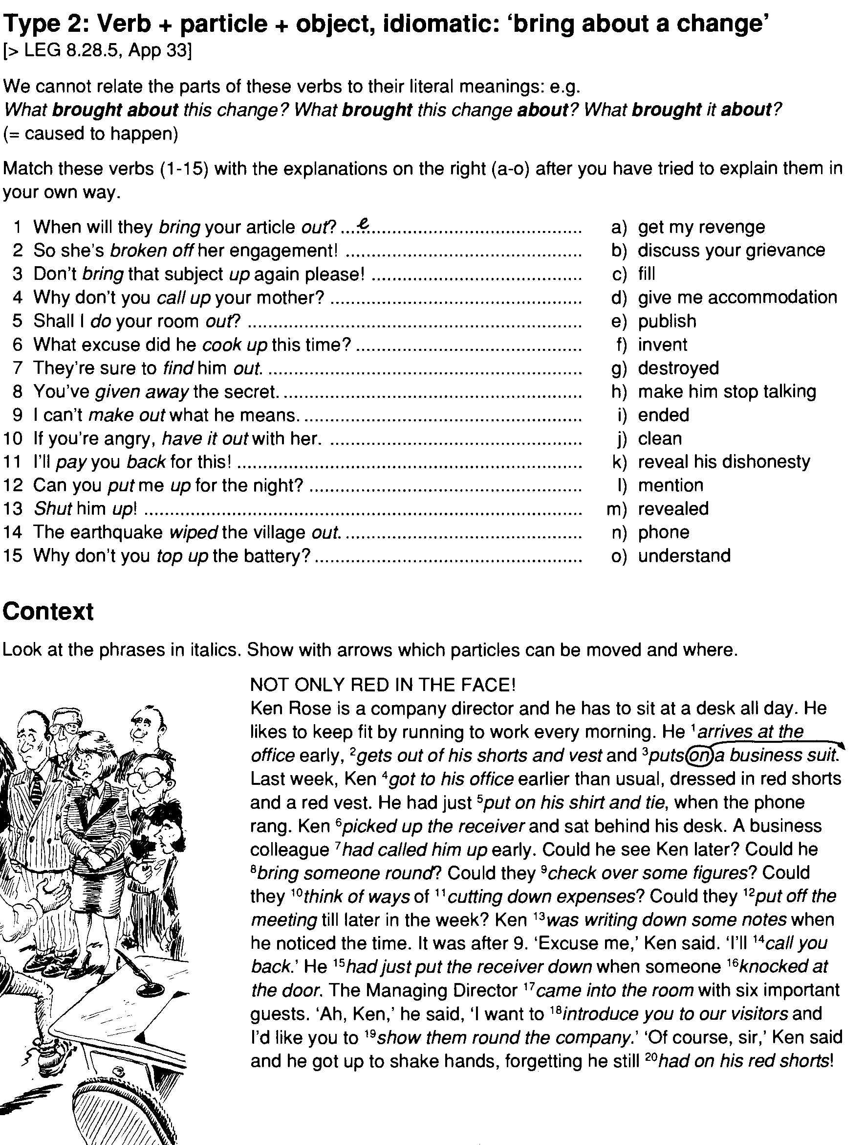

Lesson 25 Idioms and fixed expressions. M.: Pair work.
. Look at sentences 1-10 and decide if the explanation which follows each one is true or
false. Use the words and expressions in bold to help you decide.
1. During the exam, a pencil and eraser are required.
The people organising the exam will provide you with a pencil and an eraser.
2. Parents can be made liable for their children's debts.
Parents may be legally responsible for the money their children owe.
3. He was obliged to pay back the money that he had won.
He had the choice whether or not to pay back the money that he had won.
4. Students doing holiday jobs are exempt from paying income tax.
Students doing holiday jobs pay a smaller amount of income tax than other people.
5. The United Nations voted to impose mandatory sanctions on the country.
The United Nations imposed legally-binding sanctions which had to be obeyed by everyone, without
exception.
6. The doctors forced him to stop smoking.
The doctors asked him to stop smoking,
7. It was an emergency and she pressed the red button; there was no alternative.
There was nothing else she could do; she had to set off the alarm by pressing the red button.
8. Classes on Wednesday afternoons are optional.
It is necessary to attend classes on Wednesday afternoons.
9. It is compulsory to wear a crash helmet on a motorcycle.
It is your choice whether or not to wear a crash helmet when you ride a motorcycle.
10. The museum is asking visitors for a voluntary donation of £2.
You don't need to pay £2 to visit the museum.
B. Complete these sentences with an appropriate word or expression from the exercise
above. In some cases, more than one answer may be possible.
1. Visitors to the country are to declare any excess tobacco or alcohol
imports to the customs officer.
2. I'm afraid I have but to resign from the committee.
3. If you are caught speeding, you will be the payment of the fine.
4. Attendance at all classes is __ , otherwise you may not get a certificate at the
end of the course.
5. Many retired people do work in their local community.
6. In some countries, there is a death sentence for all drug traffickers.
7. For visitors to Britain from outside the European Union, a visa may be .
8. He said he was innocent, but the police . him to confess.
9. Most new cars come with air-conditioning.
10. Children's clothes are . __from VAT.
Complete these sentences with an appropriate word or expression from A, B or C.
FAILURE
1. The People's Foundation Party decided to its plans to establish a coalition government
with the Democratic Liberal Party.
A, abate B. abandon C abhor
2. Peace talks between the two countries , with neither side able to agree on terms.
A. collapsed B. collaborated C collared
3. Progress in the talks when the inevitable impasse was reached.
A. faulted B. faltered C fondled
4. Our planned visit to the Czech Republic because we were unable to get the visas.
A. fell over B. fell down C. fell through
5. The company with debts of over £1 million.
A. faulted B. folded C foiled
6. Their plans to impose stricter import quotas when the European Bank declared their
actions illegal.
A. mistook B. mislead C misfired

Lesson 26 Make, do, have, take, give, keep, break, catch, see. M: Brainstorming.
In many of these usages the verbs are "light verbs" that lend relatively little semantic content. Other light verbs include: give, pay, put, raise, offer.
For people who are learning English, or even who speak it moderately well, these four verbs present difficulties when it comes to many collocations. For example, what about the shopping? Is it do the shopping, or make the shopping? How about photograph (see picture)? Do a photograph or make a photograph? Neither! You should take a photograph... and so on. This appendix is an attempt to clear up some of the most common doubts and errors.
This is not a definitive list. The intention is orientative. All the following nouns and expressions can, of course, take other verbs. The four options do, make, take, have are in the sense of doing the activity. Have, for instance, normally indicates possession, but that is not the sense of the verb as used in each of the collocations listed in this table. To have a bath, for example, does NOT normally mean to possess a bath. In each case, the idea of the verb is to do the activity.
Readers of this appendix are strongly recommended to read the main entry for the noun or expression to check for correct usage and meaning.
Contributors are encouraged to place Usage notes into this appendix similarly, and also into the collocate's main entry, such as:
- We normally do the shopping.
- We normally make or take a (tele)phone call.
make | take | have | notes
 |  | take action |  | To take action means to act positively and decisively to resolve a problem. (light)
 |  | take advantage, take advantage of | have an advantage | To take advantage of something or someone means to profit from the momentary situation of the person or thing. To have an advantage means to be in a better position than someone else.
 | make amends |  |  | To make amends means to compensate for a loss or injury.
 | make an application | take an application |  | To make an application means to apply for something. Usually a job, or a bank account, etc. (light). To take an application from someone means to allow someone to apply to you or to a party whom you are representing.
 | make an appointment |  | have an appointment | To make an appointment means to organise a meeting with other people. To have an appointment means you are to participate in a meeting with other people.
 | make an argument |  | have an argument | To have an argument with someone means to argue with that person. (light) To make an argument for something means to present a logical argument in its favor.
 | make arrangements |  |  | To make arrangements means to organise or arrange. (light)
 | make an attempt |  |  | To make an attempt means to try, to attempt. (light)

B
do | make | take | have | notes
 | make a baby |  | have a baby | To make a baby is, informally, to engage in sexual intercourse, leading to impregnation. To have a baby is to give birth, to produce a child.
 | make a bath | take a bath | have a bath | To take or have a bath is to bathe oneself. (light) To make a bath is to prepare a bath to the right temperature.
 | make the bed, make one's bed |  |  | To make the or one's bed is to arrange its sheets and covers nicely and rectify any disorder that was caused by sleeping in it.
do one's best, best | make the best of |  | have the best | If you do your best, it means you have acted correctly and that no-one can expect more from you. To make the best of a situation means to take as much advantage as possible from a bad situation. See take advantage. To have the best is to be in possession of the best of something.
 | make a bid | take bids |  | To make a bid means to bid, to make a monetary or economic offer. (light) To take bids is to solicit offers from several competitors, with the intention of accepting the best bid.
 |  | take a bite | have a bite | To take a bite means to bite. (light) To take a bite and to have a bite both mean to eat a quick, light snack.
 | make a bow | take a bow |  | To make a bow means to bow. (light) To take a bow means to bow (light) or to accept applause. See take a bow.
 | make a break | take a break | have a break | To make a break means to try to escape, to break. (light) To take and have a break means to rest from work for a short while, to break. (light) To have a break (more often get a break) also means to be lucky.
 | make a breakthrough |  | have a breakthrough | To make a breakthrough means to make an important discovery. To have a breakthrough means to realize something about oneself.
do business | make business | take business | have business | To do business means to agree a commercial contract. To have business with someone means to have matters to be settled with that person. To take business is to deprive a competitor of a customer by acquiring that customer. To make business is to create a business opportunity

C
do | make | take | have | notes
 | make a cancellation |  | have a cancellation | To make a cancellation means to contact the person you have an appointment with and to be the person who cancels it.  To have a cancellation means that a person who had an appointment with you told you they would not make the appointment, often with the implication that the time will then be available to someone else so they can be seen sooner than they would have been otherwise.
 |  | take care, take care of | have a care | To take care means to be careful. To take care of someone or something means to look after it. See also take care.  To have a care means to be careful because you are upsetting someone.
 | make certain |  |  | To make certain of something means to check that something is correct. See also make sure.
 |  | take a chance, take chances | have a chance | To take a chance means to try something risky. See take a chance. To have a chance means to have some possibility of success.
 | make a charge | take charge |  | To make a charge for something means to request money for an item or service; it can also mean to make an accusation. To take charge of something is to assume authority over it.
 | make a claim | take a claim | have a claim | To make a claim is usually applied to legal court cases where damages and retribution payments are claimed from the accused. To take a claim is to have someone submit a claim to you. To have a claim to or on something is to be entitled or potentially entitled to it.
 |  | take a class | have a class, have class | One takes a class for a semester or year or the like; to have (a) class refers to a single class session. (Note that to have class can also mean "to be classy, sophisticated".)
 | make a complaint | take a complaint |  | To make a complaint means to complain about bad service or faulty goods (light). To take a complaint means to have someone submit a complaint to you.
 | make a concession |  |  | To make a concession means to concede, to yield to, or grant a request even though it is not in agreement with the normal rules. (light)
 | make contact (with) |  |  | To make contact with someone means to establish communication with them or contact them. (light)
 | make conversation |  | have a conversation | To make conversation means to start a conversation with someone with no other aim than to talk and break the silence. To have a conversation means to converse. (light)

D
do | make | take | have | notes
do a deal | make a deal |  |  | To do (UK) or make (both US and UK) a deal means to make a contract with someone.
 | make a decision | take a decision |  | To make or take a decision is to decide. (light)  Make is about 50 times more common in the US; 7 times in the UK.
 | make demands on |  |  | To make demands on someone means to give them a lot of work to do or to impose a burden on them.
 | make a difference
 | make a discovery |  |  | To make a discovery is to discover something. (light)
do the dishes |  |  |  | To do the dishes is to wash dirty dishes, cutlery and so on by hand.
 |  | take a dump |  | To take a dump is to defecate (vulgar slang).

E
do | make | take | have | notes
 | make an effort | take (a lot of) effort |  | To make or put forth an effort is to try. An activity takes a lot of effort when it is very difficult to do, or is strenuous.
 | make an enquiry |  |  | To make an enquiry means to ask or inquire. (light)
 | make an error |  |  | To make or commit an error is to err. (light)
 |  | take an exam | have an exam | When students take, complete, sit for (UK), or sit (UK) an exam, test, or quiz, they are tested to demonstrate knowledge or competency; educators (UK) set or (US) write it (create it for students to take) and then (US) give it (have the students complete it). To have an exam is to be given it.
 | make an example of |  |  | To make an example of someone is to punish someone to disuade others from repeating the offense. See make an example of
 | make an exception (for) | take exception, take exception to |  | To make an exception is to grant a request even though it is not in agreement with the normal rules. To make an exception for is to except. (light) See also make a concession. To take exception to something means to be offended by something, usually something that is said. See also take exception.
 | make an excuse, make excuses |  | have an excuse | To make an excuse means to excuse, to justify or explain the reason for an incorrect action. (light) To have an excuse means to have a good reason for an incorrect action, whether it is stated or not.
do some exercise, do some exercises |  | take exercise |  | To take (some) exercise means to exercise the body. (light) Do needs a quantifier. To do some or an exercise means to exercise the body. To do an exercise can also mean to resolve a problem set in a class.
do an experiment | make an experiment |  |  | To experiment Generally, one does an experiment in a laboratory, and one makes an experiment when one tries out an idea to see if it works. (light)

F
do | make | take | have | notes
do a (UK) favour, (US) favor |  |  |  | To do a favour means to help someone with no thought of reward or payment.
 | make a fortune |  |  | To make a fortune means to amass wealth.
 | make a friend; make friends with |  |  | To make friends is to strike up or start a new friendship or become friends.
 | make fun of |  | have fun | To make fun of something or someone is to mock or belittle them. To have fun is to enjoy oneself.

G
do | make | take | have | notes
do (some) good | make good |  |  | To do good or do some good means to do something constructive or helpful. To make good has a number of meanings, including to put right.
 |  |  | have a grudge | To have a grudge is to maintain a negative feeling against someone or something because of a previous wrong against oneself by that someone or something.

H
do | make | take | have | notes
do (some) harm |  |  |  | To do harm or some harm means to harm, to do something destructive, or hurtful, or unhelpful. (light)
 | make headway |  |  | To make headway means to progress in the desired direction.
 | make a heart | take heart | have a heart, have heart | To make a heart is to create the shape of a heart. To take heart is to be cheered up. To have a heart is to be generous. To have heart is to be courageous or persistent.
 |  | take someone hostage |  | Means to keep, or retain a person or group of people until a specific demand is met.

I
do | make | take | have | notes
 | make an inquiry |  |  | To make an inquiry means to ask, to inquire. (light)
 | make an investment |  |  | To make an investment means to invest time or money. (light)

L
do | make | take | have | notes
 | make someone laugh |  | have a (good) laugh | To have a laugh is to laugh (light), or to enjoy laughing with friends. To make someone laugh is to do or say something that causes that person to laugh.
 |  | take the lead | have a/the lead | To take the lead /li:d/ means to be the leader, or to demonstrate the correct way to do something. Also to gain the lead position in a competition. (light) To have a lead means to have the lead position. (light)
 | make a list |  |  | To make a list means to write a list.
 |  | take a look | have a look | To take or have a look at something means to look at it (with purpose). (light)
 | make a loss | take a loss |  | To make or take a loss means to lose money on an investment or a bet.

M
do | make | take | have | notes
 | make a meal, make a meal of | take a meal | have a meal | To make a meal (breakfast, lunch, dinner, etc) means to prepare the food for that meal. To make a meal of means to spend more time and energy on some task than it warrants. To take a meal and to have a meal mean to eat the food. (Note: do lunch with someone or have a working lunch means to eat lunch with someone while working at the same time.)
 | make (a) mention of |  |  | To make (a) mention of something is to mention it, to say it or talk about it briefly. (light)
do the messages |  | take a message | have a message, have a message for s/o | To do the messages is to do the shopping, to buy groceries. To take a message is to write down or record a message given (e.g. by a telephone caller) for someone who is absent. To have a message for someone is to wish to convey a message to someone (or to be in possession of a message one is to give to someone on another person's behalf). To have a message means that a message taken in one's absence is awaiting one.
 | make a mistake |  |  | To make a mistake is to err.
 | make a mockery of |  |  | To make a mockery of something or someone is to mock or belittle them. (light)
 | make a model (of) |  |  | to make a model means to fabricate or build a model structure. To make a model of {something} means to model it, to build a model of it. (light)
 | make money |  |  | to make money means to gain monetary income.

N
do | make | take | have | notes
 |  | take a nap | have a nap | to take or have a nap means to nap, sleep for a short while. (light)
 | make a noise |  |  | To make a noise is the act of creating a sound that can be heard
 | make notes | take notes |  | To make or take notes is to write the notes, usually to record on paper what someone is saying.
 | make note (of) | take note (of) |  | To make note or to take note is to note or notice (something).
do a number, do a number on someone |  | take a number |  | To do a number is to perform an act, usually a song; to take a number is to take a position in a queue. To do a number on someone is to cheat or trick them.

O
do | make | take | have | notes
do an operation on someone | make an operation |  |  | To do an operation means to operate medically on someone. To make an operation means to conclude a business transaction.
 | make an opportunity | take an opportunity | have an opportunity | To take an opportunity means to the same as take advantage of a situation. To make an opportunity means to arrange things to your advantage. To have an opportunity means to be at the right place at the right time to do something advantageous.

P
do | make | take | have | notes
 |  |  | have a party | To have a party is to organise an informal event with friends, or to enjoy oneself.
 | make a (tele)phone call | take a (tele)phone call |  | To make a telephone call is to initiate a call to another person, to take a telephone call is to receive a call, to be called. To have a telephone call is to participate in a phone call, without reference to who made the phone call. In technical usage, initiating a call is referred to as placing a call.
 |  | take a picture |  | To take a picture means to capture an image using a photographic camera.
 | make a plan |  | have a plan | To make a plan is to develop an idea, to have a plan is possess, generally in one's mind, an idea that is ready.
 | make a point, make a point of doing s/t | take someone's point | have a point | To make a point means to state a logical argument. To have a point means to have a valid argument. To take someone's point means to accept or at least acknowledge someone's argument. To make a point of doing something means to be sure not to forget to do it, to do it consciously to ensure one does not forget.
 | make progress |  |  | To make progress is to advance.
 | make a promise to someone | take someone's promise |  | To make a promise to someone is to affirm, or vow, to do something without fail. To take someone's promise means to accept at their word that they will keep their promise and act accordingly.

R
do | make | take | have | notes
do research |  |  |  | To do research is to try to discover something new by doing experiments. Also it means to discover information by checking through factual books and magazines.
 |  | take a rest | have a rest | To take or have a rest is to rest, or to stop doing something.

S
do | make | take | have | notes
 | make sense (of) |  |  | To make sense means to communicate clearly and understandably. To make sense of something means to understand it. To have sense means to be sensible.
do the shopping |  |  |  | To do the shopping means to go to the local shops to buy household needs such as food, clothes, cleaning things, and so on.
 | make a stop |  |  | To make a stop means to take a break in the middle of a journey.
 |  |  | have store of | To have store of means to store something or to have something in storage.
 |  | take a shower | have a shower | To take or have a shower means to wash one's body under a shower to get clean.
 | make a suggestion | take someone's suggestion | have a suggestion | To make a suggestion means to present an idea to another person or group for their consideration. To take someone's suggestion means to accept the idea they have presented. To have a suggestion means to have an idea to present. In the past tense it can mean the same as made a suggestion.

T
do | make | take | have | notes
do a talk |  |  | have a talk | To have a talk with someone means to speak with them seriously. To do a talk means to give an oral presentation or lecture
 | make tea | take tea | have tea | To make tea (or coffee, etc) is to prepare the drink. To take tea and to have tea both mean to drink some tea (or coffee, etc), with taking tea suggesting a more formal event. To have tea with someone implies that it is a social meeting or break, accompanied by conversation. In the UK, to have (one's) tea can also mean to have the evening meal.
do a test |  | take a test | have a test | To do a test is the same as to do an experiment. For take and have, see the notes for exam.
do time | make time | take (one's) time | have time | To do time means to be a prisoner in prison. To make time for an activity means to arrange one's agenda so that there is enough time to do that activity. If something takes time it means it is not quick to do. To take one's time means to be slow and careful in doing something. If one has time it means one does not need to make time to do an activity.
 | make trouble | take trouble, take the trouble to | have trouble | To make trouble means to cause or provoke problems for other people, especially conflict or fighting. To take trouble means to be meticulous or careful in how one does an activity. To take the trouble to do something is to do something, especially generously for another person, that one did not necessarily have to do. To have trouble means to suffer from errors or problems.

W
do | make | take | have | notes
do the washing-up |  |  |  | To do the washing-up means to wash the dirty plates, dishes, cutlery, and so on after a meal.
do well |  |  |  | If you do well, it means you have acted correctly and the best you can, or that you are prospering. See also do one's best.
 | make a wish |  |  | If you make a wish, it means you express, often silently, a desire for some particular outcome.
 |  |  | have words / a word | To have a word or words with someone is to tell them off or to argue with them. To have a word with someone could be a gentle rebuke or request without hostility, but to have words means there is hostility and quarrelling. You can request Can I have a word with you? but not Can I have words with you?
do (some) work | make work |  | have work | If you do some work, you are working. You make work (for someone else, or for yourself) when the task is needless or your efforts are counterproductive. To have work is to be employed, or (also to have work to do) to have tasks that require completion.
do homework, housework etc. |  |  |  | Most derivations of work collocate with do.

General differences among English light verbs

make
In light-verb constructions "make" implies an active role by the subject, who causes something new to occur or come into existence from pre-existing material or a pre-existing situation or the normal course of events.

take
"Take" implies an active role by the subject, but no change in the object except for its ownership.

do
"Do" implies that the subject is active, but fitting into a pre-existing role. In addition do is often used when someone performs an action, activity or task.

have
"Have" implies a greater degree of passivity and no causation.

get
When used with a participle, it implies a change from a state without the action of the verb to a state with it. For the present participle that means starting to do the (intransitive, continuous) action of the verb. For the past participle that means receiving the action of the verb.
When used with an infinitive, it means that one is allowed to perform the action of the verb, or to assume the state of a stative verb.
When have is followed by got and an infinitive, it means that one must perform the action of the verb, or to assume the state of a stative verb. In other words, it's exactly equivalent to have and the infinitive. In informal, proscribed usage, the word have is left out in the present tense. In such cases, the only way to tell this from the past tense of the get-and-infinitive construction above is through the context.

Lesson 27 Get: uses and expressions. Go: uses and expressions. M: Individual work.
“Get” is a great word in English! It is used in so many different ways.

GET + Adjective

Get Married
We’re getting married next year – the wedding will be in August.

Get Divorced
Brenda got divorced ten years ago, and she hasn’t seen her ex-husband since!

Get Angry
My sister gets really angry when I borrow her clothes without telling her.

Get Tired
It’s late and I’m getting tired. Let’s go home.

Get Dark
The theater’s getting dark – I think the movie is starting!

Get Lost
Philip got lost in the NYC subway and had to ask for directions to Times Square.

GET + Comparative

Get Better
Larissa’s getting better at dancing. She practices every day.

Get Worse
If your headache gets worse, you should see a doctor.

Get More Expensive
It’s getting more and more expensive to buy an apartment in Rio de Janeiro.

Get Safer
Buying things online has gotten safer with tools like PayPal.

Get More Important
It’s getting more important to speak multiple languages in today’s globalized world.

Get Deeper
Be careful – the water gets deeper quickly on that side of the pool.

GET + Preposition (Phrasal Verbs)

Get Up
My alarm clock goes off at 6:30, but I don’t get up until 7:15.

Get Along With
I get along really well with my colleagues. They’re a pleasure to work with.

Get Into
How did the dog get into the house? He’s supposed to stay outside!

Get Out
Randall got out of the car to check the tires.

Get Around
It’s very easy to get around Berlin – there’s a great subway system.

Get Together
My family always gets together for major holidays like Christmas and New Year’s.

GET + A Place = Arrive

Get To The Office
My boss always gets to the office by 7:30 AM.

Get Home
I had to work overtime, so I didn’t get home until midnight.

Get To School
Sarah got to school late and missed her first class.

Get To The Train Station
When they got to the train station, they realized they’d left their tickets at home.

Get To The Store
Hurry up! I want to get to the store before it closes.

Get There
I don’t know exactly where the post office is. Could you tell me how to get there?

GET = Receive

Get An E-Mail
Did you get my e-mail?

Get A Present
I got lots of presents for my birthday this year.

Get Grades
If you get good grades in high school, you can get into a good college.

Get A Certification
I got my scuba diving certification last year.

Get An Award
Ted got an award for being the best salesperson in the company.

Get A Shipment
We got a large shipment of books today – what should I do with them?

GET = Buy / Obtain

Get A Job
Tanya moved to Los Angeles because she got a job there.

Get An Apartment
“Have you found a place to live?”
“Yeah, I just got a great apartment right in the city center!”

Get A Computer
I got this computer just last month, and it’s already broken.

Get A Jacket
That’s a really nice jacket! Where did you get it?

Get Shoes
I got these shoes in Barcelona.

Get [Something] For A Good Price
We got this TV for a good price during the spring sale.
Get and go have similar meanings, when talking about travel or motion. When we use get, we emphasise arrival:
We’ll phone you as soon as we get to Rome.
Not: We’ll phone you as soon as we go to Rome.
The thing is, he missed the bus and got to school late and missed part of the match.
Not: … and went to school late and …
We use get on and get off not go on and go off for buses, trains, planes:
When I got on the plane, there was someone sitting in my seat.
Not: When I went on the plane …
Liam will be waiting for me when I get off the train.
Not: … when I go off the train.
Warning:
Get up means ‘leave your bed in the morning’; go up means ‘go to a higher place or position’:
What time do we have to get up tomorrow?
Not: What time do we have to go up tomorrow?
Get and go are both used to mean ‘become’, but they combine with different adjectives. We often use get with words like dark, light and late; we use go with colours and words with negative associations such as mad, bald, bad:
It’s getting dark now so be careful.
Not: … going dark …
He’s only 30 and he’s going bald.
Not: … and he’s getting bald.
We left the milk in the sun too long and it’s gone bad.
Not: … and it’s got bad.
However, with some adjectives such as old, sick, tired and ill, we use get:
He got very tired walking to the match in such a large crowd.
Not: He went very tired walking …

Lesson 28 Analogies, excuses and thanks. M: Collage.
“Thanks for helping me tidy up.” | “It was really no trouble at all. I actually enjoy washing up. In fact, I'd happily do it every day.”
“Are you okay?” | “Much better, thanks for asking.”
“I was worried about you.” | “I'm fine, but thank you for your concern.”
“Thank you for coming all this way.” | “It really is no problem at all. It's nice to get out of the  office.”
“Thanks for your patience.” | “Thank you for all your efforts trying to get it sorted out.”
“Thank you for coming.” | “Thanks for inviting me.”
“I've photocopied last week's notes for you.” | “Thank you sooooo much, that's a great help.”
“I was going to help but they've given me another project.” | “Okay. Thanks anyway.”
“Thank you so much for your help while I was in hospital.” | “Don't be silly, it was the least I could do.”
“Here's your beer.” | “Ta. I'll get you one later.”
“Thanks for getting the milk and bread.” | “No worries, I go to the shops every Saturday anyway, so I can do it every weekend if you like. Perhaps you can do the same for me on a weekday sometime.”

“Thanks, I couldn't have done it without you. I'll buy dinner.” | “There's really no need, I was just happy to be of help.”
“I bought you something for your birthday.” | “Oh, you shouldn't have!”
“I'd also like to thank you, Sarah, for being such a great friend.” | “Stop it, you're embarrassing me!”
“Here are the keys to my car.” | “Thanks. I'll get them back to you by Friday.”
“I've found a copy of that CD you've been looking for.” | “No? Really? You're a star!”
“I had a great time. Thanks for inviting me.” | “I'm glad you enjoyed it.”
“Thank you so much for rescuing my cat from the tree.” | “No need to thank me, madam. Just doing my job.”
“Would you like to come for a drink later on?” | “Thanks for the invitation, but...”
“Here's your hammer back. Thanks for lending it to me.” | “Thanks for getting it back to me so quickly.”
“Thanks for having me.” | “It's been our pleasure. You must come and stay again  soon.”
“Thanks. That's just what I needed after that walk.” | “Would you like another?”
“There's no need to apologise, it could happen to anyone.” | “Thanks for your understanding.”
“Would you like me to carry that for you?” | “That would be a great help. Thanks.”
“Can I help you?” | “No thanks, I'm just looking.”
“Would you like a cup of tea?” | “Thanks for the offer, but I've just had one.”

B: Language brainstorming and analysis
From your own knowledge and the phrases you looked at before, discuss the questions below:
What are more informal ways of saying “Thank you”?
What are more formal ways of saying “Thank you”?
What words can you add to “Thank you” and its more formal and informal versions to make longer sentences?
Which examples of thanking on the previous worksheet use the structure Thanks +
Reason + Future action? Could you add that structure to any of the other examples on the last two pages?
What phrases are often used to reply to “Thank you”?
Which less generally used phrases above mean the same thing/ are used in the same way?
Which replies to thanks use the structure Fixed phrase + Reason why thanks not needed + Offer of future help and/or Ways of repayment? Could you add that to any of the other examples?
What thanking sentences can you use in phrases for starting and ending business phone calls and emails?
In which situations are these phrases used?
- Thanks anyway
- Thanks again
- Thanks for asking
- Thanks for your concern
- You're a star/ a hero/ a lifesaver
- You shouldn't have
- Thanks for your understanding
- Thanks for having me
- Thanks for the offer
- Thanks in advance

C: Roleplays
Roleplay some of the following situations with at least four lines per conversation, paying attention to how and how often you say thank you.
- Someone has helped you carry a heavy box.
- You've spent the weekend on someone's yacht.
- Someone has helped you write a report.
- An ex-colleague invites you to a restaurant and pays the bill
- You are receiving presents from a few friends, one at a time.
- Someone sent you a birthday message. This is the first time since then that you've spoken
- Buy two or three things in a newsagent's (e.g. cigarettes, a magazine and some chewing gum)
- Phone reception and ask to speak to someone. They are not there.
- You are leaving your host family to get a taxi to the airport to fly home.
- You are leaving the company today. Go round and talk to your colleagues.
- Politely refuse all your partner's offers of help
- Your partner helped you when you were sick and is now asking after your health

D: Common errors in thanking language
What is wrong with each of the lines below?
- Thanks for the lovely meal - Thanks for eating it x
- Thanks for carrying the box for me - It was my pleasure x
- Thanks for coming here to see me today - You're welcome x
- Thanks for coming here to see me today - Thanks for having me x
- Cheers very much x
- I managed to find you a vase to replace the one from your set that got broken - Sorry. That's so kind x
- I am very gratitude x
- Thank you a lot x
These phrases can only be used in very particular situations and are often used wrong by language learners? What are the correct situations?
- Thank you for your cooperation.
- Thank you for continuing to do business with us.
- Thank you for your kind attention.
What are the differences between these phrases?
- Thanks in advance/ Thanks for your cooperation
- Thanks in advance for.../ Thanks for...
- Thanks for your hospitality/ Thanks for having me
- Thanks for your recommendation/ Thanks for your recommendation, but.
- Thank you. That's so thoughtful./ Thank you. That's very kind
- Suggested answers
More informal ways of saying “Thank you”
Thanks/ Cheers/ Ta/ I owe you one/ You're a star/ You're a lifesaver

More formal ways of saying “Thank you”
I am very grateful for.../ I would like to express my gratitude for.../ Please accept my thanks for.

Words can you add to make longer sentences
Thank you so much/ Thank you very much/ I would like to thank you for../ Thank you for./ I really can't thank you enough for./ Thanks a lot/ Thanks for./ Thanks again/ Thanks anyway/ Cheers for./ You're an absolute star./ You're a real lifesaver./ You're a total hero.

Thanks + Reason + Future action
Thanks, I couldn't have done it without you. I'll buy dinner.

Typical replies
You're (very) welcome/ Not at all/ (It was) no problem. (Anytime)./ Don't mention it/ (It was) my pleasure/ No worries/ It was really no trouble (at all)./ No, no, no. Thank you/ It was the least I could do

Fixed phrase + Reason why thanks not needed + Offer of future help and/or Ways of repayment
No worries, I go to the shops every Saturday anyway, so I can do it every weekend if you like. Perhaps you can do the same for me on a weekday sometime.

Thanking phrases for starting and ending business phone calls
Thank you for calling./ Thanks for your call./ Thanks for getting back to me so quickly.

Thanking phrases for starting and ending business emails
Thank you for your email (yesterday)/ Thanks for making the time to meet me yesterday/ Thank you for your interest in our company/ Thanks again/ Thanks in advance

In which situations are these phrases used?
- Thanks anyway - When they can't help
- Thanks again - When you thanked them for the same thing earlier in the conversation/ email
- Thanks for asking - When refusing an invitation or when someone asks after your health
- Thanks for your concern - When someone asks about your health
- You're a star/ a hero/ a lifesaver - When someone really helps you
- You shouldn't have - When receiving gifts
- Thanks for your understanding - When they respond to your rejection
- Thanks for having me - After staying at someone's house (although others use it for hospitality more generally)
- Thanks for the offer - After turning down an offer of help or an invitation
- Thanks in advance - After asking someone to do something for you
Thanking errors
- Thanks for the lovely meal - Thanks for eating it x - Should be “I'm glad you enjoyed it”, although this is possible as a joke
- Thanks for carrying the box for me - It was my pleasure x - It can't be a pleasure to carry a box!
- Thanks for coming here to see me today - You're welcome x - You should also thank them
- Thanks for coming here to see me today - Thanks for having me x - Only used for hospitality, not business meetings
- Cheers very much x - Perhaps because it comes from the word for toasts, you can't added words to cheers to make it stronger
- I managed to find you a vase to replace the one from your set that got broken - Sorry. That's so kind x - Sorry never means thank you in English
- I am very gratitude x - Gratitude is a noun.
- Thank you a lot x - The levels of formality don't match. Should be “Thanks a lot” or “Thank you very/ so much”

What are the correct situations?
- Thank you for your cooperation. - After a polite command or explain rules
- Thank you for continuing to do business with us. - Only usually used after they have complained or in set letters
- Thank you for your kind attention. - Only usually used in sales letters, i.e. junk mail

What are the differences?
- Thanks in advance/ Thanks for your cooperation - The former is much more general and more common
- Thanks in advance for.../ Thanks for... - The latter is only used for things that have already happened
- Thanks for your hospitality/ Thanks for having me - The former is more general
- Thanks for your recommendation/ Thanks for your recommendation, but. - The latter is a rejection
- Thank you. That's so thoughtful./ Thank you. That's very kind - The latter is more general
Expression of apology

I’m very sorry that I’m late but the main road was blocked due to construction.
- I am sorry to interrupt you, but could you please repeat the last part one more time?
- Please send my apologies to the meeting, as I shan’t be able to attend.
- There’s really no excuse for my behavior last night. I hope that in time we can get back to where we used to be.
- I beg your pardon, I must’ve dialed the wrong number.
- I am very sorry for what I did. Please accept this small present as my way of making amends for all the trouble I’ve caused.
- Please forgive me for interrupting you, I didn’t realize you were busy with someone else.
- I know I shouldn’t have made those remarks about your work and I hope you now know how deeply I regret what I said. If it helps to put things right, please let me take back everything I said earlier.
Possible Apology Scenarios
- You are late for work.
- You cannot understand what someone else is saying to you
- You are writing to a colleague informing him/her that you cannot attend a meeting in the afternoon.
- You insulted a friend last night.
- You dial the wrong telephone number.
- You accidentally grab the wrong luggage bag.
- You came to the meeting with your boss, but he/she was busy with another person.
- You were wrong criticizing your colleague’s work.
Activity
The students will first have several types of apologies modeled for them, by the
teacher. Afterwards, the teacher will play the video (mentioned above) for students, and
the apologies used in the video should be brought to the students’ attention.
Then, students should review expressions of apology with the teacher, such as
“excuse,” “forgive,” or “apologize” (see Appendix One). Students should be made aware
that different apologies should be used when expressing an apology orally, or in writing.
At this point, students should be given the Apology Handout, and they should review
different apologies used in America, as well as several types of intensifiers.
Once this is done, the teacher should model some of the apologies with students
and indicate which intensifiers should be used with specific apologies to match the
appropriate situations. This should be done well before the second and third steps of
American apologies: acknowledgement of responsibility and an offer of repair. These two
areas can supplement the lesson on apologies.
After students are familiar with the many different types of apologies, and some of
the situations in which they should be appropriately used, the teacher should assign
groups. Students should be given specific scenarios (see Appendix Two for a list of
possible scenarios that match expressions of apology presented in Appendix One), in
which they are to assess the situation and offer an appropriate apology. Students should
be allowed to practice several scenarios, as well as several different types of apologies.
The teacher should also take into consideration some of the factors that may
affect how students would deliver an apology:
1. familiarity with the person being apologized to
2. the intensity of the act
3. the relative authority that each of the people have
4. relative ages
5. gender
6. the place where the exchange takes place
7. modality (orally vs. in writing). TESOL Resource Center – Resource Templates and Guidelines

Conclusion
Materials: bord, markers
Objective: the revision of the lesson
Procedure: teacher asks students to make the feedback on the lesson.(oral or written) and gives home task.

Glossary:
- Apology– a word or statement saying sorry for something that has been done wrong or that causes a problem
- Familiarity – a friendly informal manner
- Acknowledgement – an act of accepting that something exists or is true, or that something is there
- Search – an attempt to find something, especially by looking carefully for it

Lesson 29 Requests, invitations and suggestions. M: Group work.

Commands expressed by the imperative
A The second person imperative
1.This has the same form as the bare infinitive:
Hurry! Wait! Stop!
For the negative we put do not (don't) before the verb: Don't hurry!
2. The person addressed is very often not mentioned, but can be expressed by a noun placed at the end of the phrase:
Eat your dinner, boys. Be quiet, Tom.
(These nouns can be placed before the verb, but this is much less usual.
The pronoun you is rarely used unless the speaker wishes to be rude, or wishes to make a distinction, as in: You go on; I'll wait.)
3.do can be placed before the affirmative imperative:
Do hurry. Do be quiet.
(This do could be persuasive, but could also express irritation.)
В.The first person imperative Form let us (let's) + bare infinitive:
Let us stand together in this emergency. For the negative we normally put not before the infinitive:
Let us not be alarmed by rumours. But it is possible in colloquial English to put don't before let's:
Don't let's be alarmed by rumours.
By let us (let's) the speaker can urge his hearers to act in a certain way, or express a decision which they are expected to accept, or express a suggestion (see 289).
С. The third person imperative Form let him/her/it/them + bare infinitive (see also 322):
Let them go by train.
This is not a very common construction in modern English. It would be more usual to say:
They are to go/must go by train.
The negative imperative, let him/her/them + negative infinitive, is not used in modern English. Instead, we would use must not or is/are not to:
They must not/are not to go by air. .

-----------------------------------------------------------------------------------------------------------

Other ways of expressing commands
A.Subject + shall for third person commands (in written English)
shall can be used in very formal written regulations which will normally remain in force for some time. These are very often in the passive (see also 234):
The Chairman, Secretary, and Treasurer shall be elected annually.
(club regulations)
A record shall be kept of the number of students attending each class
(college regulations)
В.Subject + will, mainly for third person commands:
When the alarm rings passengers and crew will assemble at their boat
stations, (notice on board ship)
This is a formal, impersonal, peremptory type of command, implying that the person giving the order is quite certain that he will be obeyed. It is used chiefly in written instructions by people who have some authority, e.g. captains of ships, officers of the services, headmasters of schools, trainers of sports teams etc.:
The team will report to the gymnasium for weight-lifting training. Note that if we move the will and place it before the subject, we turn the command into a request. It is possible to use you will for spoken commands:
You will not mention this meeting to anyone. But it is more usual and more polite to use must:
You must not mention this meeting to anyone.
С.Commands are often expressed as obligations by must:
You must not smoke in the petrol store. Passengers must cross the line by the footbridge. Dogs must be kept on leads in this area.
D Instructions or orders can be conveyed by the be + infinitive construction:
You are to report for duty immediately.
The switchboard is to be manned at all times.
E Prohibitions may be expressed in written instructions by may not:
Candidates may not bring textbooks into the examination room.
--------------------------------------------------------------------------------------------------------------

Requests with can/could/may/might I/we
A can/could/may/might I/we + have + noun/pronoun
can is the most informal:
(a) 'Can I have a sweet?' said the little boy.
can I/we, when used by adults, sounds more confident than could
I/we.
could I/we is the most generally useful form:
(b) Could 1 have a cup of tea? Could I have two tickets, please?
may and might are more formal than could, but possible in both spoken and written English:
(c) May/Might I have a copy of the letter?
These requests are usually reported by ask (+ indirect object) + for + object:
The little boy asked (me) for a sweet.
He asked for a copy of the letter. But (c) above could also be reported:
He asked if he might have a copy of the letter.
B can/could/may/might I/we + verb
For the difference between them, see A above.
These could be requests for permission (see 131), but with certain
verbs, e.g. see, speak (to), talk (to), they can be ordinary requests:
May/Could I see Mr Jones? = I would like to see Mr Jones. This type of request is reported by ask to see/to speak to etc.:
/ asked to see Mr Jones.
Do not put a noun/pronoun after ask, as this would change the meaning (see 243 B).
In colloquial English ask for + name etc. would also be possible, especially when reporting a telephone conversation:
CALLER: Could I speak to the secretary, please? =
She asked for the secretary/to speak to the secretary.
С could/might I/we requests can be preceded by do you think/
I wonder(ed)/was wondering if. These prefixes make the requests more diffident:
/ wonder/was wondering if I could have tomorrow off?
Do you think I could speak to the secretary? Note the change from interrogative to affirmative verb (see 104).

-----------------------------------------------------------------------------------------------------------

Requests with could/will/would you etc. For starred forms,
A.`could you` is a very useful request form:
Could you please show me the way?
possibly can be added to show that the speaker is asking for something extra:
Could you possibly lend me £500?
couldn't expresses the speaker's hopes for a more favourable answer than has just been indicated:
I can't wait. ~ Couldn't you wait five minutes? you couldn't . . . could you? can be used to express a not very hopeful request:
You couldn't wait five minutes, could you?
You couldn't give me a hand with this, could you? (The speaker doesn't really expect a favourable answer in either case.)
В.will/would you* (please):
Will/Would you please count your change? would you (please) has the same meaning as could you.
will you is more authoritative and therefore less polite. will/would you can be placed at the end of the phrase:
Shut the door, will you?
But this form can only be used in very friendly relaxed situations. Used otherwise, it would sound very rude. will/would can also be used for third person requests:
Would Mrs Jones, passenger to Leeds, please come to the Enquiry
Desk?
Will anyone who saw the accident please phone this number . . . ?
(police announcement)
С.you'll . . . won't you? is a persuasive type of request used mainly among friends:
You'll write to me, won't you?
D.would you mind* + gerund (see 263): Would you mind moving your car?
E.perhaps you would implies confidence that the other person will perform this service.
It would not be used at the beginning of a conversation or letter, but would be possible later on:
Perhaps you would let me know when your new stock arrives =
Please let me know when your new stock arrives.
F if you would is a useful request form. It is used in spoken English for routine-type requests which the speaker is quite sure will be obeyed: If you'd fill up this form/take a seat/wait a few minutes, (in an office) If you 'd sign the register/follow the porter, (in a hotel) just can be added to show that the action required is very easy:
If you 'd just put your address on the back of the cheque, (in a shop)
G.would you like to . . . ? is also a possible request form:
Would you like to take a seat? = Please take a seat.
H.I should/would be very grateful if you would is a formal request form found chiefly in letters but possible in speech:
/ should be very grateful if you would let me know if you have any vacancies.
I Would you be good/kind enough to keep me informed? Would you be so kind as to keep me informed?
] I wish you would can be a request form. It sometimes implies that the other person should be helping or have offered to do it (see 301): / wish you 'd give me a hand.
К Starred would and could forms may be introduced by phrases such as do you think? I wonder(ed) if, I was wondering if (see 104): Do you think you could lend me £500?

Requests with might
A. you might can express a very casual request:
You might post these for me. But it can only be used in friendly relaxed situations, otherwise it would
sound rude.
В. With a certain intonation and a strong stress on the important word
might can express a reproachful request:
You might \help me with
stress on help might imply 'Why aren't you helping me?/You should be
helping me'.
С.might can also be used with other persons to express this sort of
irritation:
He might \pay us! with stress on pay could mean 'We are
annoyed that he doesn't pay/hasn't paid us'.
D. might + perfect infinitive can express irritation at or reproach for the
non-performance of an action in the past:
You might have 4old us with
stress on told could mean 'You should have told us'.

----------------------------------------------------------------------------------------------------------

Invitations
A. will you have/would you like + noun:
Will you have a drink? (sometimes shortened to Have a drink.) Would you like a coffee? Note that do you want is not an invitation. (For want and would like, see 296.) In indirect speech we use offer + indirect object (= person addressed)+ noun:
She offered me a drink/a coffee.
В.will/would/could you? would you like to?
Will you have lunch with me tomorrow? is informal, but Would/Could you have lunch with me? or Would you like to have lunch with me? can be used in both informal and formal situations.
These invitations would be reported by invite/ask + direct object + to + noun, or invite/ask + direct object + infinitive: He invited me to lunch/to have lunch with him.
С. Answers to invitations
Offers of a drink/a cigarette etc. are usually answered:
Yes, please or No, thank you. Invitations with would you/could you/would you like are usually
answered:
I'd like to very much/I'd love to or
I'd like to very much but I'm afraid I can't. wouldn't like, of course, would not be possible. An invitation and answer might be reported:
He invited us to dinner/to a party/to spend the weekend with him and
we accepted/but we refused/but we had to refuse because . . .
D.When the speaker doesn't really expect his offer/invitation to be accepted he can say:
You wouldn't like another drink, would you? (Perhaps the speaker would like another drink himself, and wants an excuse. He doesn't really expect that his friend will accept, though.) You wouldn't like to come with me, would you? (Again he doesn't really expect an acceptance.)
---------------------------------------------------------------------------------------------------------------

Advice forms
A. must, ought to and should can be used for advice:
You must read this book. It's marvellous.
You should grow your own vegetables.
You ought to plant some trees.
In indirect speech must, ought to and should here can remain unchanged or be reported by advise + object:
He advised me to plant trees.
В.you had better + bare infinitive (see 120): You 'd better take off your wet shoes. You 'd better not wait any longer. had better can be used with the third person: He 'd better stop taking those pills.
С.if I were you I should/would:
If I were you I'd buy a car.
This is often shortened to I should/would with a slight stress on the I:
I'd buy a car.
In indirect speech If I were you I should/would ... is reported by advise + object:
He advised me to buy a car.
D.I advise/would advise you + infinitive:
/ (would) advise you to apply at once or I advise/would advise + gerund: I('d) advise applying at once.
E.why don't you . . . ? can be either advice or suggestion:
Why don't you learn to play your guitar? Why don't you take a holiday?
When this is advice it is reported by advise + object: He advised me to take a holiday.
F.it is time you + past tense:
It is time you bought a new coat. (See 293.) This would be reported:
He said it was time I bought a new coat.
Advice with may/might as well + infinitive
This construction can express very unemphatic advice:
You may/might as well ask him =
It would do no harm to ask him.
She said I might as well ask him. This form can be used with the third person:
He may as well come with me and the speaker may use it of himself:
As there isn 't anything more to do, I may as well go home early.

Suggestions
A First person suggestions with let's or shall I/we
let's + infinitive:
Let's paint it ourselves. shall we is sometimes added:
Let's get the paint today, shall we? shall I/we + infinitive:
Shall we invite Bill?
Suggestions with let's or shall we can be answered affirmatively by yes, let's, let's not could be used jokingly as a negative answer:
Let's take the tent. ~ Let's not! Or it can introduce a negative suggestion:
Let's not start too early. don't let's could also be used here:
Don't let's start too early.
В First and second person suggestions
why don't we/you + infinitive or why not + infinitive/expression of time or place:
Why don't we meet and discuss it?
Why not meet and discuss it?
Where shall we meet? ~ Why not here?/Why not at the hotel? In colloquial English what's wrong with/what's the matter with + noun could also be used:
What's wrong with the hotel? what/how about + gerund/noun:
Where shall we sleep? ~ What about renting a caravan?
What about a bed and breakfast place? suppose I/we/you + present or past tense:
Suppose you offer/offered to pay him?
С First, second or third person suggestions with suggest or propose
suggest (+ possessive adjective) + gerund, or suggest that + subject + present tense/should.
propose is used in exactly the same way but is slightly more formal than suggest.
In the active, suggest + should + infinitive is more formal than suggest + a present or past tense.
/ suggest (your) selling it.
We suggest that you should sell it. (formal)
/ propose that the secretary sends in/should send in a report, (formal)
I propose that a report (should) be sent in. (formal) that . . . should is necessary in the passive. With should be it is possible in formal English to omit the should, leaving the be alone, as shown above.
D Suggestions in indirect speech Suggestions can be reported by:
suggest/suggested (+ possessive adjective) + gerund, or suggest that + subject + present tense/should, or suggested that + subject + past tense/should, or suggest (any tense) + noun/pronoun:
Tom suggests/suggested (our) having a meeting.
Ann suggests that he sells/should sell his house.
Ann suggested that he sold/should sell it.
Mr Jones suggested a meeting. (For suggestions with let's, see also 322.)

Lesson 30 Opinions, agreeing and disagreeing. M: Brainstorming.

Expressions for Agreeing and Disagreeing
This page is about words and phrases that we use when we agree or disagree with someone in English.

Stating an opinion
- In my opinion...
- The way I see it...
- If you want my honest opinion....
- According to Lisa...
- As far as I'm concerned...
- If you ask me...

Asking for an opinon
- What's your idea?
- What are your thoughts on all of this?
- How do you feel about that?
- Do you have anything to say about this?
- What do you think?
- Do you agree?
- Wouldn't you say?

Expressing agreement
- I agree with you 100 percent.
- I couldn't agree with you more.
- That's so true.
- That's for sure.
- (slang) Tell me about it!
- You're absolutely right.
- Absolutely.
- That's exactly how I feel.
- Exactly.
- I'm afraid I agree with James.
- I have to side with Dad on this one.
- No doubt about it.
- (agree with negative statement) Me neither.
- (weak) I suppose so./I guess so.
- You have a point there.
- I was just going to say that.

Expressing disagreement
- I don't think so.
- (strong) No way.
- I'm afraid I disagree.
- (strong) I totally disagree.
- I beg to differ.
- (strong) I'd say the exact opposite.
- Not necessarily.
- That's not always true.
- That's not always the case.
- No, I'm not so sure about that.

Interruptions
- Can I add something here?
- Is it okay if I jump in for a second?
- If I might add something...
- Can I throw my two cents in?
- Sorry to interrupt, but...
- (after accidentally interrupting someone) Sorry, go ahead. OR Sorry, you were saying...
- (after being interrupted) You didn't let me finish.

Settling an argument
- Let's just move on, shall we?
- Let's drop it.
- I think we're going to have to agree to disagree.
- (sarcastic) Whatever you say./If you say so.
This page lists suggested subjects that can be discussed to practise agreeing and disagreeing in English.

Here are 20 topics to discuss with a friend or group. Practise agreeing and disagreeing even if you have to argue against something you actually believe in. One way to have fun with this is to make up a bunch of cards that say agree or disagree. Each person has to pick up a card and then the topic is read out. It is more fun to have a debate this way because you don't have to play your true self. Try to continue each discussion for at least five minutes. Use the expressions that you learned, including agreeing, disagreeing, asking for opinions, interrupting, etc.

Breakfast is the most important meal of the day.
Swimming in the ocean is better than swimming in a public pool.
Alcohol should be illegal.
Children should provide room and board for their aging parents.
Studying grammar is more important than practising conversation skills.
Television is the leading cause of violence in today's society.
Dogs make better companions than cats.
Smoking should be permitted in public places.
Females are better students than males.
A parent shouldn't pierce a baby's ears.
Women should be allowed to go topless in public.
Lawyers should make a higher salary than nurses.
Everyone should plan their own funeral.
Reading English is more difficult than writing English.
Summer is the best season of the year.
Children under 13 should not be allowed to babysit.
High school students should wear uniforms.
21 should be the legal driving age around the world.
Rock and Roll is the best kind of music.
The government should pay for post secondary education.

Agreeing and Disagreeing Quiz
You can do this quiz online or print it on paper. It tests what you learned on our Agreeing and Disagreeing in English pages.

1. If you're agreeing with someone, it means you have _______ views on the topic you're discussing.
correct
different
the same
2. Which is best for listening to people agreeing and disagreeing?
a news report
a history lecture
a political debate
3. Which expression shows you strongly agree with what someone's just said?
That's for sure.
I'm not so sure.
Well, I suppose so.
4. Which expresses weak or unsure agreement on something?
No doubt about it.
I doubt it.
I guess so.
5. Which expression makes it clear that you're sharing an opinion, not stating a fact?
As far as I'm concerned...
As far as I can tell...
As far as I know...
6. If you say "I couldn't agree with you more", it means you
totally agree
no longer agree
totally disagree
7. Which expresses the strongest disagreement?
I'm not so sure about that.
Not necessarily.
No way.
8. If someone says "Exactly!" after you've shared an opinion, it means they _______ with you.
strongly disagree
strongly agree
might agree
9. What can you say if someone interrupts you before you've finished making your point?
You didn't let me finish.
You didn't finish me.
Sorry, go ahead.
10. What can you say to settle an argument or end a discussion that's getting too heated?
I beg to differ.
Can I throw my two cents in?
Let's just agree to disagree.

Lesson 31 Verb –ing form, infinitive. M.: Pair work.

The Infinitive
The infinitive is a verbal form (a non-finite verb form) which consists of the base form of the verb with the particle "to": to do; to go; to play; to take; to break; to find.
The English infinitive and the Russian non-finite verb form have similar features. At the same time, the infinitive in English has a number of peculiarities which make using the infinitive difficult for language learners.
Note: Linguistic terms related to verbs are explained in Verbs Glossary of Terms in the section Grammar.

Properties and functions of the infinitive
The infinitive has some properties of the verb. The infinitive names an action (to drive a car) or state (to be sick), but cannot show person, number, or mood. The infinitive has active and passive forms (to take; to be taken) and can express voice and time, though in a rather limited way.
The infinitive can have a direct object (He plans to visit a museum) or a prepositional object (He wants to know about it) and can be modified by an adverb (He tried to walk slowly).
The infinitive can be part of the compound verbal predicate (She can drive; We must go) or part of the compound nominal predicate (His aim is to help you). The infinitive alone, without another verb, is generally not used as the predicate.
The infinitive has some properties of the noun and can be in the function of the subject (To quit now would be a mistake) or of an object (He likes to sing; She asked me to wait). The infinitive can be in the function of an attribute (He has no desire to see them).
The infinitive can function as an adverbial modifier of purpose (He came here to study) or as an adverbial modifier of consequence (He was too tired to go to the cinema).

Use of particle "to"
As a rule, the infinitive is preceded by the particle "to".
The particle "to" is omitted after modal verbs (You can go; You must take it), after the verbs "make, let" (Make him eat; Let her play), after the verb "help" in American English (Help me find my book), and in constructions like "She saw him leave; He heard her sing". The infinitive without the particle "to" is called bare infinitive.
If the verbs "make, help, see, hear" in such constructions are used in the passive voice, the infinitive after them keeps the particle "to": He was made to leave. She was helped to do it. He was seen to enter that building. He was heard to laugh.
If there are two infinitives next to each other connected by "and, or, but, except, than", the second infinitive is often used without "to": I told him to sit down and rest. She didn't know whether to go or stay. There was nothing to do but wait. There is nothing for him to do but watch TV. It's easier to type than write.
But it is often necessary to repeat "to" before the second infinitive for clarity, especially in longer infinitive phrases: I told him to sit down on the sofa and to rest a little. It is easier to type this text than to write it. To buy or not to buy is a hard choice for her.
The particle "to" is often used without the infinitive at the end of the sentence if the infinitive is clearly mentioned earlier in the sentence: He asks me to do this work, but I don't want to. I didn't want to go there, but I had to. He would prefer to sleep till noon if he were allowed to.
(The place of the particle "to" is also described in the part "Split infinitive" at the end of this article.)

How infinitives express time
The finite verb forms express the time of the action in the present, past, or future. For example: He works in a bank. He worked yesterday. He will work tomorrow.
The infinitive can express time only relatively, i.e., in relation to the action expressed by the verb in the predicate.
The action indicated by the infinitive can be simultaneous with the action expressed by the verb in the predicate: He seemed to be sleeping. He is trying to work.
The action indicated by the infinitive can precede the action expressed by the verb in the predicate: The rain seems to have stopped. It is nice to have talked to you.
The action of the infinitive later than the action of the verb in the predicate is understood from the context and meaning: He intends to do it tomorrow. The goods are to be delivered next week.

Forms of the infinitive
The infinitive has the following active and passive forms: simple (to write), continuous (to be writing), perfect (to have written), perfect continuous (to have been writing), simple passive (to be written), perfect passive (to have been written). The examples below illustrate the use of the infinitive forms in sentences.
I asked him to write a report.
He is supposed to be writing a report now.
He appears to have written a report already.
He seems to have been writing a report for two hours already.
I expect his report to be written tomorrow.
I expect his report to have been written by now.
Simple active and passive forms are the most common. Compound (analytical) forms of the infinitive are not used very often in general speech and writing.
More examples with perfect and passive forms:
He is said to have sold all his houses.
She was sorry to have said it.
He is known to have been working in this field for many years.
He wants to be informed about any problems immediately.
He asked to be informed of their arrival.
She is lucky to have been given such an opportunity.

Note: Modal verbs
All of the infinitive forms are used with modal verbs in order to express certain meanings of modal verbs. For example:
He can write reports.
He must be writing a report now.
He should have written a report yesterday.
This report might have been written by one of our freelance workers.
Read about the forms of the infinitive with modal verbs in Modal Verbs Introduction and see examples with the forms of the infinitive in Possibility and Strong Probability in the subsection Modal Verbs in the section Grammar.
Simple and compound infinitive forms, together with the verbs "would, could, might", are used in the forms expressing unreal condition. For example: If I had known it, I would have stayed home. (See Conditional Sentences in the section Grammar.)

Typical constructions with infinitives
Typical constructions in which the infinitive is used are described below, with examples of use. A shorter description of such constructions (in Russian) is given in the commentary to the song Phil Collins - Another Day in Paradise in the section Hobby.
Only the most common verbs after which the infinitive is used are included in the lists of verbs in this material. Note that the verbs after which the infinitive is used may be found in more than one construction. For example: I expect to arrive tomorrow. – I expect her to arrive tomorrow. – She is expected to arrive tomorrow.
Bear in mind that some of the verbs listed in this material may be followed by infinitives or gerunds. For example: He likes to read. – He likes reading. (Examples of the use of gerunds and infinitives after certain verbs are given in Infinitive or Gerund in the section Grammar.)

Verb + infinitive
In this construction the infinitive stands immediately after the verb, usually after the following verbs: afford, agree, appear, ask, beg, begin, continue, decide, deserve, expect, fail, forget, hate, hesitate, hope, intend, learn, like, love, manage, mean, need, offer, plan, prefer, prepare, pretend, promise, refuse, regret, remember, seem, start, threaten, try, want, would like.
The infinitive is an object after most of the verbs of this group. The infinitive after the linking verbs "appear, seem" is a complement, i.e. part of a compound nominal predicate. In some sources, the infinitive after "appear, seem" is regarded as part of a compound verbal predicate.
He hopes to see them soon.
His daughter is learning to drive.
I need to talk to him.
She forgot to lock the door.
He refused to help them.
I want to go home.
He appears to be tired.
She seems to like her job.
The continuous infinitive (emphasizing duration of the action) and the perfect infinitive (indicating the preceding action) are rather often used after the verbs "seem, appear, pretend".
He pretended to be reading.
The weather seems to be improving.
He seems to have lost weight.
He appears to have forgotten about it.
Note the use of the passive infinitive in those cases where the person indicated in the subject undergoes the action of the infinitive (i.e., that person does not perform the action himself / herself).
She doesn't like to be disturbed during her work.
I would like to be invited to the party.

Note: Particle NOT
Depending on the meaning of the sentence, NOT can be used with the verb in the predicate or with the infinitive.
He did not promise to do it.
He promised not to do it.
Don't even try to lie to me.
Try not to be late.
They decided not to go to the party.
More examples can be found in Negative Constructions (the part NOT and Verb + infinitive) in the section Miscellany.
Note: Gerunds
The verbs "begin, continue, forget, hate, like, love, prefer, regret, remember, start, try" are also used with a gerund, with or without a change of meaning. Compare: He began to eat. – He began eating. I remembered to lock the door. – I remember locking the door.

Verb + object + infinitive
The constructions Verb + object + infinitive are divided into four groups here according to the type of construction and the meaning that these constructions convey after certain verbs. The infinitive functions as an object in such constructions and stands after another object expressed by a noun or a pronoun.

Group 1
In this construction, the infinitive is used after the verbs "advise, allow, ask, beg, convince, encourage, forbid, force, help, hire, instruct, invite, let, make, order, permit, persuade, remind, teach, tell, urge, warn". Note that the infinitive is used without the particle "to" after the verbs "make, let" (and "help" in AmE).
The doctor advised him to rest for a few days.
He asked her to speak slowly.
She helped me to wash the windows.
It makes me think that he is lying.
She reminded him to buy cheese.
He taught me to drive.
She told me not to invite them.
Note: Gerunds
The verbs "advise, allow, forbid, permit" can be followed by a gerund directly. Compare: She doesn't permit me to use her computer. – She doesn't permit using her computer.

Group 2
In this construction, the infinitive is used after the verbs "want, would like, require, rely on, count on, expect, consider, find".
I want you to do something for me.
I count on you to do it quickly.
We expected Mike to be present at the meeting.
She found him to be a very nice person.
Note the use of the passive infinitive in those cases where the person indicated in the object undergoes the action of the infinitive (i.e., that person does not perform the action himself / herself).
She wants him to be elected.
I would like him to be invited to the party.

Group 3
In this construction, the infinitive without "to" is used after the verbs of sense perception "hear, see, watch, observe, notice, feel".
I saw him cross the street.
I watched him plant the roses.
I heard her cry.
The present participle is used instead of the infinitive in such constructions to stress that the action is in progress. For example: I saw him crossing the street. I heard her singing.

Group 4
This construction with the verbs "have" and "get" has causative meaning, i.e., "have" and "get" here generally mean "induce someone to do something; ensure that someone does something", with "have" close in meaning to "ask" and "get" close in meaning to "persuade". The infinitive is used without the particle "to" after "have", but with "to" after "get".
Have him send the letters.
I had my sister watch the baby while I was out.
Get your son to clean the carpet.
I got my brother to help me (to) repair my car.
The past participle is used after the verbs "have" and "get" in constructions like "I had my car washed" which indicate that the action is performed for you by someone.
See more examples at the end of The Verb HAVE in the section Grammar.
Note: Complex object
Constructions after the verbs in Groups 2, 3, 4 are often called "complex object" in Russian materials on English grammar. Complex object is described in Russian in the commentary to the song Joe Cocker - N'Oubliez Jamais in the section Hobby.

Infinitives after passive verb forms
Many verbs can be used in the passive voice with the infinitive in the function of an object after them.
The infinitive is used after the passive forms of the verbs "allow, permit, ask, tell, order, force, advise, warn, encourage". Compare active and passive constructions:
She allowed us to go there. – We were allowed to go there.
They warned me not to do it. – I was warned not to do it.
He advised her to find a good lawyer. – She was advised to find a good lawyer.
The infinitive is used after the passive forms of the verbs "say, report, expect, suppose, allege, believe, know".
Prices are expected to rise even higher.
He was expected to visit them.
She was supposed to arrive at 10 a.m.
You are not supposed to be here.
He is said to be 125 years old.
He is believed to be the oldest person in the country.
Such constructions containing simple, continuous, perfect, or passive forms of the infinitive are often used in news reports. For example:
The committee is expected to approve this initiative.
The commission is reported to be conducting an investigation of the incident.
He is alleged to have stolen more than ten million dollars.
Several people are reported to have been injured in the fire.
More examples can be found at the end of Passive Voice in the section Grammar.

Infinitive after linking verb BE
The infinitive after the linking verb BE is part of the compound nominal predicate.
His aim was to help them.
Your duty is to study.
Your task is to do these exercises.
His assistant's main task is to gather information for research.
His sole desire is to be accepted in their circle.

Infinitives after "how, what, where"
The infinitive as an object is often used after "how, what, who, whom, which, when, where, whether", usually after the verbs "know, ask, tell, advise, explain, show, decide, wonder, understand".
I don't know what to say.
I don't know who to ask.
Show me how to do it.
I haven't decided yet whether to go there or not.
The tour guide told us where to find interesting souvenirs.

Infinitives after adjectives
The infinitive as an object is used after many adjectives and participles, for example, after "able, afraid, amused, anxious, ashamed, astonished, careful, delighted, determined, disappointed, eager, free, frightened, glad, grateful, happy, interested, lucky, pleased, prepared, proud, ready, relieved, reluctant, sad, shocked, sorry, surprised, terrified, willing".
This construction is often used to describe people's feelings in relation to the action expressed by the infinitive.
She is afraid to go there alone.
We are ready to start.
You were lucky to find that book.
She was reluctant to go.
He is eager to be invited to the show.
The infinitives "to hear, to see, to learn, to discover, to find" are often used after the adjectives "glad, happy, delighted, disappointed, surprised, sorry".
She was glad to hear that.
He was happy to see her.
I was sorry to hear about their divorce.
I was surprised to learn that she had quit her job.

Infinitives as attributes
The infinitive as an attribute always stands after the noun (or indefinite pronoun) that it modifies. For example:
Can you give me a book to read?
I have a lot of work to do today.
Give him something to eat.
He has nowhere to go.
Infinitives as attributes are used after many nouns, for example, after "ability, advice, attempt, capacity, chance, command, decision, desire, eagerness, effort, excuse, failure, intention, invitation, necessity, need, offer, opportunity, order, permission, power, promise, reason, recommendation, refusal, reluctance, right, time, way, willingness, wish".
Her ability to memorize words is amazing.
I have no intention to work there.
She has no desire to get married.
There's no need to hurry.
They had every reason to believe that he had left the country.
Note: The gerund is also used after some of these nouns (for example, after "chance, intention, necessity, reason"), with or without a change in meaning. (See The Gerund in the section Grammar.)

Infinitives in constructions after formal subject IT
The infinitive may be used as the subject of the sentence. For example:
To find him was difficult.
To know the rules is necessary.
To ask him for help was a mistake.
However, it is more common to use the construction in which the pronoun IT is the formal subject, and the infinitive is placed after the predicative adjective or noun.
It was difficult to find him.
It is necessary to know the rules.
It was a mistake to ask him for help.
The infinitive in this construction is often used after the following adjectives and participles: advisable, amazing, awful, bad, convenient, careless, correct, cruel, dangerous, desirable, difficult, easy, foolish, funny, good, great, hard, helpful, important, impossible, interesting, intolerable, natural, necessary, nice, pleasant, possible, reasonable, ridiculous, silly, strange, surprising, terrible, unbearable, undesirable, unnecessary, unpleasant, unreasonable, useful, useless, wise, wonderful, wrong.
It is nice to meet you.
It is useless to talk to him.
It is hard to be a doctor.
It was dangerous to stay there.
The infinitive in this construction is used after various nouns, for example, after "duty, fun, idea, mistake, pleasure, surprise, thing, time".
It's a good idea to invite John.
It is time to leave.
It was a surprise to hear such words.
It was a terrible thing to say.

FOR + noun / pronoun + infinitive
The action indicated by the infinitive usually refers to the subject or to the object. Compare: I'm planning to visit her. – I asked him to visit her.
In some sentences, the action indicated by the infinitive does not refer either to the subject or to the object: For example: It is pleasant to walk in the park. The tea was too hot to drink.
If it is necessary in such sentences to indicate the person to whom the action of the infinitive refers, add "for + noun / pronoun" before the infinitive. For example: It is pleasant for me to walk in the park. The tea was too hot for the children to drink.
Examples:
It was important for Victor to be present at the meeting.
It is difficult for him to live alone.
It is easy for her to learn English.
The first thing for you to do is to find Tom.
This is not for us to decide.
In some cases, "of + noun / pronoun" is used before the infinitive to indicate the person to whom the action of the infinitive refers. For example: It was very nice of you to bring her flowers. It was inconsiderate of him to ask her such questions.

Infinitive of purpose
The infinitive is often used as an adverbial modifier of purpose. In this function the infinitive may be preceded by "in order" or "so as".
He went to London in order to study English.
She came here to study.
I went out to buy bread and milk.
He did it to help her.
Press Enter to start the installation.
For emphasis, the infinitive of purpose is sometimes placed at the beginning of the sentence.
To understand his stories, you need to know where he grew up.

Infinitive of consequence
The infinitive is also used as an adverbial modifier of consequence, with the adverbs "too" and "enough".
I was too tired to notice it.
It is too late to call him now.
He is too young to be a manager.
She is old enough to understand it.
I don't know this subject well enough to discuss it with you.

Other infinitive constructions
In speech and writing of general character, the infinitive is not used as the predicate. But there are some constructions in which the infinitive may serve as the predicate.
The infinitive without the particle "to" may be used as the predicate in interrogative sentences beginning with "Why" and expressing suggestion, usually in everyday speech.
Why waste time on such trifles?
Why pay more than necessary?
Why not wait a little?
The infinitive with the particle "to" may be used as the predicate in the meaning close to the meaning of the phrase BE TO expressing strong expectation that some action is going to happen according to rules, agreements, plans, and the like. Such use of the infinitive is mostly found in legal, commercial, or technical texts, in newspaper articles and advertising materials.
Buyers to pay for ordered goods upon delivery. (= Buyers are to pay for ordered goods upon delivery.)
Three new schools to open next year. (= Three new schools are to open next year.)
The same construction may be used as an infinitive phrase at the end of the sentence.
Goods are ordered by catalogue, buyers to pay for ordered goods upon delivery.
Registration lasts till September, applications to be submitted in person.

Set expressions with infinitives
Set expressions containing infinitives, such as "needless to say; so to speak; to be quite frank; to make matters worse; to put it mildly; to say the least; to tell the truth", are used as parenthetical words. For example:
To be quite frank, I didn't want to lend him my books.
Needless to say, he lost my books.

Split infinitive
A split infinitive is a construction in which the adverb that modifies the infinitive is placed between the particle "to" and the infinitive. Split infinitives are quite common in informal English speech.
Generally, style manuals say that the particle "to" should not be separated from the infinitive without necessity, especially in writing.
For example, splitting the infinitive in the following sentences is considered unnecessary: They want to quickly sell the house. He seems to often complain about it. In such cases, it is better to use more typical constructions: They want to sell the house quickly. He seems to complain about it often.
However, in some cases placing the adverb between the particle "to" and the infinitive is preferable to placing that adverb in any other part of the sentence because such use may help to express the meaning more clearly and may even help to avoid possible misunderstanding of the whole sentence. The adverbs "really, fully, even, never, ever" are rather often placed between the particle "to" and the infinitive.
For example, look at this sentence: She always tried to really understand young children and their hopes and fears. If we move "really" to some other places, the meaning will change, the construction will become awkward or incorrect: always really tried to understand; always tried really to understand; to understand really young children; to understand young children and their hopes and fears really.
A hundred years ago, the split infinitive was considered to be bad writing style. Nowadays split infinitives are becoming more acceptable in speech and writing. It is advisable for language learners to use split infinitives sparingly and only when such use is necessary for clear and correct expression of the meaning.

Lesson 32 Verb patterns. Adjectives. M: Group work.

Definition
Adjectives are words that describe or modify another person or thing in the sentence. The Articles — a, an, and the — are adjectives.
- the tall professor
- the lugubrious lieutenant
- a solid commitment
- a month's pay
- a six-year-old child
- the unhappiest, richest man
If a group of words containing a subject and verb acts as an adjective, it is called an Adjective Clause. My sister, who is much older than I am, is an engineer. If an adjective clause is stripped of its subject and verb, the resulting modifier becomes an Adjective Phrase: He is the man who is keeping my family in the poorhouse.
Before getting into other usage considerations, one general note about the use — or over-use — of adjectives: Adjectives are frail; don't ask them to do more work than they should. Let your broad-shouldered verbs and nouns do the hard work of description. Be particularly cautious in your use of adjectives that don't have much to say in the first place: interesting, beautiful, lovely, exciting. It is your job as a writer to create beauty and excitement and interest, and when you simply insist on its presence without showing it to your reader — well, you're convincing no one.
Consider the uses of modifiers in this adjectivally rich paragraph from Thomas Wolfe's Look Homeward, Angel. (Charles Scribner's, 1929, p. 69.) Adjectives are highlighted in this color; participles, verb forms acting as adjectives, are highlighted in this blue. Some people would argue that words that are part of a name — like "East India Tea House — are not really adjectival and that possessive nouns — father's, farmer's — are not technically adjectives, but we've included them in our analysis of Wolfe's text.
He remembered yet the East India Tea House at the Fair, the sandalwood, the turbans, and the robes, the cool interior and the smell of India tea; and he had felt now the nostalgic thrill of dew-wet mornings in Spring, the cherry scent, the cool clarion earth, the wet loaminess of the garden, the pungent breakfast smells and the floating snow of blossoms. He knew the inchoate sharp excitement of hot dandelions in young earth; in July, of watermelons bedded in sweet hay, inside a farmer's covered wagon; of cantaloupe and crated peaches; and the scent of orange rind, bitter-sweet, before a fire of coals. He knew the good male smell of his father's sitting-room; of the smooth worn leather sofa, with the gaping horse-hair rent; of the blistered varnished wood upon the hearth; of the heated calf-skin bindings; of the flat moist plug of apple tobacco, stuck with a red flag; of wood-smoke and burnt leaves in October; of the brown tired autumn earth; of honey-suckle at night; of warm nasturtiums, of a clean ruddy farmer who comes weekly with printed butter, eggs, and milk; of fat limp underdone bacon and of coffee; of a bakery-oven in the wind; of large deep-hued stringbeans smoking-hot and seasoned well with salt and butter; of a room of old pine boards in which books and carpets have been stored, long closed; of Concord grapes in their long white baskets.
An abundance of adjectives like this would be uncommon in contemporary prose. Whether we have lost something or not is left up to you.

Position of Adjectives
Unlike Adverbs, which often seem capable of popping up almost anywhere in a sentence, adjectives nearly always appear immediately before the noun or noun phrase that they modify. Sometimes they appear in a string of adjectives, and when they do, they appear in a set order according to category. (See Below.) When indefinite pronouns — such as something, someone, anybody — are modified by an adjective, the adjective comes after the pronoun:
Anyone capable of doing something horrible to someone nice should be punished.
Something wicked this way comes.
And there are certain adjectives that, in combination with certain words, are always "postpositive" (coming after the thing they modify):
The president elect, heir apparent to the Glitzy fortune, lives in New York proper.
See, also, the note on a- adjectives, below, for the position of such words as "ablaze, aloof, aghast."

Degrees of Adjectives
Adjectives can express degrees of modification:
- Gladys is a rich woman, but Josie is richer than Gladys, and Sadie is the richest woman in town.
The degrees of comparison are known as the positive, the comparative, and the superlative. (Actually, only the comparative and superlative show degrees.) We use the comparative for comparing two things and the superlative for comparing three or more things. Notice that the word than frequently accompanies the comparative and the word the precedes the superlative. The inflected suffixes -er and -est suffice to form most comparatives and superlatives, although we need -ier and -iest when a two-syllable adjective ends in y (happier and happiest); otherwise we use more and most when an adjective has more than one syllable. | 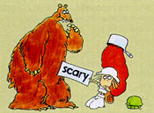  Click on the "scary bear" to read and hear George Newall's "Unpack Your Adjectives" (from Scholastic Rock, 1975).  Schoolhouse Rock® and its characters and other elements are trademarks and service marks of American Broadcasting Companies, Inc. Used with permission.

Positive | Comparative | Superlative
rich | richer | richest
lovely | lovelier | loveliest
beautiful | more beautiful | most beautiful
Certain adjectives have irregular forms in the comparative and superlative degrees:
Irregular Comparative and Superlative Forms
good | better | best
bad | worse | worst
little | less | least
much  many  some | more | most
far | further | furthest

Be careful not to form comparatives or superlatives of adjectives which already express an extreme of comparison — unique, for instance — although it probably is possible to form comparative forms of most adjectives: something can be more perfect, and someone can have a fuller figure. People who argue that one woman cannot be more pregnant than another have never been nine-months pregnant with twins.
Grammar's Response
According to Bryan Garner, "complete" is one of those adjectives that does not admit of comparative degrees. We could say, however, "more nearly complete." I am sure that I have not been consistent in my application of this principle in the Guide (I can hear myself, now, saying something like "less adequate" or "more preferable" or "less fatal"). Other adjectives that Garner would include in this list are as follows:
absolute | impossible | principal
adequate | inevitable | stationary
chief | irrevocable | sufficient
complete | main | unanimous
devoid | manifest | unavoidable
entire | minor | unbroken
fatal | paramount | unique
final | perpetual | universal
ideal | preferable | whole

From The Oxford Dictionary of American Usage and Styleby Bryan Garner. Copyright 1995 by Bryan A. Garner. Published by Oxford University Press, Inc., www.oup-usa.org, and used with the gracious consent of Oxford University Press.

Be careful, also, not to use more along with a comparative adjective formed with -er nor to use most along with a superlative adjective formed with -est (e.g., do not write that something is more heavier or most heaviest).
The as — as construction is used to create a comparison expressing equality:
- He is as foolish as he is large.
- She is as bright as her mother.

Premodifiers with Degrees of Adjectives
Both adverbs and adjectives in their comparative and superlative forms can be accompanied by premodifiers, single words and phrases, that intensify the degree.
- We were a lot more careful this time.
- He works a lot less carefully than the other jeweler in town.
- We like his work so much better.
- You'll get your watch back all the faster.
The same process can be used to downplay the degree:
- The weather this week has been somewhat better.
- He approaches his schoolwork a little less industriously than his brother does.
And sometimes a set phrase, usually an informal noun phrase, is used for this purpose:
- He arrived a whole lot sooner than we expected.
- That's a heck of a lot better.
If the intensifier very accompanies the superlative, a determiner is also required:
- She is wearing her very finest outfit for the interview.
- They're doing the very best they can.
Occasionally, the comparative or superlative form appears with a determiner and the thing being modified is understood:
- Of all the wines produced in Connecticut, I like this one the most.
- The quicker you finish this project, the better.
- Of the two brothers, he is by far the faster.

Lesson 33 Doing exercises. M: Group work.
1. He wants _____ a cold drink.
A) drink B) to drink C) drinking D) drinks
2. He never _____ by plane.
A) travels B) to travel C) traveling D) travel
3. Will you _____ off the photocopier?
A) to turn B) turning C) turned D) turn
4. Would she like _____ to the moon?
A) going B) go C) to go D) goes
5. Do you like_____ football on TV?
A) watch B) watched C) watches D) watching
6. We must_____ back the mixer back to the shop. It doesn’t work.
A) taking B) take C) took D) to take
7. She can _____ German and Italian.
A) speak B) speaking C) to speak D) speaks
8. Could you _____ more slowly?
A) speaking B) spoke C) speak D) speaks
9. I hope _____ you soon.
A) to see B) seeing C) see D) saw
10. We’d better _____ to the manager.
A) to talk B) talking C) talked D) talk
11. It takes him an hour _____ to the bank.
A) getting B) get C) gets D) to get
12. I am sorry _____ you.
A) disturbing B) to disturb C) disturb D) disturbed
13. He spoke too quickly for us _____.
A) to understand B) understand
C) understanding D) understood
14. He’s not strong enough _____ me.
A) beating B) beats C) to beat D) beaten
15. She is able _____ 100 meters in 9 seconds.
A) running B) run C) to run D) ran
16. It is important _____.
A) to win B) winning C) win D) won
17. A: This problem is too difficult. I can’t solve it.
B: Is it really too difficult for you _____?
A) solving B) solve C) to solve D) solved
18. A: He is a doctor. He looks very young.
B: Yes. He doesn’t look old enough _____ a doctor.
A) being B) be C) been D) to be
19. A: Shall I buy meat or fish?
B: I’ve already told you what _____.
A) to buy B) buying C) buy D) bought
20. A: What are you _____?
B: I’m resting.
A) done B) do C) doing D) to do
21. Thank you for_____ me.
A) helping B) help C) to help D) helped
22. Let’s _____ in the sun.
A) sitting B) to sit C) sat D) sit
23. A: Why do we go to school?
B: _____.
A) To learn B) Learning C) Learned D) Learn
24. Could you _____ me the time?
A) telling B) to tell C) tell D) told
25. There is nothing _____.
A) to do B) doing C) did D) do
26. Have you got anything _____?
A) reading B) to read C) read D) reads
27. She is good at _____.
A) to swim B) swimming C) swims D) swum
28. It takes a long time _____ a foreign language.
A) learning B) learned C) learns D) to learn
29. A: I’ve got a headache. B: Well, why don’t you _____ an aspirin?
A) to take B) take C) taken D) taking
30. Why are you _____ my tea?
A) drinking B) to drink C) drunk D) drink
31. She typed the letters carefully without _____ any mistakes.
A) made B) to make C) makes D) making
32. I haven’t _____ Anna more than five years.
A) seeing B) seen C) to see D) see
33. Why don’t we go and _____ the film at the Moonstar?
A) see B) seen C) to see D) seeing
34. My son wants _____ a manager.
A) been B) to be C) be D) being
35. I’d rather not _____ late for my interview.
A) be B) to be C) been D) being
36. A farmer uses tractors _____ fields with.
A) ploughing B) to plough C) ploughed D) ploughs
37. She wants _____ a complaint about the waiter.
A) to make B) making C) makes D) made
38. My father does the _____ himself.
A) ironing B) irons C) to iron D) iron
39. My mother does all the _____.
A) cleaning B) to clean C) cleans D) clean
40. Shall I _____ you a glass of lemonade?
A) making B) made C) make D) to make
41. Do you lie in bed after _____?
A) to wake up B) waking up C) woken up D) wake up
42. Let him _____ that for you.
A) to do B) do C) doing D) does
43. How long has he _____ the manager?
A) been B) to be C) being D) be
44. She is _____ to school by her mother every morning.
A) takes B) taken C) to take D) taking
45. A new factory is _____ here.
A) being built B) to build C) build D) building
46. I’m afraid of _____ mistakes.
A) to make B) made C) make D) making
47. I’m looking forward to _____ you next summer.
A) visit B) visited C) visiting D) visits
48. It is not necessary for him _____ every page.
A) reading B) read C) to read D) reads
49. I don’t _____ sugar, thank you.
A) take B) to take C) taking D) taken
50. He prefers walking to _____.
A) driving B) drive C) drives D) drove
51. I expect she will _____.
A) comes B) coming C) come D) to come
52. I expect her _____.
A) to come B) comes C) coming D) come
53. Hadn’t we better _____ soon?
A) leaving B) leave C) leaves D) left
54. He usually goes _____ tennis at the weekend.
A) to play B) playing C) plays D) play
55. She can’t stand _____ to rock music.
A) listening B) to listen C) listen D) listens
56. Will you _____ to what I’m saying?
A) listening B) to listen C) listen D) listened
57. Haven’t you _____ your calculator?
A) finding B) find C) found D) to find
58. It is difficult _____ a good hotel, in this town.
A) find B) to find C) found D) finding
59. May I _____ you tomorrow?
A) seeing B) to see C) seen D) see
60. I can see a man _____ towards us

Lesson 34 Time and sequence. M.: Pair work.
Although the various shades of time and sequence are usually conveyed adequately in informal speech and writing, especially by native speakers and writers, they can create havoc in academic writing and they sometimes are troublesome among students for whom English is a second language. This difficulty is especially evident in complex sentences when there is a difference between the time expressed in an independent clause and the time expressed in a dependent clause. Another difficulty arises with the use of infinitives and participles, modals which also convey a sense of time. We hope the tables below will provide the order necessary to help writers sort out tense sequences.
As long as the main clause's verb is in neither the past nor the past perfect tense, the verb of the subordinate clause can be in any tense that conveys meaning accurately. When the main clause verb is in the past or past perfect, however, the verb in the subordinate clause must be in the past or past perfect. The exception to this rule is when the subordinate clause expresses what is commonly known as a general truth:
- In the 1950s, English teachers still believed that a background in Latin is essential for an understanding of English.
- Columbus somehow knew that the world is round.
- Slaveowners widely understood that literacy among oppressed people is a dangerous thing.
The tables below demonstrate the correct relationship of tenses between clauses where time is of the essence (i.e., within sentences used to convey ideas about actions or conditions that take place over time).
Click HERE for a table describing the various tenses of the active voice.
Click HERE for a table describing tense sequences of infinitives and participles.
Tense in  Independent  Clause | Purpose of Dependent Clause/  Tense in Dependent Clause | Example(s)
Simple  Present | To show same-time action, use the present tense | I am eager to go to the concert because I love the Wallflowers.
Simple  Present | To show earlier action, use past tense | I know that I made the right choice.
Simple  Present | To show a period of time extending from some point in the past to the present, use the present perfect tense. | They believe that they have elected the right candidate.
Simple  Present | To show action to come, use the future tense. | The President says that he will veto the bill.
Simple  Past | To show another completed past action, use the past tense. | I wanted to go home because I missed my parents.
Simple  Past | To show an earlier action, use the past perfect tense. | She knew she had made the right choice.
Simple  Past | To state a general truth, use the present tense. | The Deists believed that the universe is like a giant clock.
Present  Perfect  or  Past  Perfect | For any purpose, use the past tense. | She has grown a foot since she turned nine.  The crowd had turned nasty before the sheriff returned.
Future | To show action happening at the same time, use the present tense. | I will be so happy if they fix my car today.
Future | To show an earlier action, use the past tense. | You will surely pass this exam if you studied hard.
Future | To show future action earlier than the action of the independent clause, use the present perfect tense. | The college will probably close its doors next summer if enrollments have not increased.
Future  Perfect | For any purpose, use the present tense or present perfect tense. | Most students will have taken sixty credits by the time they graduate.  Most students will have taken sixty credits by the time they have graduated.
Authority for this section: Quick Access: Reference for Writers by Lynn Quitman Troyka. Simon & Schuster: New York. 1995. Used with permission. Examples and format our own.
Note:
Unless logic dictates otherwise, when discussing a work of literature, use the present tense: "Robert Frost describes the action of snow on the birch trees." "This line suggests the burden of the ice." "The use of the present tense in Carver's stories creates a sense of immediacy."

Sequence of Tenses
With Infinitives and Participles
Like verbs, infinitives and participles are capable of conveying the idea of action in time; therefore, it is important that we observe the appropriate tense sequence when using these modals.
INFINITIVES
Tense of  Infinitive | Role of Infinitive | Example(s)
Present  Infinitive  (to see) | To show same-time action or action later than the verb | Coach Espinoza is eager to try out her new drills. [The eagerness is now; the trying out will happen later.]
Present  Infinitive  (to see) | To show same-time action or action later than the verb | She would have liked to see more veterans returning. [The present infinitive to see is in the same time as the past would have liked.]
Perfect  Infinitive  (to have seen) | To show action earlier than the verb | The fans would like to have seen some improvement this year. ["Would like" describes a present condition; "to have seen" describes something prior to that time.]
Perfect  Infinitive  (to have seen) | To show action earlier than the verb | They consider the team to have been coached very well. [The perfect infinitive to have been coached indicates a time prior to the verb consider.]
PARTICIPLES
Tense of  Participle | Role of Participle | Example(s)
Present  Participle  (seeing) | To show action occurring at the same time as that of the verb | Working on the fundamentals, the team slowly began to improve. [The action expressed by began happened in the past, at the same time the working happened.]
Past  Participle  or  Present  Perfect  Participle | To show action occurring earlier than that of the verb | Prepared by last year's experience, the coach knows not to expect too much. [The action expressed by knows is in the present; prepared expresses a time prior to that time.]
Past  Participle  or  Present  Perfect  Participle | To show action occurring earlier than that of the verb | Having experimented with several game plans, the coaching staff devised a master strategy. [The present perfect participle having experimented indicates a time prior to the past tense verb, devised.]

Lesson 35 Addition and contrast. Similarities and differences. M: Brainstorming.
Imagine you are participating in a discussion about ideas. It's not small talk. It's a discussion about how you feel about something important, like your beliefs, politics, who you feel is better for a job, and so on. Using the right phrases and grammar structures can help you express your ideas well. Knowing how to compare and contrast is a particularly useful tool to get your point across in an interesting way.

Words and Short Phrases Used to Compare
The following words or short phrases compare two items or ideas:
- like
- likewise
- same as
- as well as
- also, too
- likewise
Here is a short paragraph using some of these expressions:
Time, like money, is a limited resource. You can't buy everything you want, likewise, you don't have enough time to do everything you want to do. Our time is the same as our money: it's limited. Also, time is a resource when work needs to be done.

Words and Short Phrases Used to Contrast
The following words or short phrases contrast two items or ideas:
- unlike
- in contrast to
- as opposed to
- different from
- whereas
Here is a short paragraph using some of these expressions to contrast:
Unlike time or money, desire is an unlimited resource. Think about it: In contrast to money which can run out, your desire for new experiences and ideas will never end. Whereas there is never enough time to do everything you want, your desire will always come up with something new and exciting.

Forms Used When Comparing Ideas
The most important form to use when comparing two ideas is the comparative form. For three or more ideas, use the superlative form.

Comparative Form
These sentences use the comparative form to discuss ideas concerning the difficult economy:
Employment issues are more important than political problems at this point in time.
Job training is more critical to a sustained well being than food stamps and other welfare programs.
Politicians are more worried about reelection than truly improving the economy.
As ... as
A related form to the comparative is the use of "as ... as." The positive form shows something is equal. However, when using "as ... as," do not modify the adjective as in the comparative form.
The loss of manufacturing jobs is as unfortunate as the drop in pay.
Spending on education in my state is as high as in some foreign countries like Korea.
The negative form shows that something is not equal.
It isn't as easy as you think.
The loss in production isn't as great as in the past.

Superlative Form
These sentences use the superlative form to state what someone feels are the most important aspect of success at university:
Dedication is the most important factor in success at University.
Opening my mind to new perspectives was the most rewarding part of my time at university.

Conjunctions and Connectors
Use these subordinating conjunctions, connecting words, and prepositions to contrast positive and negative aspects.
Though, Although, Even Though​
Although the initial cost will be high, we will eventually profit from the time spent.
It's important to remember that time is money even though many believe that money is more important.
However, Nonetheless
We need to improve the local infrastructure. However, we must also respect nature.
The government should invest in job training programs. Nonetheless, that would be expensive.
Despite, In Spite Of
Despite the difficulty, students will soon see the benefit of this topic of study.
The situation will improve in spite of the economy.

Practice Situations
Find a partner and use these suggestions to practice comparing and contrasting ideas, events, and people. Make sure to vary the language you use when practicing rather than using the same phrase over and over again. For practice, you could try the following topics:
- Discuss the economic situation in your country
- Speak about the positive and negative aspects of a politician or political party
- Compare and contrast two different courses at school
- Consider both sides of an important decision such as an investment, a career change, etc.

Lesson 36 Physical world.
The term derived from Greek word meaning nature. Sanskrit equivalent of the word Physics isBhautikithat is used to refer to the study of the physical world
In a broader sense Physics is the study of the basic laws of nature and their manifestation.

RELATED STORIES
- CBSE Registration 2019-2020: Check latest rules for students' registration in class IX and XI
- CBSE Instructs Schools to Complete Registrations for Class 9, 11 till August 15; Check details here
- CBSE to standardise admissions to class IX, XI in all its affiliated schools from 2020
- CBSE Class 11 Syllabus 2019-20: All Subjects
- CBSE Class 11 Book List 2019-20: Important Reference Books besides NCERT Textbooks
- CBSE Class 11 Computer Science Syllabus 2019-20
Physics is all about explaining diverse physical phenomena with the help of few concepts and laws.
CBSE Class 11 Physics Syllabus 2017 - 2018
Scope and Excitement of Physics
In Physics, there are two domains of interest macroscopic and microscopic.
Macroscopic domain: It includes phenomena at the laboratory, terrestrial and astronomical scales.
Microscopic domain: It includes atomic, molecular and nuclear phenomena.
However, recently a third domain of interest between macroscopic domain and microscopic domain (Mesoscopic) has also come in light. In this domain scientists deals with a few tens or hundreds of atoms, has emerged as an exciting field of research.
Various theories related to macroscopic domain and microscopic domain are further categorised as given below
Classical Physics
It is the study of macroscopic phenomena. It includes subjects like
• Mechanics:
Under mechanics, we study
Newton’s laws of motion
The law of gravitation is concerned with the motion (or equilibrium) of particles, rigid and deformable bodies, and general systems of particles.)
• Electrodynamics:
It deals with electric and magnetic phenomena associated with charged and magnetic bodies.
• Thermodynamics:
It deals with systems in macroscopic equilibrium and is concerned with changes in internal energy, temperature, entropy, etc., of the system through external work and transfer of heat. The efficiency of heat engines and refrigerators etc.
• Optics:
It is the study of phenomenon connected with light and optical instruments like telescope, microscope etc.
Quantum Theory
It is the framework for explaining microscopic phenomena as classical physics can’t explain phenomenon at microscopic level (or smaller dimensions like atoms, nuclei etc.)
Physical World: CBSE Class 11 NCERT Solution
Physics, Technology and Society
There are number of examples in the world which shows close relation between physics, technology and society. Such as, the steam engine is inseparable from the Industrial Revolution in England in the 18th century, which had great impact on the course of human civilisation. Wireless communication technology, computers are some other examples.
Some physicists from different countries of the world and their major contributions
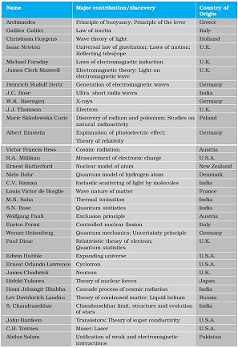
Image source: NCERT textbooks
Link between technology and physics
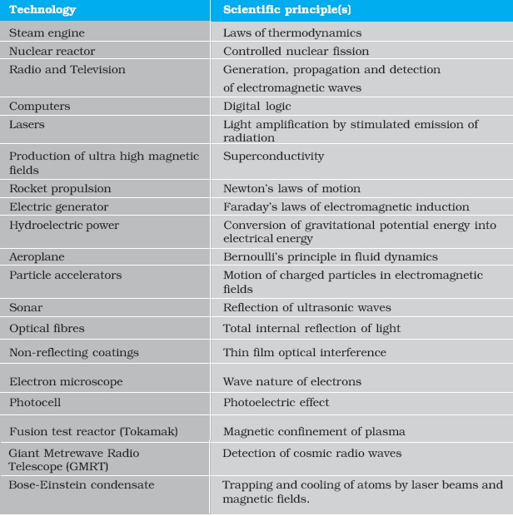
Image source: NCERT textbooks
Fundamental Forces in Nature
Four fundamental forces in nature that govern the diverse phenomena of the macroscopic and the microscopic world are given below
• Gravitational Force
• Electromagnetic Force
• Strong Nuclear Force
• Weak Nuclear Force
Basic Properties of Fundamental Forces in Nature
Name | Relative Strength (& Range) | Operates among
Gravitational force | 10^{–39} (Infinite) | All objects in the universe
Weak nuclear force | 10^{–13} (Very short, Sub-nuclear size: ∼10^{–16} m) | Some elementary particles, particularly electron and neutrino
Electromagnetic force | 10^{‒2} (Infinite) | Charged particles
Strong nuclear force | 1 (Short, nuclear size ∼10^{–15} m) | Nucleons, heavier elementary particles
Conservation Laws in Physics
The physical quantities that remain unchanged in a process are called conserved quantities.
Some of the general conservation laws in nature include the laws of conservation of energy, mass, linear momentum, angular momentum, charge, parity, etc. Some conservation laws are true for one fundamental force but not for the other.
You will study details of these laws in consecutive chapters.
These conservation laws have a deep connection with symmetries of nature. Symmetries of space and time, and other types of symmetries play a central role in modern theories of fundamental forces in nature.

Lesson 37 The body and what it does
Body Parts
 |  |  |  | 1.x |  | 2. x | x | x | x | x | x | x
 |  |  |  | x |  | x
 |  |  |  | x |  | x
3. x | x | x | x | x | x | x
 |  |  |  | x
 |  |  |  | 4.x | x | x | x
 |  |  |  | x

down  1. your ears are pierced there  2. located in the region of the neck or throat,  and if it's cut you're dead. The most essential  part. | across  2. it's also the name of a  film about a killer shark  3. they show when you smile  4. Shakespeare had a big one
Idioms.
1. If you finger someone it means:
a. you touched him b. you accused him c. you poked him d. you made an obscene gesture
2. If you give someone the finger it means:
a. you touched him b. you accused him c. you poked him d. you made an obscene gesture
3. To bone up on means:
a. to study or prepare for b. create a supporting structure or framework c. get sexually excited
d. to be angry
4. Someone who is cheeky is:
a. worshipful b. sarcastic c. brainy d. disrespectful
5. to use a lot of elbow grease means:
a. It was easy b. It was disgusting c. it took a lot of hard work d. It took up a lot of space
6. play it by ear means:
a improvise b. economize c. devise d. supervise
7. to be gutsy is to be:
a. famous b. courageous c. outrageous d. infamous
8. something that is hair-raising is:
a. scary b. hairy c. pigmented d. naughty
9. someone who is an air head is:
a. stingy b. flighty c. mannerly d. obnoxious
10. Eat your heart out means:
a. to be lucky b. to be suspicious c. to be devious d. to be envious

Name the five digits on your hand. Do you have ankles? a womb? a trunk? an appendix? Where is your fetlock?
Touch your brow. Rub your belly. Squat. Stand on your heels on your heels only. Squint. Stick out your tongue.

Lesson 38 Doing exercises. M: Group work.

Lesson 1. Discourse analysis and grammar. M: Brainstorming.

Discourse analysis of grammar

Discourse is what we get when language is used in communication between people. Usually we do not consider communication that does not involve competent linguistic speech as discourse, even if the communication is successful. If a child stamps his foot and starts crying when he is told to come in for supper, the meaning I don’t want to may be inferred, but it has not yet been expressed in discourse. However, sign language is also discourse and so are text messages.

Discourse then consists of larger linguistic units than those dealt with in traditional linguistic analysis, and involves issues of linguistic performance and sociolinguistics. By communicating in linguistically competent speech, the speaker places himself in a particular society with its cultural norms, values and symbols.

Discourse analysis, as an approach to studying psychological phenomena, developed out of the ‘turn to language’ in social psychology in the 1970s and 1980s and the emergence of social constructionism. Although its main developments have taken place in social psychology, over the last two decades it has been increasingly used in the fields of clinical psychology, counseling psychology and psychotherapy, where it is usually associated with critical approaches.

Discourse analysis is a broad and diverse field, including a variety of approaches to the study of language, which derive from different scientific disciplines and utilize various analytical practices (Wetherell, Taylor, & Yates, 2001ab). In a broad sense, discourses are defined as systems of meaning that are related to the interactional and wider sociocultural context and operate regardless of the speakers’ intentions. Discourse analysis examines language in use, rather than the psychological phenomena, such as attitudes, memory or emotions, which are traditionally presumed to underlie talk and be revealed through it.

Grammar

Even where the value of discourse as a locus of grammatical research is granted, there may remain differences regarding what goals are to be pursued and what methods established. How one conceives the nature of dis course has much to do with how one conceives the nature of language itself. It will be instructive to briefly consider some alternative approaches, without any pretense to surveying the rich diversity of viewpoint that characterizes the present intellectual ferment in the arena of discourse.

Handout 2.

A Very Short Story

Ernest Hemingway

One hot evening in Padua they carried him up onto the roof and he could look out over the top of the town. There were chimney swifts in the sky. After a while it got dark and the searchlights came out. The others went down and took the bottles with them. He and Luz could hear them below on the balcony. Luz sat on the bed. She was cool and fresh in the hot night.

Luz stayed on night duty for three months. They were glad to let her. When they operated on him she prepared him for the operating table; and they had a joke about friend or enema. He went under the anaesthetic holding tight on to himself so he would not blab about anything during the silly, talky time. After he got on crutches he used to take the temperatures so Luz would not have to get up from the bed. There were only a few patients, and they all knew about it. They all liked Luz. As he walked back along the halls he thought of Luz in his bed.

Before he went back to the front they went into the Duomo and prayed. It was dim and quiet, and there were other people praying. They wanted to get married, but there was not enough time for the banns, and neither of them had birth certificates. They felt as though they were married, but they wanted everyone to know about it, and to make it so they could not lose it.

Luz wrote him many letters that he never got until after the armistice. Fifteen came in a bunch to the front and he sorted them by the dates and read them all straight through. They were all about the hospital, and how much she loved him and how it was impossible to get along without him and how terrible it was missing him at night.

After the armistice they agreed he should go home to get a job so they might be married. Luz would not come home until he had a good job and could come to New York to meet her. It was understood he would not drink, and he did not want to see his friends or anyone in the States. Only to get a job and be married. On the train from Padua to Milan they quarreled about her not being willing to come home at once. When they had to say good-bye, in the station at Milan, they kissed good-bye, but were not finished with the quarrel. He felt sick about saying good-bye like that.

He went to America on a boat from Genoa. Luz went back to Pordonone to open a hospital. It was lonely and rainy there, and there was a battalion of arditi quartered in the town. Living in the muddy, rainy town in the winter, the major of the battalion made love to Luz, and she had never known Italians before, and finally wrote to the States that theirs had only been a boy and girl affair. She was sorry, and she knew he would probably not be able to understand, but might some day forgive her, and be grateful to her, and she expected, absolutely unexpectedly, to be married in the spring. She loved him as always, but she realized now it was only a boy and girl love. She hoped he would have a great career, and believed in him absolutely. She knew it was for the best.

The major did not marry her in the spring, or any other time. Luz never got an answer to the letter to Chicago about it. A short time after he contracted gonorrhea from a sales girl in a loop department store while riding in a taxicab through Lincoln Park.

Handout 3.

“A very short story” is a short story written by Ernest Hemingway. It was first published as a vignette,, or chapter, in the 1924 Paris edition titled In Our Time, and it later rewritten and added as a story to Hemingway’s first American short story collection In Our Time, published in 1925.

The atmosphere of the story is very dark and hopeless. It may fall anyone into the hands of depression, because the work itself is a story of a “disintegration”. Hemingway’s famous word economy is presented in such an obvious way that the reader learns most of the information about setting, tone, plot, atmosphere and so on even in the first paragraph.

According to M.A.K Halliday, a sentence can be interpreted as a clause complex: a Head clause together with other clauses that modify whether paratactically or hypotactically.

Parataxis: refers to the logical interdependency between clauses where the interdependents are of equal status, roughly comparable to coordination in traditional grammar.

Hypotaxis: refers to the logical interdependency between clauses where the interdependents are of unequal status.

As far as sentence types are concerned, the analysis proves that the parataxis type is the most common type, especially with the “and” conjunction. Moreover the most prevailing sentence within the story as far as number of words is the one with 21 words, examining these sentences proves that four of them are of the parataxis type, the remaining one is mixed, this may reflect the fact that expressing flow of ideas need more words to be included and this story it seems that Hemingway prefers to express such ideas in sentences within about 21 words.

Generally speaking, Hemingway’s writing is minimalist and sparse, with few adverbs and adjectives. He includes only essential information, often omitting background information, transitions, and dialogue tags such as “he said” or “she said”. He often uses pronouns without clear antecedents, such as using the word “it” without clarifying what “it” refers to. He is mainly known for his simple style. However, having analyzed the present story as far as sentence length and complexity are concerned, using Halliday’s model(1985), it has been found that essential ideas have been loaded in complex, lengthy sentences. A technique of perfect integration between grammar and style.

Glossary:

Analysis – the detailed study or examination of something in order to understand more about it, the result of the study.

Discourse – a long and serious treatment or discussion of a subject in speech or writing.

Integration – the act or process of combining two or more things so that they work together.

Linguistic – connected with language or the scientific study of language.

Prevailing – existing or most common at a particular time.

Vignette – a short piece of writing or acting that clearly shows what a particular person, situation, etc.

Lesson 2. Tense and aspect. M: Brainstorming.
Consider the following statement:
Present tenses refer to the present and past tenses refer to the past.
How far do you agree with this statement? Can you think of any exceptions? What about the following:

I wish you were more polite.
Earthquake kills 200.
Could you possibly open the window, please?
As you can see, the examples above show that the ‘rule’ given above isn’t very robust, as there are many, perfectly acceptable, exceptions. What we’re using when we say things like the statement above are not really ‘rules’, but ‘hints’. Michael Lewis (1986) makes the following distinction:
Advice and classroom hints are one thing, grammar rules are another. Rules cannot be given which include words like sometimes, in certain circumstances, might mean, etc.
So, what’s going on with the exceptions above? Well, in fact, these are not exceptions but actually part of a wider rule about the use of tenses. In order to gain a fuller understanding of what’s happening here, we first need to look more closely at what tense and aspect actually refer to.
Tense vs aspect
Tense and aspect are often labelled as the same thing. It’s not uncommon to see the present progressive referred to as ‘the present progressive tense’ or will have + past participle referred to as ‘the future perfect tense’, for example. However, tense and aspect are not the same thing.
Aspect
There are two aspects in English: the progressive aspect (also referred to as continuous), and the perfect aspect.
The progressive aspect is formed with the auxiliary be (reflecting the tense) and the addition of -ing to the main verb. It usually describes an event which is taking place during a limited time, e.g. I’m staying with friends while my house is being redecorated. We also often use it when we’re more concerned with the action rather than the time frame or result, e.g. I’ve been writing reports all day as opposed to I’ve written all four reports.
The perfect aspect links two times together in some way, for example, by showing that an event which started in the past is ongoing (I’ve lived here for twenty years), or by showing a future result of a present action (They’ll have visited all the continents by 2025).
Tense
In Collins COBUILD English Grammar (2017), tense is defined as ‘… a verb form that indicates a particular point in time or period of time’. And in his study of The English Verb, Lewis, (1986:50), describes tense as involving ‘a morphological change in the base form of the verb. A verb form which is made with an auxiliary is not, in this technical meaning, a “tense”.’
Following this understanding, we can see that there are two tenses in English, the ‘present’ and ‘past’ tense; these are the only verbs forms that do not require an auxiliary. We add further meaning and viewpoints to these basic forms through the use of aspect. Aspect allows the speaker to interpret the events being described and express how they view them.
A closer examination of what tense really refers to can provide us with a deeper understanding of how tenses work in English. Rather than think in terms of present and past, it can be useful in English to think in terms of distance. What we refer to as ‘past’ in English is better thought of as ‘remote’. Likewise, what we consider the ‘present’ is better thought of in terms of ‘close’. With this in mind, our choice of tense in English is influenced by three key factors, time, reality, and register:
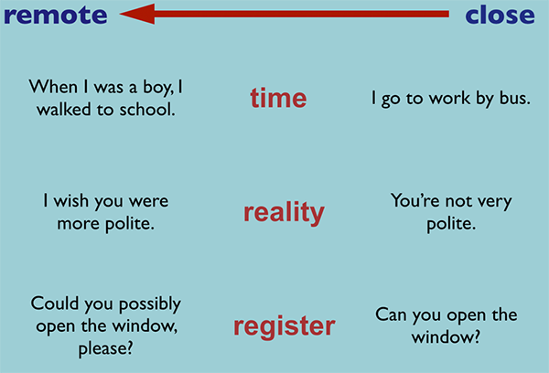
In the diagram above, you can see there are three ways in which distance affects our choice of tense: time (close as in ‘my life now’ or remote as in ‘my life in the past’), reality (close to reality or remote from it, i.e. unreal), and register (the ‘closer’ someone is to me socially, the more ‘present’ tenses I use).
There are no exceptions to this rule.
It’s important to remember that so much of our choice of tense and aspect depends not only on how we view the events, but also how we want the events to be viewed. For example, in the newspaper headline given at the top of this post, ‘Earthquake kills 200’, a present tense is used, even though the event occurred the day before. However, if a past tense were used, the event would sound less immediate, and therefore less newsworthy.
Another very common use of the present simple tense is to describe past events in the ‘historic present’, often used when recounting personal anecdotes, e.g. So she just walks in, sits down, and doesn’t even say hello! The use of a present tense here makes the story more personal/informal, and therefore brings the speaker and listener closer.
Why is the distinction between tense and aspect important?
Raising your learners’ awareness of this ‘remote → close’ framework can really help when they start to meet hypothetical language. The regret I wish I hadn’t been so lazy is expressed using the past perfect, for example, as it contains two elements of remoteness – past time and unreality (the speaker was lazy). Conversely, the regret I wish I wasn’t so lazy is expressed using the past simple, as it contains only one element of remoteness – unreality (the speaker is lazy), but is ‘close’ in terms of time (the speaker is referring to now).
Similarly, an awareness of the common uses of aspect across the different tenses can help learners have a more accurate understanding of what’s going on when we use them. An understanding that our choices aren’t only affected by how we view events but by how we want them to be viewed, can help learners gain a fuller, more critical understanding of the language they hear. For example, an employer referring to an employee might say, ‘Harry works at my restaurant’, whereas the employee, Harry, may say, ‘I’m working at a restaurant’, implying that it’s temporary, until he can find a better job.
As teachers, we need to be aware of these concepts, so we can be aware of what’s really going on with the language we teach. The question is: to what extent should we share such theories of language with our students? Thornbury (2010) disparagingly calls the more simplified, traditional grammar descriptions that we come across in coursebooks ‘Grammar McNuggets’, describing them in the following way:
An enthusiasm for compartmentalization, inherited from grammars of classical languages, has given rise to the elaborate architecture of the so-called tense system – including such grammar McNuggets as the future-in-the-past, and the past perfect continuous, not to mention the conditionals, first, second and third – features of the language that have little or no linguistic, let alone psychological, reality.
Many teachers feel that the classroom ‘McNuggets’ we teach learners, especially at lower levels, can be useful ‘stabilisers’ in order to help communication and build confidence. However, it’s vital that as teachers we see the ‘hints’ as the simplified half-truths that they really are; we must go beyond a simple coursebook-style ‘compartmentalization’, so as to raise our own awareness of what’s actually going on with the language we teach. We can then gradually introduce our learners to more complex ideas and descriptions as they become more confident, and so able to deal with further subtleties in the language.
Collins COBUILD English Grammar aims to do this by breaking down elements of grammar into useful chunks while also reflecting the true nature of the tense and aspect systems outlined above.
Explore this topic in greater detail with our free guided worksheet.
——————————–
References:
Lewis, M. 1986 The English Verb: An Exploration of Structure and Meaning LTP

Lesson 3 Doing Grammar exercises. M: Group work.

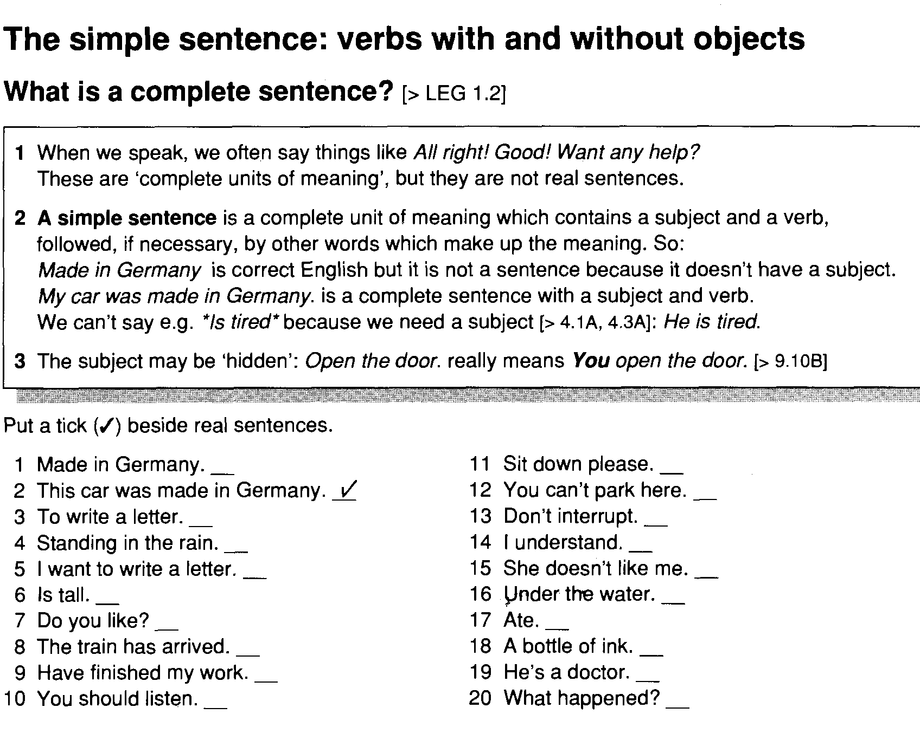

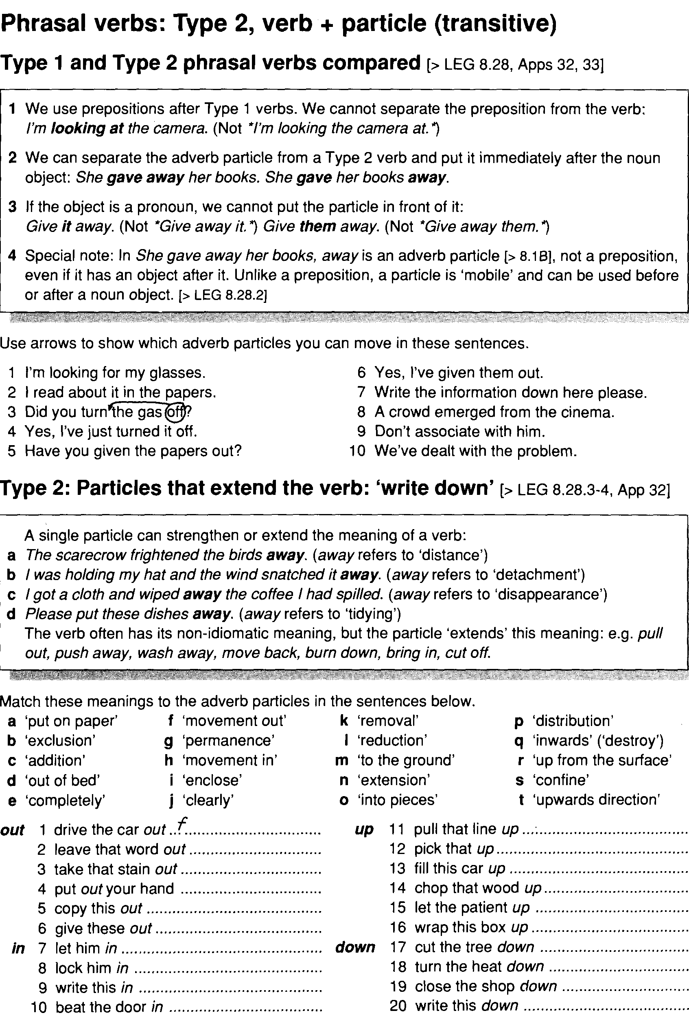

Lesson 4. Discourse analysis and vocabulary. M: Brainstorming.

The vocabulary lesson will still have a place in a discouse-oriented syllabus; the challenge is to bring the discourse dimension into vocabulary teaching alongside traditional and recent, more communicative approaches.
This chapter will look at research into vocabulary in extended texts in speech and writing and consider if anyting can be usefully exploited to give a discourse dimension to vocabulary teaching and vocabulary activities in the classroom.
Most are already in agreement that vocabulary should be taught in context, but context is a rather catch-all term and what we need to do at this point is to look at some of the specific relationships between vocabulary choice, context (in the sense of the situation in which the discourse is produced) and co-text(the actual text surrounding any given lexical item).
One recent attempt at studying vocabulary patterns above sentence level is Halliday and Hasan's (1976) description of lexical cohesion.
Related vocabulary items occur across clause and sentence boundaries in written and across act, move and turn boundaries in speech and are a major characteristic of coherent discourse.
The relations between vocabulary items in texts described by the Halliday-Hasan model are of two principal kinds : reiteration and collocation
Collocation only refers to the probability that lexical items will co-occcur , and is not a semantic relation between words.
Here, we shall consider the term"Lexical Cohesion" to mean only exact repetition of words and the role played by certain basic semantic relations between words in creating textuality, the property of text which distinguishes it from a random sequence of unconnected sentences.
Reiteration means either restating an item in a later part of the discourse by direct repetition or else reasserting its meaning by exploiting lexical relations.
Lexical relations are the stable semantic relationships that exist between words and which are the basis of descritpions given in dictionaries and thesauri : for example, rose and flower and related by hyponymy; rose is a hyponym of flower. Eggplant and aubergine are related by synonymy .
e.g.., The meeting commenced at six thirty. But from the moment it began, it was clear that all was not well.
Here, commence and begin co-refer to the same entity in the real world.
e.g.., The meeting commenced at six thirty; the storm began at eight.
Here, commence and begin refer to separate events, but we would still wish to see a stylistic relationship between them.
e.g.., There was a fine old rocking-chair that his father used to sit in, a desk where he wrote letters, a nest of small tables and a dark, imposing bookcase. Now all this furniture was to be sold , and with it his own past.
The superordinate need not be an immediate superordinate in the family tree of a particular word; it can be a general word. Instead of furniture we could have had all these items/objects/things, which are examples of general superordinates. Other general super-ordinates, covering human and abstract areas, include people, creature, idea and fact.
Reiteration of this kind is extremely common in English discourse; we do not always find direct repetition of words, and very ofthen find considerable variation from sentence to sentence in writing and from turn to turn in speech;.
Such variation can add new dimensions and nuances to meaning, and serves to build up an increasingly complex context, since every new wordl even if it is essentially repeating or paraphrasing the semantics of an earlier word, brings with it its own connotations and history of occurrence.
Learning to observe lexical links in a text according to Halliday and Hasan's model could be useful for language learners in various ways.
For one thing, it encourages learners to group lexical items together according to particular contexts by looking at the lexical relations in any given text.
Words presented by the teacher or coursebook as synonyms will probably only be synonymous in certain contexts and the learner has to learn to observe just when and where individual pairs of words may be used interchangeably.

5 Lexical cohesion. M: Diagram
- Lexical Cohesion Lexical Cohesion is a linguistic device which helps to create unity of text and discourse. In contrast to grammatical cohesion, lexical cohesion is the cohesive effect achieved by the selection of vocabulary.” (Halliday 1994: 274). Thus, a speaker or writer‟s either conscious or unconscious selection of certain lexical items that are in some way connected to each other creates lexical cohesion. A way of achieving cohesion by way of repeating the same word or phrase or using chains of related words that contribute towards the continuity of lexical meaning: „Each day she had gone with Tom and Peter or just with Tom down into the Underground and played her violin‟ (BNC, EDN). In the above example, Tom is repeated a second time, in order to make it clear who is being referred to. A pronoun like him would have been ambiguous. In other cases of lexical cohesion, a related word can occur in place of the original reference: „Father Death climbs the tree to gather a rosy apple but directly he touches the fruit he is caught‟ (BNC, HH3). Here, apple is later referred to by the superordinate category fruit. Another type of lexical cohesion involves repetition of another member of a semantic category: „To the right, a brickred dune stood alone among golden yellow ones‟ (BNC, AT3). Here, brick-red and golden yellow both belong to the category of colours. A text or discourse is not just a set of sentences, each on some random topic. Rather, the sentences and phrases of any sensible text will each tend to be about the same things that is, the text will have a quality of unity. This is the property of cohesion the sentences “stick together” to function as a whole. Cohesion is achieved through back-reference, conjunction, and semantic word relation. Cohesion is not a guarantee of unity in text but rather a device for creating it. Lexical cohesion deals with the meaning in text. “This is the cohesive effect achieved by the selection of vocabulary” (Halliday and Hasan, 1976). Lexical cohesion is the cohesion that arises from semantic relationship between words. All that is required is that there be some recognizable relation between the words. Halliday and Hasan have provided a classification of lexical cohesion based on the type of dependency relationship that exists between words. There are five basic classes:
- 3. 1. Reiteration with identity of reference: Example: a. Mary bit into peach b. Unfortunately the peach wasn‟t ripe 2. Reiteration without identity of reference Example: a. Mary ate some peaches. b. She likes peaches very much 3. Reiteration by means of superordinate: Example: a. Mary ate a peach b. She likes fruit 4. Systemic semantic relation (systematically classifiable). Example: a. Mary likes green apple. b. She does not like red ones. 5. Nonsystematic semantic relation (not systematically classifiable). Example: a. Mary spent three hours in the garden yesterday. b. She was dinging potatoes. Example 1,2, and 3 fall into the class of reiteration. Note that reiteration includes not only identity of reference or repetition of the same word, but also the use of super ordinates, subordinates, and synonyms. Example 4 and 5 fall into the class of collocation, that is semantic relationships between words that often co-occur. They can be further divided into two categories or relationship: systematic semantic, and nonsystematic semantic.
- 4. Systematic semantic relationship can be classified in a fairly straightforward way. This type of relation includes antonyms, member of an ordered set such as (one,two,three), members of an unordered set such as white,black,red), and part-to-whole relationships like {eyes,mouth,face}. Example 5 is an illustration of collocation where the word relationship, {garden,dinging}, is nonsystematic. This type of relationship is the most problematic, especially from a knowledge representation point of view. Such collocation relationship exist between words that tend to occur in similar lexical environment. Words tend to occur in similar lexical environments because they describe things that tend to occur in similar situations or contexts in the world. Hence, context-specific examples such as {post office, service, stamps, pay, leave} are include in the class. B. Categories In classifying the sources for lexical cohesion, the system of categories varies from one author to another. However, since they all comprise the same notions (only subdivided differently), the following categorization mainly refers to Halliday and Hasan (1976). a. Repetition Repetition, or sometimes called reiteration, is the most direct and obvious source of lexical cohesion since it is the mere identical recurrence of a preceding lexical item. Example: Algy met a bear. The bear was bulgy. In this example, the second occurrence of bear refers back to the first. Also, there is the referential link the signaling that the same bear is intended. Repetition therefore establishes a cohesive tie between at least two identical lexical items. b. Synonym According to the Oxford advance learning Dictionary (sixth edition), 2000), synonymy refers to “[…] the fact of two or more words or expressions having the same meaning.” In this case, “[…] lexical cohesion results from the choice of a lexical item that is in some sense synonymous with a preceding one […]” (Halliday and Hasan, 1976: 331). However, different types of synonymy can be distinguished:
- 5. (a) Identity of reference: Here, lexical cohesion is established by synonyms in the narrower sense on the one hand and superordinates on the other hand, both types referring back to the same entity. Example: I heard a sound, but I couldn’t figure out where that noise came from. -> Noise refers back to sound. Both terms have the same level of generality and are therefore synonyms in the narrower sense. Example: Seven blackbirds began to sing in the morning. These birds were singing beautifully. -> Birds refers back to blackbirds but has a higher level of generality and is therefore a superordinate term. (b) without identity of reference: In this case, a lexical item that synonymously refers back to a preceding one is not of the same entity. However, “[i]t is not necessary for two lexical occurrences to have the same referent […] in order for them to be cohesive.” (Halliday, 1994: 282). Thus, “[t]he occurrence of a synonym even where there is no particular referential relation is still cohesive […]” (Halliday and Hasan, 1976: 332). Example: Why does this little boy have to wriggle all the time? Good boys don’t wriggle. In this example, boy and boys are not coreferential since boys does not explicitly refer to that specific little boy that wriggles all the time. Nevertheless, still boy and boys build a cohesive relation. According to Halliday, “[m]any instances of cohesion are purely lexical, a function simply of the co-occurrence of lexical items, and not in any way dependent on the relation of reference. A lexical item, therefore, coheres with a preceding occurrence of the same item whether or not the two have the same referent, or indeed whether or not there is any referential relationship between them.” (1994: 283). Further, there are three additional types of synonymy without identity of reference (cf. Halliday and Hasan, 1974). a. Hyponymy: Describes a “specific-general” relationship between lexical items.
- 6. Example: Then they began to meet vegetation – prickly cactus-like plants and coarse grass… . -> Plants and grass are specific parts of vegetation and therefore altogether form a cohesive relationship. b. Meronymy: Describes a “part-whole” relationship between lexical items. Example: She knelt down and looked along the passage into the loveliest garden you ever saw. How she longed to […] wander about among those beds of bright flowers and those cool fountains, […]. -> Flowers and Fountains are typical parts of a garden and therefore altogether form a cohesive relationship. c. Antonymy: Describes a relationship between lexical items that have opposite meanings. -> Example: He fell asleep. What woke him was a loud crash. -> Asleep and woke are antonyms and therefore form a cohesive relationship. C. Collocation The term collocation, as McCarthy et.al. put it, describes “[…] a natural combination of words; it refers to the way English words are closely associated with each other.” (2005: 4). In other words, it is the tendency of at least two lexical items to co-occur frequently in a language. Collocation can serve as a source of lexical cohesion since it is “[…] one of the factors on which we build our expectations of what is to come next.” (Halliday and Hasan, 1976: 333). That means that collocations help to establish unity of text or discourse. This is also due to the fact that “[…] each occurrence of a lexical item carries with it its own textual history, a particular collocational environment that has been built up in the course of the creation of the text and that will provide the context within which the item will be incarnated on this particular occasion.” (Halliday, 1994: 289).
- 7. Example: A little fat man of Bombay Was smoking one very hot day But a bird called a snipe Flew away with his pipe, Which vexed the fat man of Bombay. In this example, smoke collocates with pipe and therefore makes the occurrence of pipe cohesive. The cohesive effect or force of a collocational relationship depends on proximity and closeness of the respective lexical items in the linguistic system as well as in the text itself (cf. Haliday, 1994: 289, 290). The cohesive effect is stronger. In general, Halliday calls collocation “[…] the most problematic part of lexical cohesion” because basically every lexical item can to some extend build a collocational relationship with another one. (1994: 284). This may be a reason why the category of collocation is often underrepresented in studies on lexical cohesion. The difficulty certainly lies within defining and analyzing collocations since the boundaries of this source of lexical cohesion are sometimes fuzzy and “ what is considered as a valid relation will inevitably slightly vary from one communicator to the next.” (Tanskanen, 2006: 34). Hence, an analysis of the contribution of collocation to lexical cohesion seems to be limited to a subjective point of view. However, Halliday again notes that “ it is the occurrence of the item in the context of related lexical items that provides cohesion and gives to the passage the quality of text. The relatedness is a matter of more or less; there is no clearly defined cutoff point. But we can say that [a lexical item] is more closely related to some than to others; and it is the closeness of the relationship that determines the cohesive effect. D. Lexical chains Often, lexical cohesion occurs nit simply between pairs of words but over a succession of a number of nearby related words spanning a topical unit of the text. These sequences of related words will be called lexical chains. There is a distance relation between each word in the
- 8. chain, and the words co-occur within a given span. Lexical chains do not stop at sentence boundaries. They can connect a pair of adjacent words or range over an entire text. Lexical chains tend to delineate portions of the text that have a strong unity of meaning. Example: In front of me lay a virgin crescent cut out of pine bush. A dozen houses were doing up, in various stages of construction, surrounded by hummocks of dry earth and stands of precariously tall trees nude halfway up their trunks. They were that kind of trees you might see in the mountain. A lexical chain spanning these three sentences in {virgin‟pine‟bush‟trees‟trunk‟trees}. E. Why lexical cohesion is important There are two reasons why lexical cohesion is important for computational text understanding systems: 1. Lexical chains provide an essay to determine context to aid in the resolution of ambiguity and in the narrowing to a specific of a word. 2. Lexical chains provide a clue for the determination of coherence and discourse structure, and hence the large meaning of the text.

6 Lexis in talk. M: Collage.
In generative linguistics, a lexis or lexicon is the complete set of all possible words in a language (vocabulary). In this sense, child, children, child's and children's are four different words in the English lexicon. In systemic-functional linguistics, a lexis or lexical item is the way one calls a particular thing or a type of phenomenon. Since a lexis from a systemic-functional perspective is a way of calling, it can be realised by multiple grammatical words such as "The White House", "New York City" or "heart attack". Moreover, since a lexis is a way of calling, different words such as child, children, child's and children's may realise the same lexical item.

Contents
- 1Lexicon
- 2Formulaic language
- 3Context and co-text
  - 3.1Concordance for possibility
- 4Metaphor as an organizational principle for lexis
- 5Grammar
- 6Register
- 7See also
- 8References

Lexicon
In short, the lexicon is:
- Formulaic: it relies on partially fixed expressions and highly probable word combinations
- Idiomatic: it follows conventions and patterns for usage
- Metaphoric: concepts such as time and money, business and sex, systems and water, all share a large portion of the same vocabulary
- Grammatical: it uses rules based on sampling of the Lexicon
- Register-specific: it uses the same word differently and/or less frequently in different contexts
A major area of study, psycholinguistics and neurolinguistics, involves the question of how words are retrieved from the mental lexicon in online language processing and production. For example, the cohort model seeks to describe lexical retrieval in terms of segment-by-segment activation of competing lexical entries.^{[1][2]}

Formulaic language
 | This section needs additional citations for verification. Please help improve this article by adding citations to reliable sources. Unsourced material may be challenged and removed.  Find sources: "Lexis" linguistics – news · newspapers · books · scholar · JSTOR (July 2012) (Learn how and when to remove this template message)
Main article: Formulaic speech
In recent years, the compilation of language databases using real samples from speech and writing has enabled researchers to take a fresh look at the composition of languages. Among other things, statistical research methods offer reliable insight into the ways in which words interact. The most interesting findings have taken place in the dichotomy between language use (how language is used) and language usage (how language could be used).
Language use shows which occurrences of words and their partners are most probable. The major finding of this research is that language users rely to a very high extent on ready-made language "lexical chunks", which can be easily combined to form sentences. This eliminates the need for the speaker to analyse each sentence grammatically, yet deals with a situation effectively. Typical examples include "I see what you mean" or "Could you please hand me the..." or "Recent research shows that..."
Language usage, on the other hand, is what takes place when the ready-made chunks do not fulfill the speaker's immediate needs; in other words, a new sentence is about to be formed and must be analyzed for correctness. Grammar rules have been internalised by native speakers, allowing them to determine the viability of new sentences. Language usage might be defined as a fall-back position when all other options have been exhausted.

Context and co-text
This section needs additional citations for verification. Please help improve this article by adding citations to reliable sources. Unsourced material may be challenged and removed.
Find sources: "Lexis" linguistics – news · newspapers · books · scholar · JSTOR (July 2012) (Learn how and when to remove this template message)
When analyzing the structure of language statistically, a useful place to start is with high frequency context words, or so-called Key Word in Context (KWICs). After millions of samples of spoken and written language have been stored in a database, these KWICs can be sorted and analyzed for their co-text, or words which commonly co-occur with them. Valuable principles with which KWICs can be analyzed include:
- Collocation: words and their co-occurrences (examples include "fulfill needs" and "fall-back position")
- Semantic prosody: the connotation words carry ("pay attention" can be neutral or remonstrative, as when a teacher says to a pupil: "Pay attention!"
- Colligation: the grammar that words use (while "I hope that suits you" sounds natural, "I hope that you are suited by that" does not).
- Register: the text style in which a word is used ("President vows to support allies" is most likely found in news headlines, whereas "vows" in speech most likely refer to "marriages"; in writing, the verb "vow" is most likely used as "promise").^{[3]}
Once data has been collected, it can be sorted to determine the probability of co-occurrences. One common and well-known way is with a concordance: the KWIC is centered and shown with dozens of examples of it in use, as with the example for "possibility" below.

Concordance for possibility
About to be put on looks a real possibility. Now that Benn is no longer
Hiett, says that remains a real possibility: As part of the PLO, the PLF
Graham added. That's a possibility as well," Whitlock admitted.
Severe pain was always a possibility. Early in the century, both
that, when possible, every other possibility, including speeches by outside
that we can, that we use every possibility, including every possibility of
could be let separately. Another possibility is `constructive vandalism'
a people reject violence and the possibility of violence can the possibility
the French vote and now enjoy the possibility of winning two seats in the
immediately investigate the possibility of criminal charges and that her
Sri Lankan sources say that the possibility of negotiating with the Tamil
Sheikhdoms too there might be the possibility of encouraging agitation.
the twelve member states on the possibility of their threatening to
Marie had already looked into the possibility of persuading the [f]
a function of dependency, but the possibility of capitalist development,
were almost defenceless. The possibility of an invasion had been apparent
oddly and are worried about the possibility of drug use, say so. Tell them
was first convened to discuss the possibility of a coup d'état to return the
in the mi5 line and in the possibility of the state being used to smear
reasons behind the move was the possibility of a new market. Cheap terminals
be assessed individually. The possibility of genetic testing brings that
given the privilege. The other possibility, of course, is that the jaunt
All this undermines the possibility of economic reform and requires
get. (Knowing that there is no possibility of attempting coitus takes the
who was openly cynical about the possibility of achieving socialism 5
so that they can perceive the possibility of being citizens engaged in
poisoning and fire, facing the possibility of their own death just to be
hearing yesterday that the possibility of using the agency to gather
in 1903, and I don't foresee any possibility replacing that. The car we
a genetic factor at work here, a possibility supported by at least a few
refused even to entertain the possibility that any of the nations of the
has a long history, there is the possibility that the recent upsurge in
Police are investigating the possibility that she was seen a short time
any doctors who think there is a possibility that they may have been infected
are in a store, there is a good possibility that you are wearing moisturizer
living must be made. The possibility that a young adult will be
he'd completed his account of the possibility that there was a drug-smuggling
has been devoted to exploring the possibility that so-called ancient peoples
Once such a concordance has been created, the co-occurrences of other words with the KWIC can be analyzed. This is done by means of a t-score. If we take for example the word "stranger" (comparative adjective and noun), a t-score analysis will provide us with information such as word frequency in the corpus: words such as "no" and "to" are not surprisingly very frequent; a word such as "controversy" much less. It then calculates the occurrences of that word together with the KWIC ("joint frequency") to determine if that combination is unusually common, in other words, if the word combination occurs significantly more often than would be expected by its frequency alone. If so, the collocation is considered strong, and is worth paying closer attention to.
In this example, "no stranger to" is a very frequent collocation; so are words such as "mysterious", "handsome", and "dark". This comes as no surprise. More interesting, however, is "no stranger to controversy". Perhaps the most interesting example, though, is the idiomatic "perfect stranger". Such a word combination could not be predicted on its own, as it does not mean "a stranger who is perfect" as we should expect. Its unusually high frequency shows that the two words collocate strongly and as an expression are highly idiomatic.
The study of corpus linguistics provides us with many insights into the real nature of language, as shown above. In essence, the lexicon seems to be built on the premise that language use is best approached as an assembly process, whereby the brain links together ready-made chunks. Intuitively this makes sense: it is a natural short-cut to alleviate the burden of having to "re-invent the wheel" every time we speak. Additionally, using well-known expressions conveys loads of information rapidly, as the listener does not need to break down an utterance into its constituent parts. In Words and Rules, Steven Pinker shows this process at work with regular and irregular verbs: we collect the former, which provide us with rules we can apply to unknown words (for example, the "-ed" ending for past tense verbs allows us to decline the neologism "to google" into "googled"). Other patterns, the irregular verbs, we store separately as unique items to be memorized.^{[4]}

Metaphor as an organizational principle for lexis
Another method of effective language storage in the Lexicon includes the use of metaphor as a storage principle. ("Storage" and "files" are good examples of how human memory and computer memory have been linked to the same vocabulary; this was not always the case). George Lakoff's work is usually cited as the cornerstone to studies of metaphor in the language.^{[5]} One example is quite common: "time is money". We can save, spend and waste both time and money. Another interesting example comes from business and sex: businesses penetrate the market, attract customers, and discuss "relationship management". Business is also war: launch an ad campaign, gain a foothold (already a climbing metaphor in military usage) in the market, suffer losses. Systems, on the other hand, are water: a flood of information, overflowing with people, flow of traffic. The NOA^{[clarification needed]} theory of Lexicon acquisition argues that the metaphoric sorting filter helps to simplify language storage and avoid overload.

Grammar
Computer research has revealed that grammar, in the sense of its ability to create entirely new language, is avoided as far as possible. Biber and his team working at the University of Arizona on the Cobuild GSWE noted an unusually high frequency of word bundles that, on their own, lack meaning. But a sample of one or two quickly suggests their function: they can be inserted as grammatical glue without any prior analysis of form. Even a cursory observation of examples reveals how commonplace they are in all forms of language use, yet we are hardly aware of their existence. Research suggests that language is heavily peppered with such bundles in all registers; two examples include "do you want me to", commonly found in speech, or "there was no significant" found in academic registers. Put together in speech, they can create comprehensible sentences, such as "I'm not sure" + "if they're" + "they're going" to form "I'm not sure if they're going". Such a sentence eases the burden on the Lexicon as it requires no grammatical analysis whatsoever.^{[6]}

Register
This section needs additional citations for verification. Please help improve this article by adding citations to reliable sources. Unsourced material may be challenged and removed.
Find sources: "Lexis" linguistics – news · newspapers · books · scholar · JSTOR (July 2012) (Learn how and when to remove this template message)
British linguist Michael K. Halliday proposes a useful dichotomy of spoken and written language which actually entails a shift in paradigm: while linguistic theory posits the superiority of spoken language over written language (as the former is the origin, comes naturally, and thus precedes the written language), or the written over the spoken (for the same reasons: the written language being the highest form of rudimentary speech), Halliday states they are two entirely different entities.
He claims that speech is grammatically complex while writing is lexically dense.^{[7]} In other words, a sentence such as "a cousin of mine, the one about whom I was talking the other day—the one who lives in Houston, not the one in Dallas—called me up yesterday to tell me the very same story about Mary, who..." is most likely to be found in conversation, not as a newspaper headline. "Prime Minister vows conciliation", on the other hand, would be a typical news headline. One is more communicative (spoken), the other is more a recording tool (written).
Halliday's work suggests something radically different: language behaves in registers. Biber et al. working on the LGSWE worked with four (these are not exhaustive, merely exemplary): conversation, literature, news, academic. These four registers clearly highlight distinctions within language use which would not be clear through a "grammatical" approach. Not surprisingly, each register favors the use of different words and structures: whereas news headline stories, for example, are grammatically simple, conversational anecdotes are full of lexical repetition. The lexis of the news, however, can be quite dense, just as the grammar of speech can be incredibly complicated.

References
  - ^ Altmann, Gerry T.M. (1997). "Words, and how we (eventually) find them." The Ascent of Babel: An Exploration of Language, Mind, and Understanding. Oxford: Oxford University Press. pp. 65–83.
  - ^ Packard, Jerome L (2000). "Chinese words and the lexicon". The Morphology of Chinese: A Linguistic and Cognitive Approach. Cambridge: Cambridge University Press. pp. 284–309.
  - ^ Lewis, M (1997). Implementing the Lexical Approach. Language Teaching Publications, Hove, England.
  - ^ Pinker, S. (1999). Words and Rules, the Ingredients of Language and life. Basic Books.
  - ^ Lakoff, G; Johnson, M (1980). Metaphors we live by. University of Chicago Press.
  - ^ Biber, D et al., M (1999). Longman Grammar of Spoken and Written English. Longman.
  - ^ Halliday, M. A. K. (1987). "Spoken and Written Modes of Meaning". In Graddol, D.; Boyd-Barret, O. (eds.). Media Texts: Authors and Readers. Clevedon, Multilingual Matters and Open University.

7 Doing Grammar exercises. M: Individual work.

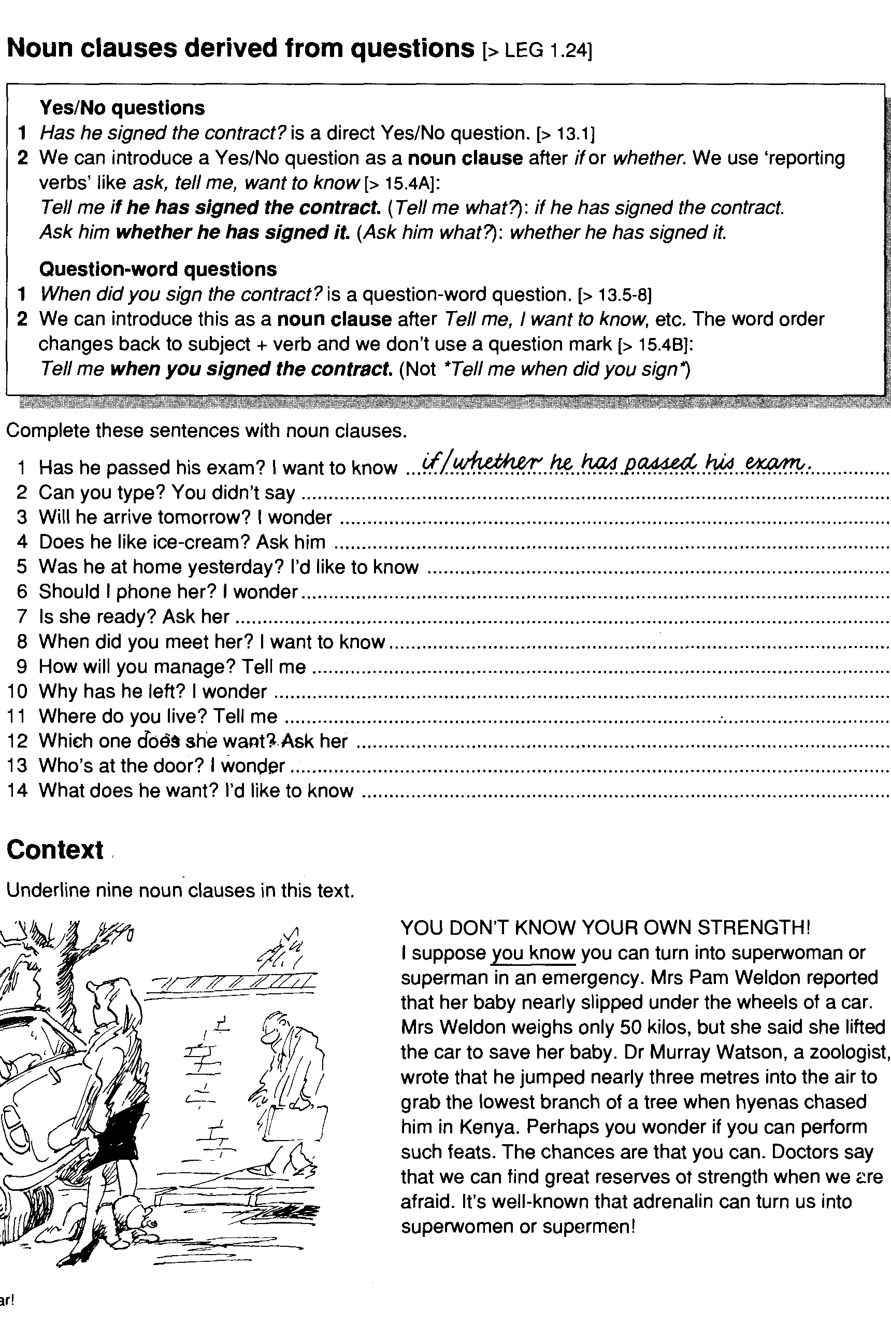

8 Lexical cohesion. (synonyms, antonyms, homonyms)

9 Doing Grammar exercises. M: Group work.
High-tech trouble
It all (1) as I made my way home from work. We (2) on a top secret
computer program, and everyone (3) pretty nervous about finishing on time, so it was
good to get away from the office. It (4) and it seemed like everyone
(5) home at the same time, anxious to avoid getting wet. I (6) down
into the underground station and (7) for the train when I (8) her at
the end of the platform. She (9) a red leather jacket that (10) me
of something I'd seen in a film, although I couldn't remember when. As I watched, she
(11) her handbag and (12) out what looked like a hand-held
computer. She (13) something on the screen, then (14) in my
direction. Suddenly, my mobile phone (15) a sound that (16) I had a text message. Frowning, I (17) a key and the message (18)
'We (19) your daughter. We know you (20) the program. Follow the
woman in red.' I looked up just as she (21) around the corner. I (22)
after her.
Case 4 One verb in each sentence is in the wrong tense. Underline the incorrect word or phrase and
write it in the correct tense.
- I've been having a lot of problems with my computer recently and so I got a technician to come and have a look at it, but she has told me that it was because I wasn't using it properly.
- It was a few days since I heard from Roger, but he left Russia last Monday and he was planning to arrive in China yesterday, so I called his mum to see if she had heard anything.
- Patricia and I were having a really good discussion when Jason suddenly appeared and decided that he wanted to join in, even though he has known absolutely nothing about what we were talking about.
- I had never been visiting a working prison before, so when the opportunity came up I was really eager to have a look around and I certainly wasn't disappointed, although we weren't actually allowed to see the area where the prisoners live.
- Charlie didn't know what Callum had said to Imogen, but he could see immediately that she had been crying and he was putting his arm around her to comfort her, which made her feel a little better.
- Although there was no reason to doubt what Alex said, I was ringing Rick to check and he told me that Alex had been right and the concert really had been cancelled because the lead singer had come down with flu.
- The year before, I had given Lisa a CD for her birthday, but this particular year I wanted to surprise her, so I went into town and I was looking round the shops when suddenly I had seen an old-fashioned hat, and it was her size, so I immediately bought it.
Olivia was cycling to school, as she usually did on those days when her father was working and wasn't able to drive her, when she was passing an old woman, who was waiting for the lights to change so that she could cross the road.

Lesson 10 Lexical units.

Kinds of lexical unit
Intuitively, the prototypic lexical unit is a word. This definition has a number of catches to it, however, because the notion of word is not as simple as it seems, and because lexical phrases (idioms ) also exist. The intuitive notion of word has ``fuzzy edges'', as in the following cases:
1.
Words may contain other words (e.g. compound words such as database, Sprachtechnologie).
2.
Words have different status in respect of their phonetic realisations and their meaning; compare the difference between function words, e.g. to, for with reduced pronunciations and structural meanings, and content words, e.g. word, spell, which refer to real world objects, properties, event types, abstract concepts.
3.
Words may be merged with other words in informal speech ( cliticisation). Examples of clitics are English 's in he's - /hi:z/, French l' in il l'a vu - /il la vy:/, German 'm in auf'm Tisch - /afm t/.
4.
Particular types of word formation such as spelling and acronym formation may require special attention: ecu - /i:kju:/, /i:si:ju:/.
5.
Words may be inflected word forms , making sound (singular) and sounds (plural) into different words. On the other hand, words may be regarded as a class of inflectionally related forms (a paradigm), i.e. sound and sounds then belong to the same word, which may be characterised by a canonical inflected form (e.g. nominative singular), or by the stem shared by the forms and identified by linguistic analysis, or by a number or other abstract label. In speech technology, the inflected word form is the standard definition. In standard dictionaries, the paradigm definition of word is used, represented by a headword or lemma , generally the canonical inflectional form such as nominative singular, in orthographic representation.
6.
Lexical units may need to be larger than the word (e.g. phrasal idioms ).
7.
Lexical units may need to be smaller than the word: Semantically oriented morphological word subunits (word constituents) include
- word stems minus inflections ; indivisible word stems are lexical morphemes);
- constituent words words formed by compounding (composition);
- constituent prefixes , stems and suffixes in words formed by derivation.
Pronunciation oriented phonological word subunits include syllables and their parts; phonological subunits do not necessarily correspond closely with morphological subunits.
8.
Linguistic textbooks distinguish between several different views of words as lexical units, depending on which kind of lexical sign information is regarded as primary:
- The phonological word (based on its conformity to the phonotactic structure of a language).
- The prosodic word , based on its conformity to the accentuation and the rhythm patterning of the language.
- The orthographic word (for instance, as delimited by spaces or punctuation marks ).
- The morphological word (based on the indivisibility and fixed internal structure of words).
- The syntactic word (based on its distribution in sentences).
9.
The lexical word as a type, as opposed to an occurrence of the type in larger units, and a token of the type in a corpus of speech or writing.
The central meaning for the purpose of spoken language lexica will be taken to be the morphological word.
Lexical units (entries, items) are assigned sets of properties; these identify the lexical units as signs, and determine the organisation of the lexicon. In practical contexts, the choice of lexical unit and the definition of priorities among its properties may be important for procedural reasons, i.e. in determining ways in which a lexicon may be most easily accessed: through orthography, pronunciation, meaning, syntactic properties, or via its morphological properties (stem, inflection ). The application-driven decision on the kind of lexical unit which is most suitable for a given purpose is a non-trivial one. However, for many practical purposes fairly straightforward guidelines can be given:
- The form of a lexical item, in particular its orthography, is often used as the main identifying property for accessing the lexicon.
- However, access on phonetic grounds, via the phonological form, is evidently the optimal procedure for speech recognition , and access on conceptual semantic or syntactic grounds is evidently the optimal procedure for speech synthesis.
- The use of orthography as an intermediate stage in speech recognition is a useful and widespread heuristic which generally does not introduce significant numbers of artefacts into the mapping from speech signals to lexical items, but is not recommended for complex systems with large vocabularies, except as a means of visualisation in user interfaces.
- For text-to-speech applications orthography is likely to be the optimal lexical access key.

Fully inflected form lexica

It has already been noted that fully inflected form lexica and lexical databases are fairly standard for speech recognition. Where a small closed vocabulary is used, and new, unknown or ad hoc word formations are not required (as with most current applications in speech synthesis and recognition ), fully inflected word forms are listed. This procedure is most convenient in languages with very small inflectional paradigms; for languages of the agglutinative type, in which large numbers of inflectional endings are concatenated, the procedure rapidly becomes intractable. In other applications, too, such as speech synthesis, it may be more tractable to generate fully inflected word forms from stems and endings.
An example of a language with few inflections is English, where (except for a few pronouns) only nouns and verbs are inflected, and even here three forms exist for nouns (uninflected, genitive and plural) and four for verbs (uninflected, third person singular present, past, and present participle; irregular verbs in addition have a different past participle form - the verb to be is, as always, an extreme case). English is therefore not a good example for illustrating inflectional morphology (in other areas of morphology, i.e. in word formation, languages appear to be equally complex).
French is much more complex, with inflections on adjectives, and large verb paradigms; note that orthographic inflection in French has more inflectional endings than are distinguished in phonological inflection.
German also has complex inflectional morphology, with significantly more endings on all articles, pronouns, nouns, adjectives and verbs, increasing the size of the vocabulary over the size of a stem -oriented lexicon by a factor of about 4.
In extremely highly inflecting languages such as Finnish, the number of endings and the length of sequences of endings multiply out to increase the vocabulary by a factor of over 1000. Special morphological techniques have been developed (e.g. two-level morphology ) to permit efficient calculation of inflected forms and to avoid a finite but unmanageable explosion of lexicon size for highly inflecting languages [Koskenniemi (1983), Karttunen (1983)]. These techniques have so far not been applied to any significant extent in speech technology [Althoff et al. (1996), but cf.,].
The figures cited refer only to the sets of forms. When the form-function mapping, i.e. the association of a given inflected form with a morphosyntactic category, is considered, the figures become much worse. A single inflected adjective form such as guten in German has 44 possible interpretations which are relevant for morphosyntactic agreement contexts [Gibbon (1995)], with 13 feminine readings, 17 masculine readings, and 14 neuter readings, depending on different cases (nominative, accusative, genitive and dative) and different determiner (article) categories (strong, weak and mixed). It is possible to reduce the size of these sets by means of default-logic abbreviations in a lexical database , but for efficient processing, they ultimately need to be multiplied out. Similar considerations apply to other word categories, and to other highly inflecting languages.
Complex inflectional properties in many languages other than English imply that, for these languages, large vocabulary systems with complex grammatical constructions require prohibitively large fully inflected form inventories. Although the sets of mappings involved can be very large, the inflectional systems of languages define a finite number of variants for each stem , and therefore it may make sense in complex applications in speech recognition to define a rule-based ``virtual lexical database'' or ``virtual lexicon'' which constructs or analyses each fully inflected word form on demand using a stem or morph lexicon with a morphological rule component [Althoff et al. (1996), Bleiching et al. (1996), Geutner (1995)].

Stem and morph lexica

Lexica based on the morphological parts of words, coupled with lexical rules for defining the composition of words from these parts, are not widely used in current speech recognition practice. They are useful, however, in expanding lexica of attested forms to include all fully inflected forms, for instance for word generation and speech synthesis, and in tools which verify the consistency of corpus transcriptions and lexica.
Terminology in this area is somewhat variable. In the most general usage, a stem is any uninflected item, whether morphologically simple or complex. However, intermediate stages in word formation by affixation , and in the inflection of highly inflected languages, are also called stems . The smallest stem is a phonological lexical morph or an orthographic lexical morph , i.e. the phonological or orthographic realisation of a lexical morpheme . Since stems may vary in different inflectional contexts, as affixes do, it is necessary to include information about the morphophonological (and morphographemic ) alternations of such morphemes:
Knife:
<surface phonology singular> = naIf
<surface phonology plural> = naIv + z
<surface orthography singular> = knife
<surface orthography plural> = knive + s.
The use of morphological decomposition of the kind illustrated here has been demonstrated to bring some advantages in medium size vocabulary speech recognition in German [Geutner (1995)]; for languages like English, with a low incidence of inflections, the advantage is minimal.
In a stem lexicon, the basic lexical key or lemma is the stem, which is represented in some kind of normalised notation. The most common kind of normalised or canonical notation has the following two properties:
- Canonical inflected form: With morphologically inflected items, a ``normal form'' such as the infinitive for verbs or the nominative singular for nouns is used.
- Canonical orthography: A standardised orthographic representation of the canonical inflected form is used.
For specific purposes, in which lexical entries need to be accessed on the basis of a specific property, indexing based, for instance, on the canonical phonemic representation, either of a fully inflected form or of the canonical inflected form , or even of the stem itself, may be required; for stochastic language models, for example, a tree-coded representation may be the optimal representation (see Chapter 7). Phonemic representation is dealt with in more detail below.

The notion of ``lexical lemma''

As in the knife example, one particular form, for instance orthographic, of an entry is often used as a headword or lemma . From a technical lexicographic point of view, this form then has a dual function:
- It names the entry.
- It also represents one of its properties, namely its spelling.
In spoken language lexicography, this distinction is central, and ignoring it may lead to confusion. This applies particularly in the context of spoken language lexicography, where the primary criterion of access by word form is phonological.
When homographs occur (e.g. bank as a financial institution or as the side of a river), an additional consecutive numbering is used, e.g. bank, bank, etc.
The concept of an abstract lemma, deriving from recent developments in computational linguistics and their application to phonology and prosody , may be used in order to clarify the distinction [Gibbon (1992a)]: an abstract lemma may have any convenient unique name or number (or indeed be labelled by the spelling of the canonical inflected form , as already noted); all properties have equal status, so that the abstract lemma is neutral with respect to different types of lexical access, through spelling, pronunciation, semantics, etc. The examples of lexical entries given so far are based on the concept of an abstract lemma . The neutrality of the abstract lemma with respect to particular properties and particular directions of lexical access make it suitable as a basic concept for organising flexible lexical databases. A lexicon based on a neutral abstract lemma concept is the basic form of a declarative lexicon, in which the structure or the lexicon is not dictated by requirements of specific types of lexical access (characteristics of a procedural lexicon, but by general logical principles. The distinction between declarative and procedural lexica is a relative one, however, which is taken up in the section on spoken language lexicon architectures. For practical applications, a lexical database will need to be procedurally optimised (= indexed) for fast access.

Next: Lexical properties and lexical Up: Types of lexical information Previous: A simple sign model
EAGLES SWLG SoftEdition, May 1997. Get the book...

11 Doing Grammar exercises. M: Group work.
Look at these sentences and decide which object is being described in each one. Use the
words in bold to help you. You will find the objects hidden in the word grid at the bottom of
the page.
1. The most important part of this object is a strip of two different metals, one on top of the other. As
they heat up, both metals expand, but one does it faster than the other. The strip bends and connects
with a switch, which turns off the power supply. When the strip cools down, the metals contract and
the switch is disconnected. (1 word)
2. This object has several component parts, most of which are made of plastic. A disc inserted into the
object spins quickly. At the same time a thin beam of light strikes the disc and converts digital symbols
into sounds. These sounds can be increased or decreased in volume by means of a button or dial.
(3 words)
3. Liquid and gas are compressed in a hard metal tube. This can be released by pushing or squeezing a
button which opens a valve. When the liquid-gas combination leaves the tube and is mixed with
oxygen, it rapidly expands. (1 word)
4. This object is mainly made of aluminium. As it moves forward, air flows over two horizontal sections.
As it accelerates, a vacuum is formed over the horizontal sections and the object is pulled into the air
by the force of this vacuum. (1 word)
5. This object consists of two main parts; one is made mainly of plastic and metal, the other is made
mainly of glass. Light enters the glass section and a small door in the device opens up when a button
is pressed. At the same time, a smaller window called an aperture adjusts itself to control the amount
of light. The light is then absorbed by a sheet of plastic coated in a special chemical. An image is
formed and this can then be processed and developed into a two-dimensional paper-based object.
(1 word)
6. A sharp blade inside a plastic container rotates very quickly. It chops or grinds anything it touches,
which we can then use to produce soup, sauces and dressing. (2 words)
7. This is a very simple object which originated in China. A small piece of paper is lit with a match. It
burns away until the flame ignites the chemical compound inside a cardboard tube. The result is a
display of light and colour. (1 word)
B. B. There are nine more objects hidden in the grid. Choose four of them and write a brief
description of how they work, using the bold words and expressions above.
Peter A. Below, you will see eleven common situations that people encounter when they are
writing a formal letter. Choose the sentence or phrase (A, B or C) that would be most
appropriate in each situation.
1. You are writing a letter to the headteacher of a school or college, but you don't know their name.
How do you begin your letter?
A. Dear headteacher B Dear Sir / Madam C. Dear Sir
2. You have received a letter from the manager of a company which buys computer components from
your company, and you are now replying. What do you say?
A. Thank you for your letter. B. Thanks a lot for your letter. C It was great to hear from you.
3. You recently stayed in a hotel and were very unhappy with the service you received. You are now
writing to the manager. What do you say?
A. I had a horrible time at your hotel recently. B. I would like to say that I am unhappy about
your hotel. C. I would like to complain about the service I received at your hotel recently.
4. You have sent a letter of application to a college, together with your curriculum vitae which the
college requested. What do you say in the letter to explain that your curriculum vitae is attached?
A. You asked for my curriculum vitae, so here it is. B. As you can see, I've enclosed my
curriculum vitae, C. As you requested, I enclose my curriculum vitae.
5. You have applied for a job, but you would like the company to send you more information. What do
you say?
A. I would be grateful if you would send me more information. B. I want you to send me more
information, C Send me some more information, if you don't mind,
6. In a letter you have written to a company, you tell them that you expect them to reply. What do you say?
A. Write back to me soon, please. B. Please drop me a line soon.
C. l look forward to hearing from you soon.
7. In a letter you have written, you want the recipient to do something and are thanking them in
advance of their action. What do you say?
A. Thank you for your attention in this matter. B. Thanks for doing something about it.
C I am gratified that you will take appropriate action.
8. The company you work for has received an order from another company and you are writing to them
to acknowledge the order and let them know when you can deliver. What do you say?
A. About the order you sent on 12 January for... B. I would like to remind you of the order
you sent on 12 January for... C. refer to your order of 12 January
9. In a letter, you explain that the recipient can contact you if they want more information. What do you say?
A. Give me a call if you want some more information. B. If you would like any more
information, please do not hesitate to contact me. C. If you would like any more information,
why not get in touch?
10. You began a letter with the recipient's name (e.g., Dear Mr. Perrin). How do you end the letter?
A. Yours faithfully B. Yours sincerely C. Best wishes
11. You did not begin the letter with the recipient's name (see number 1 above). How do you end the letter?
A. Yours faithfully B. Yours sincerely C Best wishes
B. Look at these sentences and decide if they are true or false.
1. Formal letters are always longer than informal letters.
2. In a formal letter it is acceptable to use colloquial English, slang and idioms.
3. In a formal letter it is acceptable to use contractions (e.g., I've instead of I have)
4. In a formal letter you should include your name and address at the top of the page.
5. In a formal letter, you should always write the date in full (e.g., 1 April 2000 and not 1/4/00).
6. In a formal letter, you should always put your full name (e.g., James Harcourt and not J. Harcourt)
after your signature at the bottom of the letter.
7. Formal letters do not need to be broken into paragraphs. It is acceptable to write them as one

12 The usage of jargon and idioms.
I started my writing life as a business writer, compelled to try to improve the tortured, often incomprehensible language I found in operating manuals, annual reports, memoranda, and other formats that some bad writers tried to pass off as business “communication”. There seems to be a great misconception that passive voice, undefined acronyms and abbreviations, and loads of jargon make for good business writing.
Not true. All writers—whether writing for business, science, or academia, or those writing fiction and creative nonfiction—should strive for clarity.
But does that mean jargon, slang, and idioms are always taboo? Not if you do your job to make them serve your writing, rather confuse or bore your readers.

Jargon
jargon (noun) — specialized technical terminology characteristic of a particular subject; a characteristic language of a particular group.
To use jargon effectively, you must know your audience. Almost all industries use jargon to some extent, and that’s OK, because most practitioners of a particular profession have a basic understanding of the material and its associated jargon. Business and sports writers are notorious jargon users, as those in medicine and education.
For most writers, the goal is clarity. Unless you have a specific reason to use jargon, it’s best to avoid it. If you must include jargon, be sure to define it or make it understandable within the context of your story.
Bad writing is often the result of too much jargon. While jargon can be helpful when communicating within a specific group, too much jargon, or jargon that is not clearly defined can lead to muddy, confusing writing. If you find yourself having to reread a sentence over and over again, it is often because it contains confusing jargon.
Well-placed jargon in a piece of fiction can lend the voice of authority or the face of authenticity to a particular character. If one of your characters is a pompous Wall Street trader, using some insider jargon will help readers hear his voice on your page. Genre fiction, such as crime fiction, often relies heavily on the use of jargon. Here again, know your audience.
One way to help define jargon in your writing is to spell out acronyms or abbreviations the first time you use them:
Fuzzy: SCBWI announced on June 19 both the winner and runner up of the Don Freeman Memorial Grant-in-Aid.
Better: On June 19, the Society for Children’s Book Writers and Illustrators (SCBWI) announced this year’s recipients of the Don Freeman Memorial Grants for picture book illustrators.
See if you can translate the following jargon into language that could be understood by a general audience (note, I did not make these up). You may need your search engine to help you. How many clicks around the Internet did it take you to understand the original jargon?
- Tender mooring area; please use a long painter.
- Eye of the Leopard managed to collar pacesetter Mr. Foricos Two U at the wire to win by a neck.
- The LNA is the “front end” of the block down-converter.
- The increasingly performative quality of art is becoming the paradigm for a multiplicity of aesthetic practices.
- The MVC (also known as a Mesoscale Convective Vortex (MCV) or a “Neddy eddy”) is best seen in a Java animation of visible imagery, appearing as a cyclonic spiral moving toward Saint Louis, MO.

Slang
slang (noun) — A kind of language occurring chiefly in casual and playful speech, made up typically of short-lived coinages and figures of speech that are deliberately used in place of standard terms for added raciness, humor, irreverence, or other effect.
Slang is the language of the moment. It’s especially common among young people and, therefore, a vital component in writing young adult (YA) literature or writing authentically in the voice of a teen. In a recent issue of TriQuarterly Online, Natalie Haney Tilghman explains: “Slang is a language of exclusion and makes the world of adolescence inaccessible to outsiders, including adults.”
But using slang effectively is tricky. First, by its very nature, slang is short-lived. Words or phrases that sound fresh today may be as moldy as week-old bread by the time your book leaves the presses.
If you do use slang, you have to define it in context and use it frequently enough in your text for it to seem a natural part of the telling of your story. It should sound right coming out of the mouths of your characters. This requires consistency and a good ear. If you’re going to use real slang from a particular community—the hip hop culture, for example—you better get it right or you will lose credibility with your readers.
One way to avoid misusing slang is to make up your own. It’s not that hard; teenagers do it all the time. Mix in a few evergreens like “cool” or “hot” that most readers will immediately recognize as slang, and your imaginary slang will take on a life of its own. Again, consistency and context are key. Who knows, your made-up slang may become the real slang of tomorrow.

Idioms
idiom (noun) — a group of words established by usage as having a meaning not deducible from those of the individual words (e.g. “on pins and needles”, meaning to be worried about something).
Idioms (or colloquialisms) are those turns of phrases that mean something entirely different than the actual words would indicate. Idiom is often synonymous with cliché (a saying or expression that has been so overused that it has become boring and unoriginal), but not all idioms are clichés. Used wisely in fiction or creative nonfiction, a well-chosen idiom can add color and flavor to your writing.
Since many idioms are regional they can be an efficient way of setting a character in a particular time or place. Speech from the American South is often riddled with colorful idioms, and English literature abounds with brilliant uses of idioms:
- Tennessee Williams’ classic Cat on a Hot Tin Roof comes from a much older idiom, “like a cat on hot bricks”; both mean to be jumpy and nervous.
- Shakespeare coined many idioms that are still used today, including: wearing your heart on your sleeve, to come full circle, or to go on a wild-goose chase.
- The classic children’s book Amelia Bedelia, by Peggy Parish, is rife with idioms that confound poor Amelia, as she “dusts the furniture” by putting dust everywhere (why isn’t it “undusting” the furniture?)
Jargon, slang, and idioms are often the culprits on unimaginative and confusing text. But in the hands of good writers, they are just three more tools in your writing toolbox.

Just for Fun
If you’re in need of a few good laughs (or want to feel really good about your own writing), check out the winners of the 2011 Golden Bull Awards from the Plain English Campaign. If any of the examples sound like good writing to you, return to the top of this post and start taking good notes.

13 Doing Grammar exercises. M: Group work.

14 Idioms and collocations
Lexical semantics and pragmatics
Collocations
- Two or more words that often go together. These combinations just sound "right" to native English speakers, who use them all the time. On the other hand, other combinations may be unnatural and just sound "wrong". Look at these examples:
Natural English... | Unnatural English...
the fast train  fast food | the quick train  quick food
a quick shower  a quick meal | a fast shower  a fast meal

- two collocates, one is dominant
- con locare – zajedno se javiti
- they are more transparent than idioms

How to learn collocations
- Be aware of collocations, and try to recognize them when you see or hear them.
- Treat collocations as single blocks of language. Think of them as individual blocks or chunks, and learn strongly support, not strongly + support.
- When you learn a new word, write down other words that collocate with it (remember rightly, remember distinctly, remember vaguely, remember vividly).

Types of Collocations
There are several different types of collocation made from combinations of verb, noun, adjective etc. Some of the most common types are:
- Adverb + Adjective: completely satisfied (NOT downright satisfied)
- Adjective + Noun: excruciating pain (NOT excruciating joy)
- Noun + Noun: a surge of anger (NOT a rush of anger)
- Noun + Verb: lions roar (NOT lions shout)
- Verb + Noun: commit suicide (NOT undertake suicide)
- Verb + Expression With Preposition: burst into tears (NOT blow up in tears)
- Verb + Adverb: wave frantically (NOT wave feverishly)
Examples:
- refuse flatly
- catch disease, spread disease
- heated discussion
- thick hair, dense fog
- heavy rain
- heavy smoker
- make a wish

Idioms
- a group of words whose individual meanings are sacrificed for the union
- a phrase where the words together have a meaning that is different from the dictionary definitions of the individual words, which can make idioms hard for students to understand
- various transparency of idioms – the lower the transparency of an idiom, the higher its metaphoric value
- Idioms are fun and useful expressions that usually cannot be understood by defining the separate words. For example, if your mother says, "I think it's time to hit the hay", she means, "I think it's bed-time"! You would not be able to understand her by looking up the words hit and hay. Like phrasal verbs, these expressions need to be memorized as a whole.
Examples:
- to give somebody a cold shoulder
- to rob the cradle: to marry or have a relationship with someone much younger
- fly off the handle (get very angry)
- once bitted, twice shy
- to laugh like a drain
- beat/kick the hell out of sb
- as red as a beet
- as daft as a brush
- to look like sth that cat brought/dragged in
- to smoke like a chimney
- to swear like a trooper

Handout 1. This exercise tests your understanding of common idiomatic expressions. Fill in the blanks.

1. Rahul is known for his ................................. fuse. The other day he yelled at the teacher for asking him to leave the class.
a) quick
b)tight
c) short

2. I had ........................................ in my stomach as I waited for the results to be announced.
a)dragons
b)spiders
c) butterflies

3. Peter made the national team by the skin of his ...................................; you can tell that he hasn't fully recovered from his injuries.
a)face
b) nose
c) teeth

4. If you always cry ................................., no one will be there to help you when you actually need it.
tiger
fox
wolf

5. Cut him some ................................ After all, he is a mere child.
ice
space
slack

6. I didn't go to the party because I was down for the .................................. after working all day in the garden.
moment
count
hell

7. I know getting fired is no fun but remember that every cloud has a ....................................... lining.
white
silver
golden

8. Finding a good job these days is as hard as finding a ............................................... in a haystack.
needle
knife
pin

9. I felt like a ...................................... out of water at the party because I didn't know anyone there.
fish
frog
turtle

10. I have to get this off my ……………………………… - I was the person who reported you to the police.
head
throat
chest

11. I have never gone scuba diving, but I am going to give it a ....................................
swirl
whirl
twirl

12. Her career went down in .................................... after she started doing drugs.
arms
smoke
flames

Answers
1. Rahul is known for his short fuse. The other day he yelled at the teacher for asking him to leave the class.
2. I had butterflies in my stomach as I waited for the results to be announced.
3. Peter made the national team by the skin of his teeth; you can tell that he hasn’t fully recovered from his injuries.
4. If you always cry wolf, no one will be there to help you when you actually need it.5. Cut him some slack. After all, he is a mere child.
6. I didn’t go to the party because I was down for the count after working all day in the garden.
7. I know getting fired is no fun but remember that ever cloud has a silver lining.
8. Finding a good job these days is as hard as finding a needle in a haystack.
9. I felt like a fish out of water at the party because I didn’t know anyone there.
10. I have to get this off my chest – I was the person who reported you to the police.
11. I have never gone scuba diving, but I am going to give it a whirl.
12. Her career went down in flames after she started doing drugs.
Handout 2. Doing the test..
1. My grandfather was a …………………. smoker, so few people were surprised when he died of oral cancer.
a) serial
b) heavy
c) big
2. She was a / an ……………………. wife who loved her husband more than anything else in the whole universe.
a) devoted
b) sincere
c) intelligent
3. I always avoid his company because he is a crashing ……………………..
a) bore
b) nuisance
c) guy
4. It is a golden ………………………… If you miss it, you will regret it.
a) chance
b) opportunity
c) offer
5. She seemed quite interested in buying that house, but at the last moment, she changed her …………………..
a) mind
b) thoughts
c) offer
6. Although I was …………………. annoyed by her attitude, I said nothing.
a) moderately
b) lightly
c) slightly
7. Could you …………………. the oil?
a) inspect
b) check
c) test
Answers
1. My grandfather was a heavy smoker, so few people were surprised when he died of oral cancer.
2. She was a devoted wife who loved her husband more than anything else in the whole universe.
3. I always avoid his company because he is a crashing bore.
4. It is a golden opportunity. If you miss it, you will regret it.
5. She seemed quite interested in buying that house, but at the last moment, she changed her mind.
6. Although I was slightly annoyed by her attitude, I said nothing.
7. Could you check the oil?

Glossary

keep a promise
to do what you promised to do

x-ray vision
the ability to see into or through objects made of non-transparent materials

keep a secret
to not tell anyone a secret

daily life
life as experienced from day to day

used car
a car that's already been owned by someone
‘To feel under the weather’ – to not feel well.
“I’m really feeling under the weather today; I have a terrible cold.”
‘Speak of the devil’ – this means that the person you’re just talking about actually appears at that moment.
“Hi Tom, speak of the devil, I was just telling Sara about your new car.”
‘When pigs fly’ – something that will never happen.
“When pigs fly she’ll tidy up her room.”
‘A piece of cake’– something is very easy.
“The English test was a piece of cake.”

References:

.1. Idioms in English that Use the Word Book

2.333 Idioms + Phrases: For Business.Paperback – January 6, 2014
by Liam Lusk (Author), Scott Worden (Author)
3..http://abu.edu.iq

- Doing Grammar exercises. M: Individual work.

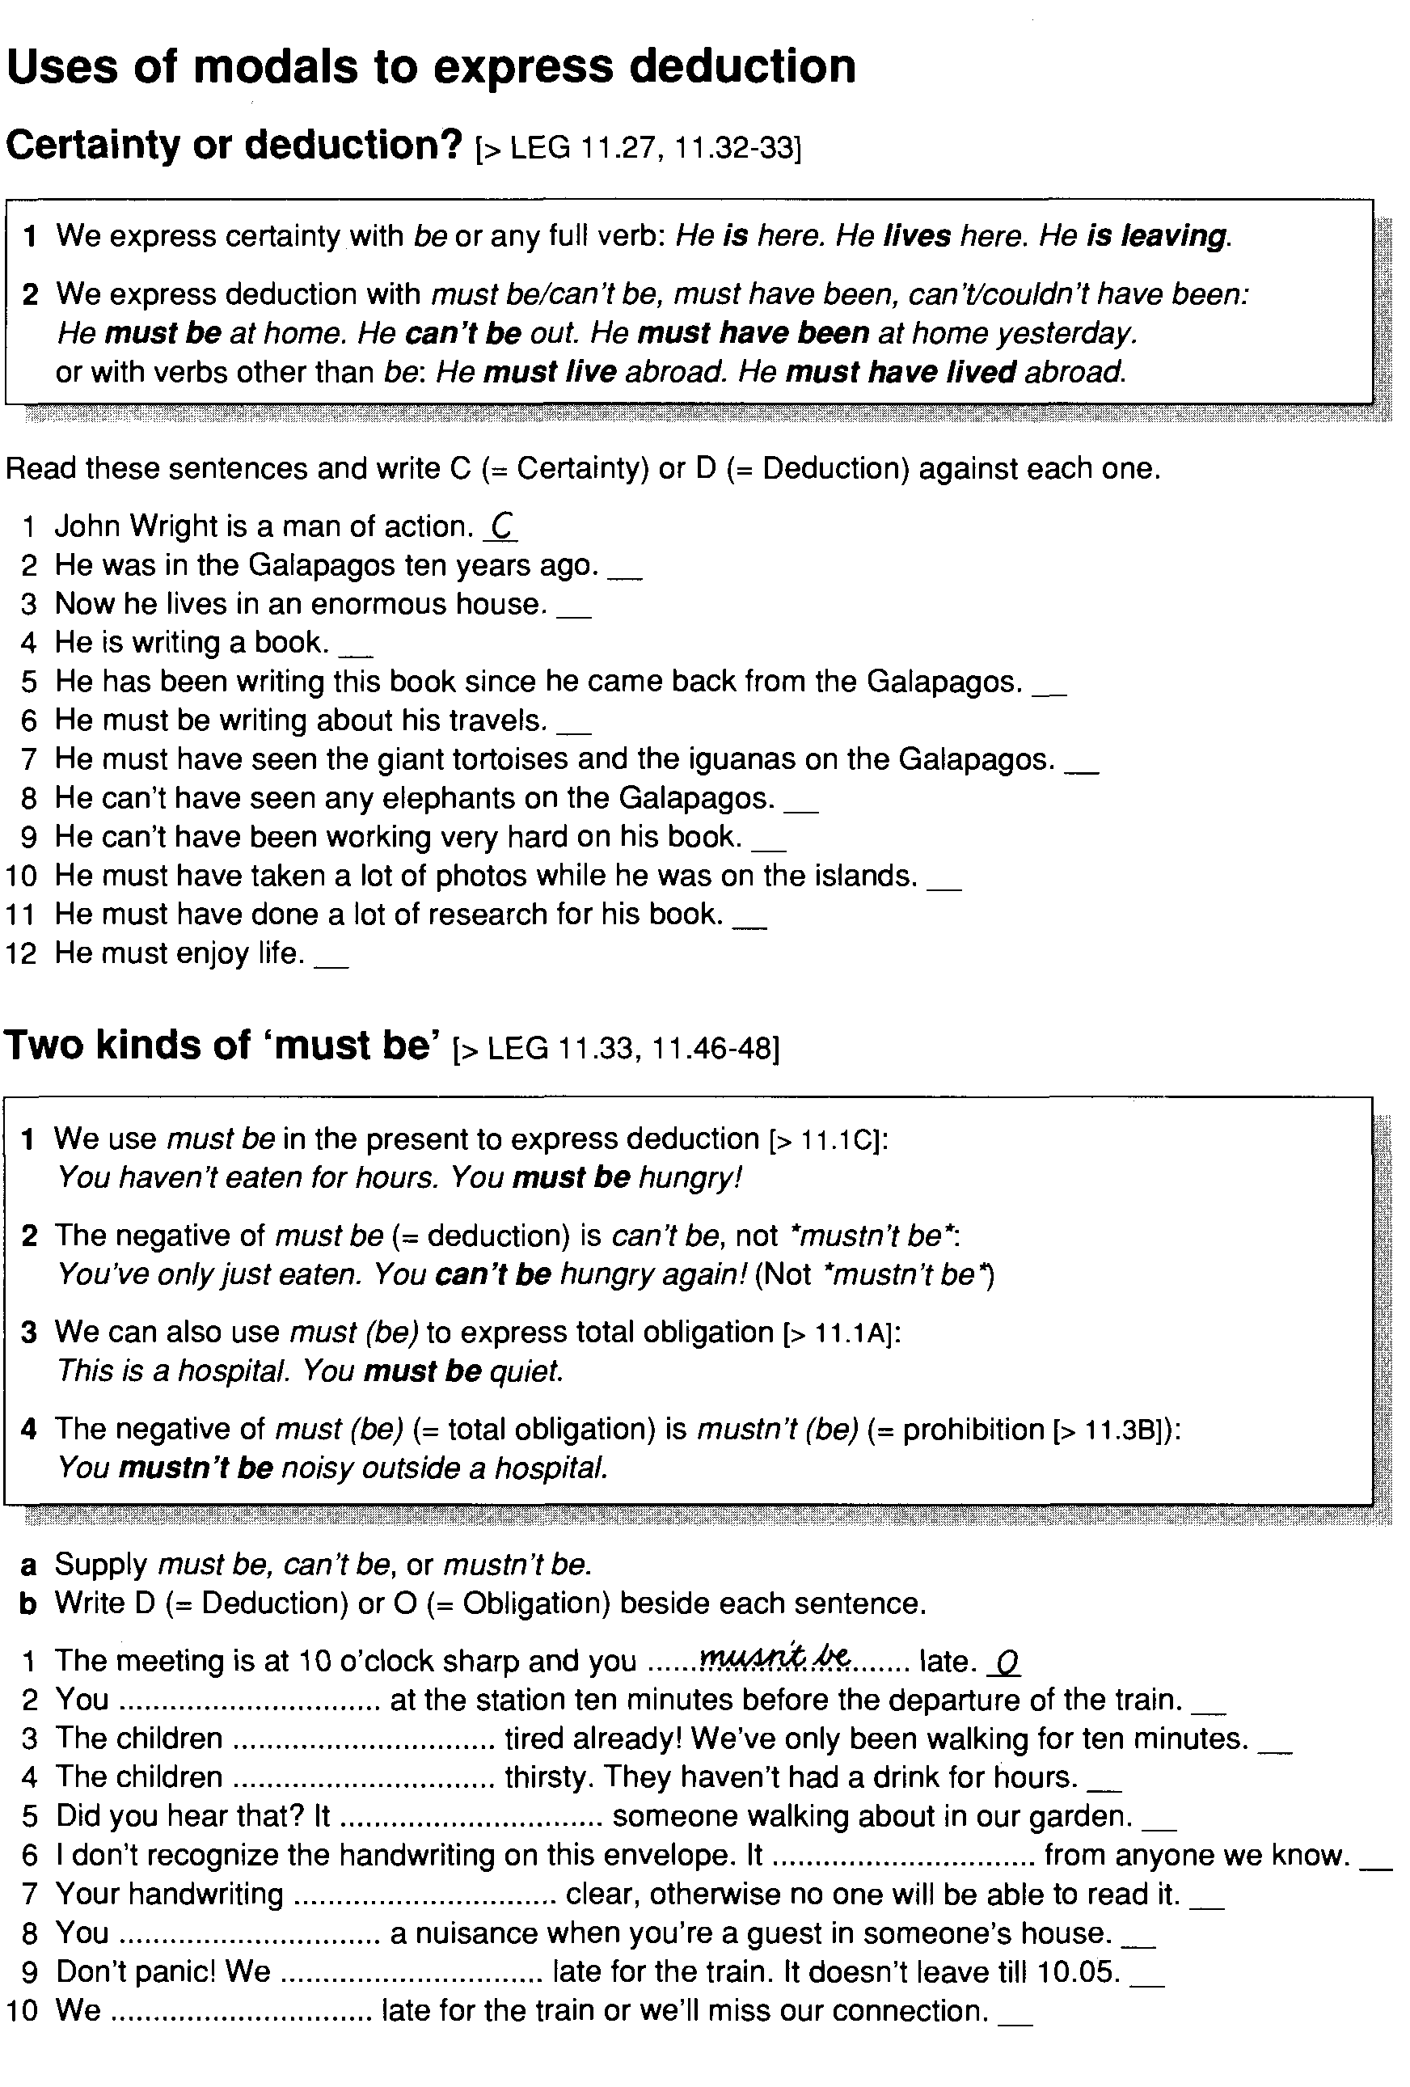

- Textual aspects of lexical competence. M: Group work.
- 1. Vocabulary knowledge a quantitative and qualitative point. The former (breadth of knowledge) is related: “How many words does an L2 learner need or how much vocabulary does an L2 learner know?”
- 2. (depth of knowledge)“What does knowing a word mean?” Richards: “Vocabulary Knowledge Framework” knowing about the word’s: frequencyand collocability; register; position; form; associations; meaning-concept and meaning-associations
- 3. Is far more than the ability to identify a given number of words learners acquire a great dealinformation about a word takes place gradually over a long period of time, and it is very elaborate
- 4. Chapelle: (three components) to describe vocabulary ability: the context of vocabulary use vocabulary knowledge knowing of word characteristics and lexicon organization and fundamental processes; and metacognitive strategies for vocabulary use
- 5. Refers to the way words settle in the mind (the huge number of words, an organizational structure of the mental lexicon) The main links that relate words in the mind are: co-ordination, collocation, superordination, synonymy
Recommended
Fill in the blanks with an appropriate word or phrase.

1. It is very difficult to give ……………………….. criticism.
objective
object
objectionable

2. Paying taxes is …………………………..
obligation
obligatory
obliging

3. How can you be so ………………………. to her rude remarks?
oblique
oblivion
oblivious

4. Don’t be so ……………………….. in other people’s affairs.
obstructive
obtrusive
objective

5. The weather was good except for an ………………………… shower.
occasion
occasional
occasionally

6. An egg with two yolks is an ………………………..
odd
oddity
odds

7. The peoples of the two countries must learn to understand …………………………
one another
each other

8. The army’s ……………………… march continued.
onward
onwards
Either could be used here

9. Now would be an ………………………….. time to buy a new book.
opportunity
opportune
opportunistic

10. The experiment was conducted under ………………………….. conditions.
optimum
optimal
Either could be used here

11. Which of the following phrases mean in good faith?
bona fide
ex gratia
sine qua non

12. The Ohio river forms the boundary …………………………. Kentucky and Indiana.
among
between

Answers
1. It is very difficult to give objective criticism.
2. Paying taxes is obligatory.
3. How can you be so oblivious to her rude remarks?
4. Don’t be so obtrusive in other people’s affairs.
5. The weather was good except for an occasional shower.
6. An egg with two yolks is an oddity.
7. The peoples of the two countries must learn to understand one another.
8. The army’s onward march continued.
9. Now would be an opportune time to buy a new book.
10. The experiment was conducted under optimum / optimal conditions.
11. Which of the following phrases mean in good faith? Bona fide
12. The Ohio river forms the boundary between Kentucky and Indiana.

